

PROJECT PROPOSAL PROFORMA
[INSERT SIGNED PROJECT PROPOSAL PROFORMA HERE]

APPROVED PROJECT SYNOPSIS
[INSERT APPROVED PROJECT SYNOPSIS HERE]



ACKNOWLEDGEMENT
I would like to express my sincere gratitude to all those who supported and guided me in the successful completion of my MCA project, "SkillKart", submitted as part of the requirements for the Master of Computer Applications programme at Indira Gandhi National Open University.

I am especially grateful to my project guide, Mr. Yadhu Krishnan T, for his valuable guidance, suggestions, encouragement, and support throughout the development of this project. His guidance helped me understand the various stages of project development, from system analysis and design to implementation and testing.

I would also like to thank the faculty members and staff of SH College, Thevara, for providing the necessary academic support and facilities during the course of this project.

I am thankful to Indira Gandhi National Open University and the School of Computer and Information Sciences for providing the academic framework and opportunity to undertake this project.

Finally, I would like to thank everyone who directly or indirectly contributed to the completion of this project.

Muhammed Yaseen
Enrolment No.: 2400337880

ABSTRACT
SkillKart is a web-based Learning Management System designed to provide a structured online platform for learners and instructors. The system enables learners to discover courses, enroll in courses, access learning content, track their progress, participate in assessments, submit reviews, and manage their learning activities through a centralised platform. Instructors can create and manage courses, organise course content, monitor enrolled learners, and manage the instructional and financial aspects of their courses. Administrators can manage users, moderate courses, and configure the platform.

The project was developed using the MERN stack, comprising MongoDB, Express.js, React, and Node.js. The frontend provides an interactive and responsive user interface, while the backend exposes RESTful APIs for application operations and communicates with the MongoDB database through Mongoose. Authentication and role-based access control are used to provide appropriate access to learners, instructors, and administrators.

The system incorporates several core learning management capabilities, including user registration and authentication with Google sign-in, onboarding, course browsing and search, course creation and moderation, a shopping cart with coupon support and Razorpay payment integration, course enrollment, lesson-based learning with completion safeguards, quizzes and assignments, reviews and ratings, verifiable certificates, notifications, instructor analytics and earnings, and an administrative panel with audit logging and system settings. The architecture follows a client-server approach in which the React frontend communicates with the Express and Node.js backend through REST APIs, while MongoDB provides persistent data storage.

The project aims to provide a practical and accessible learning environment that brings course discovery, learning activities, progress management, and instructor functionality into a single web-based platform. The implemented system demonstrates the application of modern web development technologies and software engineering principles in developing a functional Learning Management System.

Keywords: Learning Management System, SkillKart, MERN Stack, MongoDB, React, Node.js, Express.js, Online Learning, Course Management, Progress Tracking.

TABLE OF CONTENTS

- PRELIMINARY SECTION
  - Cover Page
  - Project Proposal Proforma
  - Approved Project Synopsis
  - Guide's Biodata
  - Certificate of Originality
  - Student Declaration
  - Acknowledgement
  - Abstract
  - Table of Contents
  - List of Figures
  - List of Tables
  - List of Abbreviations
- CHAPTER 1: INTRODUCTION
  - 1.1 Background
  - 1.2 Problem Statement
  - 1.3 Identification of Need
  - 1.4 Objectives of the Project
  - 1.5 Scope of the Project
  - 1.6 Significance of the Project
  - 1.7 Project Category
  - 1.8 Limitations of the Project
  - 1.9 Organisation of the Report
- CHAPTER 2: SYSTEM ANALYSIS
  - 2.1 Introduction
  - 2.2 Existing System
  - 2.3 Limitations of the Existing System
  - 2.4 Proposed System
  - 2.5 Advantages of the Proposed System
  - 2.6 Feasibility Study
  - 2.7 Fact Finding
  - 2.8 Functional Requirements
  - 2.9 Non-Functional Requirements
  - 2.10 User Roles
  - 2.11 Constraints
  - 2.12 Assumptions and Dependencies
- CHAPTER 3: PROJECT PLANNING AND SCHEDULING
  - 3.1 Introduction
  - 3.2 Project Objectives
  - 3.3 Development Methodology
  - 3.4 Project Development Phases
  - 3.5 Work Breakdown Structure
  - 3.6 Project Schedule
  - 3.7 Resource Planning
  - 3.8 Risk Management
  - 3.9 Project Monitoring and Control
  - 3.10 Project Deliverables
  - 3.11 Chapter Summary
- CHAPTER 4: SOFTWARE REQUIREMENTS SPECIFICATION
  - 4.1 Introduction
  - 4.2 Purpose
  - 4.3 Scope of the System
  - 4.4 User Characteristics
  - 4.5 Functional Requirements
  - 4.6 Non-Functional Requirements
  - 4.7 Hardware Requirements
  - 4.8 Software Requirements
  - 4.9 Development Environment
  - 4.10 External Interfaces
  - 4.11 API Requirements
  - 4.12 Security Requirements
  - 4.13 Constraints
  - 4.14 Assumptions and Dependencies
  - 4.15 Summary
- CHAPTER 5: SYSTEM DESIGN
  - 5.1 Introduction
  - 5.2 System Architecture
  - 5.3 System Components
  - 5.4 Frontend Architecture
  - 5.5 Backend Architecture
  - 5.6 Database Architecture
  - 5.7 API Architecture
  - 5.8 Authentication and Authorization Architecture
  - 5.9 Functional Modules
  - 5.10 Role-Based System Design
  - 5.11 Process Design
  - 5.12 User Interface Design
  - 5.13 Error Handling Design
  - 5.14 Security Design
  - 5.15 Design Considerations
  - 5.16 Summary
- CHAPTER 6: SYSTEM MODELLING
  - 6.1 Introduction
  - 6.2 Context Diagram / Level 0 Data Flow Diagram
  - 6.3 Level 1 Data Flow Diagram
  - 6.4 Level 2 Data Flow Diagram
  - 6.5 Data Dictionary
  - 6.6 Entity Relationship Diagram
  - 6.7 Use Case Diagram
  - 6.8 Class Diagram
  - 6.9 Activity Diagram
  - 6.10 Sequence Diagram
  - 6.11 State Diagram
  - 6.12 Chapter Summary
- CHAPTER 7: DATABASE DESIGN
  - 7.1 Introduction
  - 7.2 Database Technology
  - 7.3 Database Design Approach
  - 7.4 Database Collections and Models
  - 7.5 User Collection
  - 7.6 Course Collection
  - 7.7 Category Collection
  - 7.8 Section Collection
  - 7.9 Lesson Collection
  - 7.10 LessonItem Collection
  - 7.11 Enrollment Collection
  - 7.12 LessonProgress Collection
  - 7.13 Quiz and QuizAttempt Collections
  - 7.14 Assignment and AssignmentSubmission Collections
  - 7.15 Review, Comment, Note, Bookmark and Wishlist Collections
  - 7.16 Cart, Order, Coupon and Payout Collections
  - 7.17 Certificate, Notification, Announcement and CourseFAQ Collections
  - 7.18 AuditLog, SystemSettings and NewsletterSubscriber Collections
  - 7.19 Relationships and References
  - 7.20 Indexing
  - 7.21 Validation and Data Integrity
  - 7.22 Sample Documents
  - 7.23 Summary
- CHAPTER 8: IMPLEMENTATION
  - 8.1 Introduction
  - 8.2 Technology Stack
  - 8.3 Frontend Implementation
  - 8.4 Backend Implementation
  - 8.5 Authentication Implementation
  - 8.6 User Onboarding and Profile Implementation
  - 8.7 Role-Based Access Control
  - 8.8 Instructor Application and Course Management
  - 8.9 Course Discovery and Search
  - 8.10 Cart, Checkout and Payment Implementation
  - 8.11 Course Learning and Lesson Implementation
  - 8.12 Learning Progress Implementation
  - 8.13 Quiz and Assessment Implementation
  - 8.14 Assignment Implementation
  - 8.15 Review, Discussion and Learner Engagement
  - 8.16 Certificate Implementation
  - 8.17 Notification and Announcement Implementation
  - 8.18 Instructor Dashboard and Analytics
  - 8.19 Administrative Implementation
  - 8.20 API Communication
  - 8.21 Data Validation
  - 8.22 File Upload and Storage Implementation
  - 8.23 Database Implementation
  - 8.24 Error Handling
  - 8.25 Security Implementation
  - 8.26 Project Structure
  - 8.27 Additional Implemented Features
  - 8.28 Implementation Summary
- CHAPTER 9: USER INTERFACE DESIGN
  - 9.1 Introduction
  - 9.2 User Interface Design Principles
  - 9.3 Login and Registration Interface
  - 9.4 User Onboarding Interface
  - 9.5 Home Page
  - 9.6 Course Catalog and Search Interface
  - 9.7 Course Details Interface
  - 9.8 Cart and Checkout Interface
  - 9.9 Payment Interface
  - 9.10 Student Dashboard
  - 9.11 My Courses Interface
  - 9.12 Lesson Viewer Interface
  - 9.13 Learning Progress Interface
  - 9.14 Quiz and Assessment Interface
  - 9.15 Assignment Interface
  - 9.16 Reviews, Discussions and Learner Tools
  - 9.17 Certificate Interface
  - 9.18 Certificate Verification Interface
  - 9.19 Instructor Application and Profile Interface
  - 9.20 Instructor Dashboard
  - 9.21 Course Creation and Editing Interface
  - 9.22 Curriculum Management Interface
  - 9.23 Instructor Analytics and Earnings Interface
  - 9.24 Instructor Announcements and FAQ Interface
  - 9.25 Administrator Dashboard
  - 9.26 User and Course Management Interface
  - 9.27 Commerce and Financial Management Interface
  - 9.28 Audit Logs and System Settings Interface
  - 9.29 Notification Interface
  - 9.30 Responsive Interface
  - 9.31 UI Navigation Flow
  - 9.32 Chapter Summary
- CHAPTER 10: TESTING
  - 10.1 Introduction
  - 10.2 Testing Objectives
  - 10.3 Testing Strategy
  - 10.4 Testing Environment
  - 10.5 Authentication Testing
  - 10.6 User and Onboarding Testing
  - 10.7 Role-Based Authorization Testing
  - 10.8 Course Management Testing
  - 10.9 Course Discovery and Enrollment Testing
  - 10.10 Cart, Coupon and Payment Testing
  - 10.11 Learning and Progress Testing
  - 10.12 Quiz Testing
  - 10.13 Assignment Testing
  - 10.14 Certificate Testing
  - 10.15 Learner Engagement Testing
  - 10.16 Instructor Functionality Testing
  - 10.17 Administrative Functionality Testing
  - 10.18 File Upload and Storage Testing
  - 10.19 Notification and Email Testing
  - 10.20 Validation Testing
  - 10.21 Error Handling Testing
  - 10.22 Integration Testing
  - 10.23 Regression Testing
  - 10.24 Defect Identification and Correction
  - 10.25 Test Result Recording
  - 10.26 Testing Limitations
  - 10.27 Testing Summary
- CHAPTER 11: RESULTS AND DISCUSSION
  - 11.1 Introduction
  - 11.2 Implementation Outcome
  - 11.3 Functional Results
  - 11.4 Achievement of Project Objectives
  - 11.5 Usability Observations
  - 11.6 Testing Results
  - 11.7 Performance Observations
  - 11.8 User Feedback
  - 11.9 Comparison with the Initial System Scope
  - 11.10 Major Achievements
  - 11.11 Technical Challenges
  - 11.12 Technical and Practical Implications
  - 11.13 Scalability Considerations
  - 11.14 Security Results
  - 11.15 Deviations from the Initial Implementation Plan
  - 11.16 Discussion
  - 11.17 Limitations
  - 11.18 Summary
- CHAPTER 12: CONCLUSION AND FUTURE SCOPE
  - 12.1 Introduction
  - 12.2 Conclusion
  - 12.3 Contributions of the Project
  - 12.4 Limitations
  - 12.5 Future Scope
  - 12.6 Overall Conclusion
- REFERENCES
  - Books and Documentation
  - Additional References
- APPENDICES
  - APPENDIX A: SELECTED API ENDPOINTS
  - APPENDIX B: DATABASE MODELS
  - APPENDIX C: USER INTERFACE SCREENSHOTS
  - APPENDIX D: SAMPLE TEST EXECUTION EVIDENCE
  - APPENDIX E: PROJECT SOURCE CODE

LIST OF FIGURES

Figure No. | Caption | Page No.
Figure 6.1 | Context Diagram / Level 0 Data Flow Diagram
Figure 6.2 | Level 1 Data Flow Diagram
Figure 6.3 | Level 2 Data Flow Diagram for Learning and Progress
Figure 6.4 | Entity Relationship Diagram
Figure 6.5 | Use Case Diagram
Figure 6.6 | Class Diagram
Figure 6.7 | Course Enrollment Activity Diagram
Figure 6.8 | Learning and Progress Activity Diagram
Figure 6.9 | Authentication Sequence Diagram
Figure 6.10 | Payment Sequence Diagram
Figure 6.11 | Course Lifecycle State Diagram
Figure 6.12 | Learning Progress State Diagram
Figure 9.1 | Login and Registration Interface
Figure 9.2 | User Onboarding Interface
Figure 9.3 | SkillKart Home Page
Figure 9.4 | Course Catalog and Search Interface
Figure 9.5 | Course Details Interface
Figure 9.6 | Cart and Checkout Interface
Figure 9.7 | Payment Interface
Figure 9.8 | Student Dashboard
Figure 9.9 | My Courses Interface
Figure 9.10 | Lesson Viewer Interface
Figure 9.11 | Learning Progress Interface
Figure 9.12 | Quiz and Assessment Interface
Figure 9.13 | Assignment Interface
Figure 9.14 | Learner Engagement Features
Figure 9.15 | Certificate Interface
Figure 9.16 | Certificate Verification Interface
Figure 9.17 | Instructor Application and Profile Interface
Figure 9.18 | Instructor Dashboard
Figure 9.19 | Course Creation and Editing Interface
Figure 9.20 | Curriculum Management Interface
Figure 9.21 | Instructor Analytics and Earnings Interface
Figure 9.22 | Instructor Announcements and FAQ Interface
Figure 9.23 | Administrator Dashboard
Figure 9.24 | Administrator User and Course Management
Figure 9.25 | Commerce and Financial Management Interface
Figure 9.26 | Audit Logs and System Settings Interface
Figure 9.27 | Notification Interface
Figure 9.28 | Responsive User Interface

LIST OF TABLES

Table No. | Caption | Page No.
Table 3.1 | SkillKart Project Development Schedule
Table 4.1 | Software and Technology Requirements Specification
Table 5.1 | Role-Based System Permissions and Access Matrix
Table 6.1 | SkillKart System Data Dictionary
Table 7.1 | SkillKart Database Technologies
Table 7.2 | SkillKart Database Collections and Mongoose Models
Table 7.3 | Key Indexes and Unique Constraints
Table 8.1 | Implementation Technology Stack and Libraries
Table 10.1 | Testing Environment Configuration
Table 10.2 | Authentication Test Cases and Results
Table 10.3 | Role-Based Access Control Test Cases and Results
Table 10.4 | Quiz Test Cases and Results
Table 10.5 | External Service Integration Testing Summary
Table 10.6 | Overall Test Execution and Validation Summary
Table 11.1 | Functional Implementation Results Summary
Table A.1 | Representative API Endpoints by Module

LIST OF ABBREVIATIONS

Abbreviation | Expanded Form
API | Application Programming Interface
CSV | Comma-Separated Values
DFD | Data Flow Diagram
ER | Entity Relationship
FR | Functional Requirement
HMAC | Hash-based Message Authentication Code
HTTP | Hypertext Transfer Protocol
IGNOU | Indira Gandhi National Open University
JSON | JavaScript Object Notation
JWT | JSON Web Token
LMS | Learning Management System
MCA | Master of Computer Applications
MERN | MongoDB, Express.js, React, Node.js
OAuth | Open Authorization
ODM | Object Data Modeling
REST | Representational State Transfer
SMTP | Simple Mail Transfer Protocol
SRS | Software Requirements Specification
UI | User Interface
UML | Unified Modeling Language

CHAPTER 1: INTRODUCTION

1.1 Background
The use of web-based technology in education has made it easier for learners to access courses and learning materials from different locations. Online learning platforms also provide instructors with tools for preparing course content, managing learners, conducting assessments, and monitoring learning activities. As the number of online courses increases, there is a need for systems that can bring these activities together in an organised manner.
A Learning Management System (LMS) provides a digital environment for managing different aspects of the learning process. Depending on its scope, an LMS may support course discovery, enrollment, content delivery, assessments, progress tracking, communication, and certification. It can also provide instructors and administrators with tools for managing courses, users, and other platform activities.
SkillKart is a web-based Learning Management System developed to provide an integrated platform for online learning. The system supports three main types of users: students, instructors, and administrators. Students can create accounts, complete onboarding, discover courses, purchase or enroll in courses, access learning content, track their progress, participate in assessments, maintain learning activities, submit reviews, and obtain certificates. Instructors can apply for instructor access, create and manage courses, organise learning content, monitor learners, and access information related to their courses. Administrators are responsible for managing users, courses, platform activities, and system-level configuration.
The application follows a client-server architecture. The frontend is developed using React 19, TypeScript, Vite, and Tailwind CSS. The backend is implemented using Node.js, Express, and TypeScript, while MongoDB is used for persistent data storage through Mongoose. The system also integrates external services for functions such as Google authentication, online payment processing, cloud file storage, and email communication.
Authentication and role-based authorization are used to control access to different parts of the application. Additional functionality such as course moderation, assessments, payments, certificates, notifications, discussions, learner utilities, instructor analytics, and administrative management is incorporated into the platform.
The primary purpose of SkillKart is to provide a unified environment in which course discovery, enrollment, learning, assessment, payment, and platform management can be handled through a single web application. The project also demonstrates the practical application of full-stack web development and software engineering concepts in developing an LMS.

1.2 Problem Statement
Online learning activities are often spread across different platforms and services. Learners may use one platform to discover courses, another to access learning materials, and separate tools for assessments, payments, communication, or certification. This can make the overall learning process less organised and makes it difficult to maintain a consistent record of learner activities.
Instructors also require several functions to manage an online course effectively. These include preparing course content, organising lessons, managing enrolled learners, conducting assessments, reviewing learner activity, and monitoring course performance. Administrators require additional facilities for managing users, courses, payments, platform configuration, and other operational activities.
The absence of an integrated system can therefore increase the effort required to manage online learning activities and can result in fragmented information.
SkillKart addresses this problem by providing a unified web-based platform for course discovery, enrollment, learning, assessment, payment, certification, and management. The system aims to provide students with a structured learning environment while giving instructors and administrators the tools required to manage the different activities associated with an online learning platform.

1.3 Identification of Need
The need for SkillKart arises from the growing use of online learning and the requirement for platforms that can support different stages of the learning process within a single application.
The major needs identified for the system are:
- Centralised course access: Students require a single platform through which they can discover available courses and access course information.
- Structured course management: Instructors require facilities for creating courses and organising them into sections, lessons, and learning content.
- Online enrollment and purchasing: Students should be able to enroll in courses through the application, including courses that require online payment.
- Learning progress management: Students require a mechanism for tracking their progress and completion status within enrolled courses.
- Online assessment: The system should support quizzes and assignments for evaluating learner understanding and completion.
- Learner engagement: Features such as reviews, discussions, notes, bookmarks, wishlists, and learning streaks can support continued interaction with the platform.
- Completion recognition: Students who satisfy the required completion conditions should be able to receive certificates and verify their certificates.
- Secure access control: Different categories of users require different permissions. Authentication and role-based authorization are therefore required to protect application functionality.
- Instructor management: Instructors require facilities for creating and managing courses, monitoring learners, and viewing course-related information.
- Administrative management: Administrators require tools for managing users, courses, payouts, platform activity, system settings, and other administrative operations.
- Reliable content storage: The system requires suitable mechanisms for handling course-related files and other uploaded content.

1.4 Objectives of the Project
The main objective of SkillKart is to develop a web-based Learning Management System that provides an integrated environment for online course delivery, learning, assessment, and platform management.
The specific objectives are:
- To develop a web-based platform for discovering and accessing educational courses.
- To provide secure registration, authentication, and user onboarding facilities.
- To support student, instructor, and administrator roles with appropriate access permissions.
- To provide instructors with facilities for applying for instructor access and managing courses.
- To organise course content into sections, lessons, and lesson items.
- To provide course enrollment and online purchasing functionality.
- To support online payments and order management for paid courses.
- To provide students with access to structured learning content.
- To track learner progress and apply appropriate course completion conditions.
- To provide quiz and assignment-based assessment functionality.
- To allow students to submit reviews and ratings for courses.
- To provide certificate generation and certificate verification functionality.
- To provide learner engagement features such as notes, bookmarks, wishlist, discussions, and learning streaks.
- To provide instructors with dashboards, analytics, earnings, and course-management facilities.
- To provide administrative facilities for managing users, courses, payouts, financial reports, system settings, and platform activity.
- To develop the application using modern full-stack web development technologies.

1.5 Scope of the Project
The scope of SkillKart covers the development of a web-based Learning Management System supporting students, instructors, and administrators.
From the student's perspective, the system covers account registration, authentication, onboarding, course discovery, search and filtering, course details, wishlist management, cart and checkout, online payment, course enrollment, access to learning content, progress tracking, quizzes, assignments, reviews and ratings, certificates, notes, bookmarks, discussions, notifications, and profile management.
From the instructor's perspective, the system covers instructor application and access management, course creation and editing, course content organisation, learner management, course moderation-related workflows, announcements, frequently asked questions, analytics, earnings, and payout-related functionality.
From the administrator's perspective, the system covers user management, instructor management, course and category management, course moderation, coupon management, payout management, audit logging, financial reporting, system settings, and maintenance controls.
The backend provides REST APIs for application operations and communicates with MongoDB for persistent data storage. Authentication and authorization mechanisms are applied to protected operations. The system also integrates external services including Google OAuth, Razorpay, Cloudflare R2, and email services where required by the application.
The project focuses on developing the core functionality of a full-stack LMS. Features such as a dedicated mobile application, large-scale production infrastructure, advanced real-time communication, extensive AI-based personalisation, and other future enhancements are outside the current implementation scope.

1.6 Significance of the Project
SkillKart demonstrates the application of modern web technologies to the development of an integrated Learning Management System. Instead of treating course management, learning, assessment, payment, and administration as separate activities, the system brings these functions together within a single application.
For students, the system provides a structured environment for discovering courses, purchasing or enrolling in courses, accessing learning materials, completing assessments, tracking progress, and obtaining certificates. Additional features such as notes, bookmarks, wishlist, discussions, and learning streaks provide support for ongoing learning activities.
For instructors, the system provides facilities for creating and managing courses, organising learning content, monitoring learners, analysing course-related information, and managing instructor-related financial activities.
For administrators, the system provides tools for controlling users, courses, payouts, platform settings, audit information, and other administrative operations.
From a software development perspective, the project demonstrates practical application of REST API development, database modelling, authentication, authorization, input validation, frontend component development, file management, payment integration, and client-server communication. It also demonstrates how different application modules can be organised into a single full-stack system.

1.7 Project Category
SkillKart is categorised as a Web-Based Application, specifically a Learning Management System (LMS).
The project includes both client-side and server-side components. The frontend provides the user interface and handles user interaction, while the backend manages business logic, authentication, authorization, API operations, and communication with the database and external services.
The application follows a MERN-based full-stack architecture using React, Node.js, Express.js, and MongoDB, with TypeScript used across the frontend and backend.

1.8 Limitations of the Project
Although SkillKart implements a broad range of LMS functionality, certain limitations remain within the scope of the current academic project.
- The current implementation has not been evaluated through large-scale production deployment with a high number of concurrent users.
- Large-scale load and stress testing are outside the scope of the current project evaluation.
- Production-level infrastructure features such as comprehensive monitoring, automated disaster recovery, and enterprise backup management have not been fully evaluated.
- A professional penetration test and complete security audit have not been performed.
- The current application does not include a dedicated native mobile application.
- Real-time communication and other advanced collaboration features can be further developed in future versions.
- The current course recommendations are based on user interests and course popularity. Advanced AI-based personalisation and intelligent learning assistance remain areas for future development.
These limitations define the boundaries of the current project and provide opportunities for further development.

1.9 Organisation of the Report
This project report is organised into twelve chapters covering the analysis, planning, requirements, design, implementation, testing, evaluation, and conclusion of the SkillKart Learning Management System.
Chapter 1: Introduction presents the background of the project, problem statement, identified need, objectives, scope, significance, limitations, project category, and organisation of the report.
Chapter 2: System Analysis discusses the existing and proposed systems, feasibility study, fact-finding, functional and non-functional requirements, user roles, constraints, assumptions, and dependencies.
Chapter 3: Project Planning and Scheduling describes the development methodology, project activities, work breakdown structure, project schedule, resource planning, monitoring, deliverables, and risk considerations.
Chapter 4: Software Requirements Specification documents the purpose and scope of the system, users, functional and non-functional requirements, hardware and software requirements, development environment, external interfaces, API requirements, security requirements, constraints, and assumptions.
Chapter 5: System Design presents the overall system architecture and the design of the frontend, backend, database, APIs, authentication, modules, user roles, processes, interfaces, error handling, and security mechanisms.
Chapter 6: System Modelling presents the Context Diagram, Data Flow Diagrams, Data Dictionary, Entity Relationship Diagram, Use Case Diagram, Class Diagram, Activity Diagrams, Sequence Diagrams, and State Diagram.
Chapter 7: Database Design describes the database technology, architecture, collections, schemas, relationships, validation rules, constraints, indexes, and data integrity mechanisms used by SkillKart.
Chapter 8: Implementation explains the development environment and technology stack, project structure, frontend and backend implementation, authentication and role management, and implementation of the major system modules.
Chapter 9: User Interface presents the implemented interfaces for students, instructors, and administrators, supported by screenshots and descriptions of the major user workflows.
Chapter 10: Testing and Validation describes the testing approach, test cases, validation procedures, integration and system testing, negative testing, defect handling, and overall testing results.
Chapter 11: Results and Discussion discusses the outcomes of the implementation and testing activities, achievement of objectives, functional results, performance observations, usability findings, technical challenges, security and scalability considerations, and deviations from the original plan.
Chapter 12: Conclusion and Future Scope summarises the overall project, its contributions and limitations, and discusses possible enhancements and future development opportunities.
The report concludes with the References and Appendices, which provide the sources consulted during the project and supplementary technical and project-related material.

CHAPTER 2: SYSTEM ANALYSIS

2.1 Introduction
System analysis is an important stage of software development in which the requirements, existing problems, user needs, and feasibility of the proposed system are examined before implementation. The analysis of SkillKart focuses on understanding the limitations of fragmented online learning workflows and identifying the functions required for an integrated Learning Management System.
SkillKart is designed to bring course discovery, enrollment, learning, assessment, payment, progress tracking, certification, instructor management, and administrative activities into a single web-based application. The analysis considers the requirements of students, instructors, and administrators and provides the basis for the system design and implementation described in the subsequent chapters.

2.2 Existing System
Online learning activities are often carried out using multiple independent platforms and tools. Course information may be published through one platform, learning materials may be distributed through another, and assessments, communication, payments, and certification may be handled separately.
In a fragmented learning environment, learners may need to use different systems to discover courses, access learning materials, track their progress, complete assessments, and receive completion information. This can make it difficult to maintain a consistent record of learning activities.
Instructors may also depend on separate tools for creating course content, organising lessons, managing enrolled learners, conducting assessments, and reviewing learner performance. Administrative activities such as user management, course approval, payment management, and platform configuration may require additional processes.
These limitations create a need for a centralised platform that can combine the major activities involved in online course delivery and learning.

2.3 Limitations of the Existing System
The main limitations associated with fragmented or conventional online learning workflows include:
- Lack of centralisation: Course information, learning materials, assessments, and learner records may be distributed across different systems.
- Manual or disconnected enrollment: Enrollment and payment processes may require separate steps or administrative intervention.
- Limited progress visibility: Learners may not have a single place to view their learning progress across enrolled courses.
- Separate assessment mechanisms: Assessments may be conducted through tools that are not directly connected to course content and learner records.
- Limited instructor management: Instructors may require multiple tools to create courses, organise content, manage learners, and review course activity.
- Fragmented administration: User, course, payment, and platform management may be handled independently.
- Limited learner engagement: Features such as notes, bookmarks, wishlists, discussions, and learning activity tracking may not be available as part of the same learning environment.

2.4 Proposed System
SkillKart is proposed as an integrated web-based Learning Management System that brings the major activities of online course delivery into a single application.
The system supports three primary roles: student, instructor, and administrator.
Students can register and authenticate, complete onboarding, browse and search for courses, view course information, add courses to a wishlist or cart, complete online payment where required, enroll in courses, access learning content, track progress, attempt quizzes, submit assignments, participate in discussions, maintain notes and bookmarks, submit reviews, and obtain and verify certificates.
Instructors can apply for instructor access and, after approval, create and manage courses. They can organise courses into sections and lessons, manage learning content, view enrolled learners, publish announcements and FAQs, review course-related information, and access analytics, earnings, and payout-related functionality.
Administrators can manage users, instructors, courses, categories, coupons, payouts, and other platform activities, and can view order and revenue information through financial reports. The administrative system also provides facilities such as audit logging, system configuration, financial reporting, and maintenance controls.
The backend provides REST APIs for communication between the frontend and server. MongoDB is used for persistent storage through Mongoose. The system also integrates external services for Google authentication, payment processing, cloud file storage, and email communication.
The proposed system therefore provides a common environment for managing the learning process as well as the supporting commercial and administrative operations of an online learning platform.

2.5 Advantages of the Proposed System
The proposed SkillKart system provides the following advantages:
- Centralised learning environment: Course discovery, enrollment, learning, assessment, and certification are available within a single platform.
- Role-based access: Students, instructors, and administrators receive access to functionality appropriate to their roles.
- Structured course management: Courses can be organised into sections, lessons, and lesson items, providing a consistent structure for learning content.
- Integrated enrollment and payment: Students can use cart and checkout functionality and complete online payments for applicable courses.
- Progress management: Learner progress is recorded and used to represent completion of course content.
- Integrated assessments: Both quizzes and assignments can be used as part of the learning and evaluation process.
- Learner engagement: Wishlist, bookmarks, notes, discussions, reviews, notifications, and learning streaks provide additional support for learner interaction.
- Instructor support: Instructors can manage courses, monitor learners, view analytics, and manage earnings and payout-related information.
- Administrative control: Administrators can manage platform resources and access audit, reporting, configuration, and maintenance functionality.
- Cloud-based file management: Course-related files can be handled using the application's file storage mechanism, with cloud storage available for production deployment.
- Modular architecture: The separation of frontend, backend, database, and supporting services makes the application easier to maintain and extend.

2.6 Feasibility Study
A feasibility study is conducted to determine whether the proposed system can be developed and operated within the available technical, economic, and operational conditions.

2.6.1 Technical Feasibility
SkillKart is technically feasible because the technologies required for development are widely available and suitable for web application development.
The frontend uses React, TypeScript, Vite, and Tailwind CSS. The backend uses Node.js, Express, and TypeScript, while MongoDB and Mongoose are used for data storage and database interaction. These technologies provide the required facilities for implementing the application's user interface, REST APIs, authentication, database operations, and business logic.
The project also uses established services and libraries for specific requirements such as Google authentication, payment processing, file storage, validation, and email communication.
The development environment requires standard hardware capable of running a modern web browser, development tools, a Node.js environment, and a local or remote MongoDB connection. Therefore, the technical requirements are achievable within the resources available for the project.

2.6.2 Economic Feasibility
The project is economically feasible because the main development technologies and libraries used are open-source or available under development-friendly usage models. The system can be developed using commonly available development hardware and does not require specialised equipment.
External services such as cloud storage, payment processing, email delivery, and hosting may introduce operational costs in a production deployment. However, these costs are not a barrier to developing and evaluating the academic project.

2.6.3 Operational Feasibility
SkillKart is operationally feasible because its workflows are designed around common activities performed by students, instructors, and administrators.
Students can use the platform to discover courses, enroll, learn, complete assessments, and track their progress. Instructors can manage their courses and monitor learner activity, while administrators can manage platform resources and system-level operations.
The role-based structure also helps ensure that users interact primarily with the functions relevant to their responsibilities.

2.7 Fact Finding
The requirements for SkillKart were identified by examining the typical workflows involved in an online learning platform and analysing the activities performed by students, instructors, and administrators.
The fact-finding process focused on identifying the information and operations required for course management, learning content delivery, enrollment, assessment, progress tracking, payment, certification, user management, and administration.
The findings were used to define the functional and non-functional requirements of the proposed system and to guide the design of its modules and database structure.

2.8 Functional Requirements
The functional requirements of SkillKart describe the operations that the system must support.

2.8.1 User Management and Authentication
- The system shall allow users to register accounts.
- The system shall support secure user authentication.
- The system shall support Google-based authentication.
- The system shall allow users to manage their profiles and onboarding information.
- The system shall assign appropriate roles to users.
- The system shall restrict protected operations according to user permissions.

2.8.2 Course Discovery
- The system shall allow students to browse available courses.
- The system shall provide course search and filtering functionality.
- The system shall display course details and relevant information.
- The system shall provide course recommendations where applicable.
- The system shall allow students to add courses to a wishlist.

2.8.3 Course Management
- The system shall allow authorised instructors to create courses.
- The system shall allow instructors to edit and manage their courses.
- The system shall support course categories.
- The system shall allow course content to be organised into sections, lessons, and lesson items.
- The system shall support course moderation and administrative management.

2.8.4 Instructor Management
- The system shall allow users to apply for instructor access.
- The system shall allow administrators to review instructor applications.
- The system shall allow approved instructors to access instructor functionality.
- The system shall provide instructors with information about their courses and learners.

2.8.5 Enrollment and Commerce
- The system shall allow students to enroll in applicable courses.
- The system shall provide cart functionality.
- The system shall support checkout and order creation.
- The system shall support online payment processing.
- The system shall support payment verification.
- The system shall support coupon application where applicable.
- The system shall maintain order and payment records.
- The system shall support instructor payout-related operations.

2.8.6 Learning and Progress
- The system shall allow enrolled students to access course learning content.
- The system shall record lesson progress.
- The system shall calculate and display learner progress.
- The system shall support course completion conditions.
- The system shall apply appropriate completion safeguards for learning activities.

2.8.7 Assessments
- The system shall support quizzes.
- The system shall record quiz attempts and results.
- The system shall support assignments.
- The system shall allow students to submit assignments.
- The system shall allow instructors to manage assessment-related information.
- The system shall use applicable assessment conditions when determining learning completion.

2.8.8 Learner Engagement
- The system shall allow students to submit course reviews and ratings.
- The system shall support notes associated with learning activities.
- The system shall support bookmarks.
- The system shall provide wishlist functionality.
- The system shall support discussions and comments.
- The system shall maintain learning streak information.
- The system shall provide relevant notifications.

2.8.9 Certificates
- The system shall generate certificates for eligible learners.
- The system shall allow certificate information to be viewed.
- The system shall provide certificate verification functionality.
- The system shall support applicable certificate status management.

2.8.10 Instructor Analytics and Communication
- The system shall provide instructors with course-related analytics.
- The system shall provide information related to instructor earnings.
- The system shall support payout-related information.
- The system shall allow instructors to publish announcements.
- The system shall support course FAQs.

2.8.11 Administration
- The system shall allow administrators to manage users.
- The system shall allow administrators to manage courses and categories.
- The system shall provide administrative control over coupons and payouts, and access to order and revenue information through financial reports.
- The system shall maintain audit records for relevant administrative activities.
- The system shall provide system configuration facilities.
- The system shall support maintenance mode.
- The system shall provide administrative and financial reporting functionality.

2.8.12 File Management
- The system shall allow authorised users to upload supported files.
- The system shall process uploaded files through the application's upload mechanism.
- The system shall support local storage during development and cloud-based storage for production use.

2.9 Non-Functional Requirements

2.9.1 Performance
The application should provide reasonable response times under normal operating conditions. API performance depends on factors such as database operations, network conditions, server resources, uploaded content, and the number of concurrent users.
The system should use appropriate database indexes and efficient queries for frequently accessed data.

2.9.2 Security
The system shall protect user accounts and application resources through authentication and authorization mechanisms.
Passwords shall be securely hashed before storage. Protected API operations shall verify authentication and applicable role permissions. User input shall be validated before processing and persistence.

2.9.3 Usability
The application should provide clear navigation and interfaces appropriate to the user's role. Forms should provide suitable validation and feedback, while loading and error states should be handled within relevant workflows.

2.9.4 Reliability
The system should maintain consistent application and database behaviour during normal operation. Important operations such as enrollment, order processing, assessment submission, and progress updates should maintain appropriate data consistency.

2.9.5 Maintainability
The application should be organised into manageable frontend and backend modules. TypeScript, reusable components, structured API routes, validation, services, and database models should support easier maintenance and modification.

2.9.6 Scalability
The architecture should provide a foundation for handling increasing data and user requirements. The separation of frontend, backend, database, and external services allows individual components to be improved or scaled independently when required.

2.9.7 Compatibility
The web application should operate on modern browsers and common desktop and mobile screen sizes. The frontend should adapt its interface to different screen dimensions where supported by the implemented layouts.

2.9.8 Data Integrity
The system should validate user input and enforce appropriate database constraints. Relationships between major entities should be maintained using MongoDB ObjectId references and application-level validation.

2.10 User Roles
SkillKart supports three primary user roles.

2.10.1 Student
Students use the platform primarily for learning. Their activities include:
- Registering and authenticating.
- Completing onboarding and managing profiles.
- Browsing and searching for courses.
- Managing wishlist and cart items.
- Purchasing and enrolling in courses.
- Accessing lessons and learning materials.
- Tracking learning progress.
- Attempting quizzes and submitting assignments.
- Taking notes and bookmarking learning content.
- Participating in discussions.
- Submitting reviews and ratings.
- Viewing certificates.
- Managing notifications and other learner activities.

2.10.2 Instructor
Instructors are responsible for creating and managing educational content. Their activities include:
- Applying for instructor access.
- Creating and managing courses.
- Organising sections, lessons, and lesson items.
- Managing course content.
- Viewing enrolled learners.
- Monitoring course activity.
- Accessing course analytics.
- Managing earnings and payout-related information.
- Publishing announcements and FAQs.

2.10.3 Administrator
Administrators are responsible for managing the platform and its resources. Their activities include:
- Managing users and instructors.
- Reviewing instructor applications.
- Managing and moderating courses.
- Managing categories and other platform data.
- Managing coupons and payouts, and viewing orders and revenue through financial reports.
- Reviewing audit records.
- Accessing financial and administrative reports.
- Managing system settings.
- Controlling maintenance mode and other system-level functionality.

2.11 Constraints
The development of SkillKart is subject to several constraints:
- The project is developed within the time and resource limitations of an academic project.
- The system depends on external services such as payment processing, Google authentication, cloud storage, and email delivery for certain functions.
- Internet connectivity is required for normal access to the web application and external services.
- The system has not been evaluated under large-scale production traffic.
- Production deployment may require additional infrastructure, monitoring, backup, security, and operational resources.
- The system is primarily designed as a web application and does not currently include a dedicated native mobile application.
- The behaviour and availability of external services may affect functions that depend on those services.

2.12 Assumptions and Dependencies
The following assumptions and dependencies apply to the system:
- Users are assumed to have access to a modern web browser and a suitable internet connection.
- Users are expected to provide valid information during registration, onboarding, course management, and other application workflows.
- Payment-related functionality depends on the availability and proper operation of the configured payment service.
- Google authentication depends on the availability of the configured Google OAuth service.
- Cloud-based file storage depends on the configured storage service and valid credentials.
- Email-related functionality depends on the availability and configuration of the email service.
- The application depends on MongoDB for persistent data storage.
- The system assumes that authorised instructors and administrators use the platform according to their assigned responsibilities.
- The effectiveness of the application in a production environment depends on appropriate deployment infrastructure, security configuration, monitoring, and operational management.

CHAPTER 3: PROJECT PLANNING AND SCHEDULING

3.1 Introduction
Project planning defines the activities, sequence, resources, and expected outcomes required to develop the SkillKart Learning Management System. Proper planning was necessary because the project involved multiple interconnected areas including authentication, course management, learning content, assessments, payments, learner progress, instructor operations, and administration.
The development was organised into a series of phases so that the major requirements could be analysed, designed, implemented, and validated in a structured manner. The planning process also allowed the system to be developed incrementally, with additional functionality being introduced after the core learning workflows were established.

3.2 Project Objectives
The main objectives of the project planning process were:
- To identify the major activities required for developing SkillKart.
- To organise development activities in a logical sequence.
- To establish the main functional and technical requirements before implementation.
- To design the database and application architecture before developing dependent modules.
- To implement the system incrementally.
- To integrate external services such as authentication, payment, storage, and email.
- To validate the implemented functionality and identify defects.
- To prepare the final system and project documentation.

3.3 Development Methodology
SkillKart was developed using an iterative development approach. Instead of attempting to implement the complete system at once, development was divided into functional areas and completed progressively.
The initial development focused on the foundation of the application, including authentication, user management, database structure, and the basic frontend and backend architecture. Core LMS functionality was then implemented, followed by assessments, learner engagement, commerce, instructor functionality, and administrative features.
This approach allowed individual modules to be developed and checked before being integrated with other parts of the system. Changes to requirements and improvements identified during development could also be incorporated into later iterations.

3.4 Project Development Phases
The major phases of the project are described below.

3.4.1 Requirement Analysis
The first phase involved identifying the requirements of the LMS and the activities performed by its different users.
The requirements were analysed from the perspective of students, instructors, and administrators. Major areas identified during this phase included authentication, course discovery, course management, enrollment, learning progress, assessments, certification, payments, instructor management, and administration.
The outcome of this phase was the identification of the functional and non-functional requirements used for subsequent system design.

3.4.2 System Design
After analysing the requirements, the overall structure of the application was designed.
The design included the frontend and backend architecture, database structure, API communication, authentication and authorization flow, major application modules, and relationships between the main entities.
The database design was developed around MongoDB and Mongoose, while the application was structured using React on the frontend and Node.js with Express on the backend.

3.4.3 Core Application Development
The initial implementation focused on establishing the basic application infrastructure.
This included:
- React and TypeScript frontend setup.
- Node.js, Express, and TypeScript backend setup.
- MongoDB and Mongoose integration.
- API structure.
- Authentication and authorization.
- User onboarding and profile management.
- Common validation and error-handling mechanisms.
This phase established the foundation on which the remaining application modules were developed.

3.4.4 LMS Feature Development
The core learning functionality was implemented after the application foundation was established.
The major activities included:
- Course creation and management.
- Course categories and discovery.
- Sections, lessons, and lesson items.
- Course enrollment.
- Lesson access.
- Learning progress tracking.
- Quizzes and quiz attempts.
- Assignments and submissions.
- Reviews and ratings.
- Certificates and certificate verification.
These features formed the main learning workflow of the application.

3.4.5 Learner Engagement Features
Additional functionality was implemented to support regular interaction with the learning platform.
This included:
- Notes.
- Bookmarks.
- Wishlist.
- Discussions and comments.
- Notifications.
- Learning streaks.
- Course announcements.
- Course FAQs.
These features were integrated with the existing learning workflow rather than being implemented as separate applications.

3.4.6 Commerce and Payment Development
The commerce-related functionality was implemented to support paid courses.
This phase included:
- Shopping cart.
- Checkout workflow.
- Orders.
- Coupon management.
- Payment processing.
- Payment verification.
- Instructor earnings.
- Payout-related functionality.
Razorpay was integrated as an external payment provider. The application also uses a provider-based payment service structure so that payment functionality can be separated from the rest of the business logic.

3.4.7 Instructor and Administrative Development
After the core learner workflow was established, instructor and administrative functionality was developed.
Instructor functionality included:
- Instructor application.
- Course management.
- Learner information.
- Course analytics.
- Earnings.
- Payout information.
- Announcements and FAQs.
Administrative functionality included:
- User management.
- Instructor management.
- Course moderation.
- Category management.
- Coupon management.
- Payout management.
- Audit logs.
- System settings.
- Maintenance controls.
- Financial reporting.

3.4.8 External Service Integration
The application was integrated with external services required for specific functionality.
The main integrations include:
- Google OAuth for authentication.
- Razorpay for payment processing.
- Cloudflare R2 for cloud-based file storage.
- SMTP/email services for email-related functionality.
File uploads are handled through the application's upload layer and can use local storage during development or cloud storage in production.

3.4.9 Testing and Validation
The testing and validation phase encompassed functional, integration, workflow, system, negative, and validation testing. Identified issues were corrected and the affected workflows were re-tested.
Individual workflows were checked after implementation and then tested again after integration with related modules. Particular attention was given to authentication, authorization, enrollment, payment, progress tracking, assessments, file uploads, and administrative operations.
The testing process also included validation of incorrect inputs and restricted operations to ensure that users could not access functionality outside their permissions.
The detailed testing strategy and results are presented in Chapter 10.

3.4.10 Documentation
The final phase involved preparing the project documentation based on the implemented system.
The documentation covers system analysis, requirements, architecture, database design, system modelling, implementation, user interface, testing, results, conclusion, and future scope.

3.5 Work Breakdown Structure
The major project activities can be represented through the following work breakdown structure:
SkillKart LMS
- Requirement Analysis
  - Identify users and roles
  - Identify functional requirements
  - Identify non-functional requirements
  - Analyse learning workflows
- System Design
  - Application architecture
  - Database design
  - API design
  - Authentication and authorization design
  - UI planning
- Core Development
  - Frontend setup
  - Backend setup
  - Database integration
  - Authentication
  - User management
- LMS Development
  - Course management
  - Course discovery
  - Enrollment
  - Learning content
  - Progress tracking
  - Quizzes
  - Assignments
  - Certificates
- Learner Features
  - Reviews
  - Discussions
  - Notes
  - Bookmarks
  - Wishlist
  - Notifications
  - Learning streaks
- Commerce
  - Cart
  - Checkout
  - Orders
  - Coupons
  - Payment processing
  - Earnings and payouts
- Instructor Features
  - Instructor application
  - Course management
  - Analytics
  - Announcements
  - FAQs
- Administration
  - User management
  - Course moderation
  - Financial management
  - Audit logs
  - System settings
  - Maintenance controls
- Integration and Validation
  - OAuth integration
  - Payment integration
  - File storage integration
  - Email integration
  - API and functional testing using Postman and manual application testing
  - Integration and end-to-end workflow testing across major user workflows
- Documentation
  - Report preparation
  - Screenshots
  - Diagrams
  - Testing documentation
  - Final review

3.6 Project Schedule
The development activities were organised sequentially while allowing related activities to overlap where appropriate. The general schedule is shown below.
Table 3.1: SkillKart Project Development Schedule
Phase | Major Activities
Phase 1 | Requirement analysis and scope definition
Phase 2 | System architecture and database design
Phase 3 | Frontend and backend project setup
Phase 4 | Authentication, authorization, and user management
Phase 5 | Course management and course discovery
Phase 6 | Enrollment, learning content, and progress tracking
Phase 7 | Quizzes, assignments, reviews, and certificates
Phase 8 | Learner engagement features
Phase 9 | Cart, orders, coupons, and payment integration
Phase 10 | Instructor dashboard and instructor operations
Phase 11 | Administrative features and reporting
Phase 12 | External service integration and system-wide validation
Phase 13 | Documentation and final review
The phases represent the logical progression of development rather than completely isolated stages. Some activities could overlap, particularly integration, testing, refinement, and documentation.

3.8 Gantt Chart
The Gantt chart provides a visual representation of the project schedule. It shows the major development phases against the project timeline and illustrates the duration and overlap of activities.
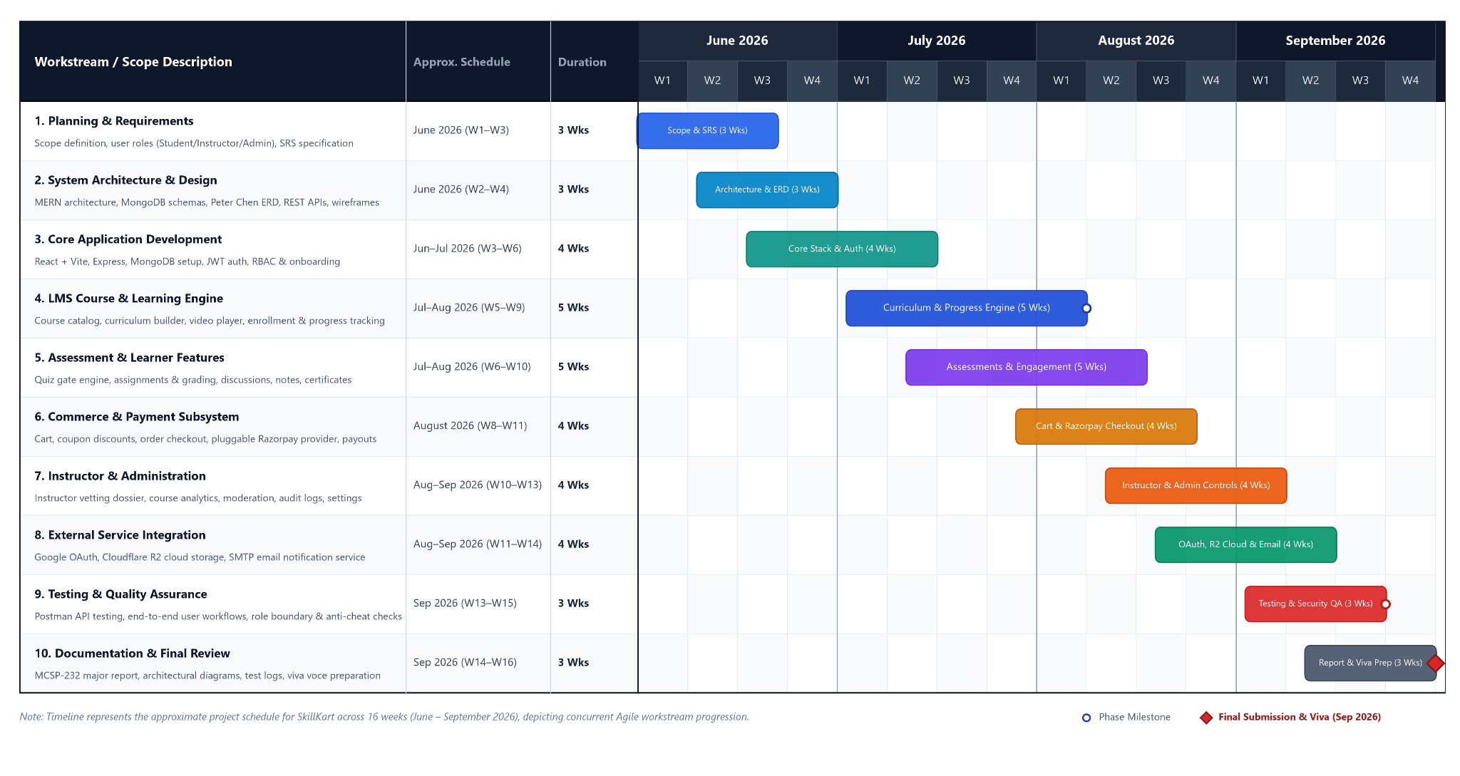

3.8 PERT Chart
A PERT (Program Evaluation and Review Technique) chart was used to represent the logical dependencies between the major project activities. Unlike the Gantt chart, which primarily represents activities against time, the PERT chart focuses on the sequence and dependency of activities.
The major dependency flow of the project begins with requirement analysis, followed by system design and core application development. The completed foundation allows the LMS, learner, commerce, instructor, and administrative features to be developed. These activities subsequently converge during external integration, system-wide validation, and documentation.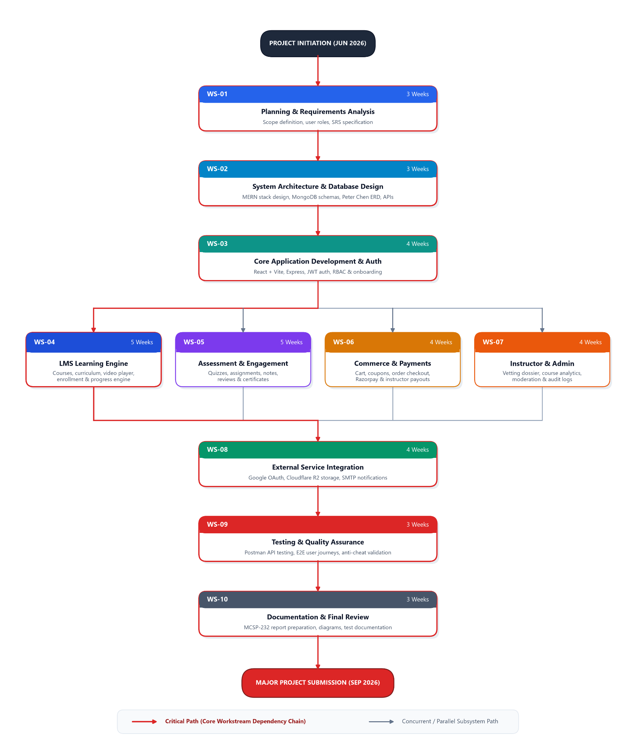
Figure 3.2: PERT Network Diagram of SkillKart LMS Development

3.9 Resource Planning
The project primarily required software development resources rather than specialised physical equipment.

3.7.1 Hardware Resources
Recommended development and testing environment:
- A modern standard workstation or laptop with recommended 8GB RAM and multi-core processor.
- Adequate SSD storage for project repository, node_modules, and MongoDB local database.
- Internet connectivity for external services and package management.
- A modern web browser for application testing.

3.7.2 Software Resources
The main software resources used include:
- Visual Studio Code or a similar development environment.
- Node.js and npm.
- React and TypeScript development tools.
- Vite.
- Express.js.
- MongoDB and MongoDB-related tools.
- Git for source code management.
- Modern web browsers.
- Testing Tools: Postman for API testing and browser-based/manual testing for application workflows.

3.7.3 External Services
The system also depends on external services for selected functions:
- Google OAuth.
- Razorpay.
- Cloudflare R2.
- SMTP/email services.
The availability and configuration of these services are important for the corresponding application features.

3.8 Risk Management
Several risks were considered during the development of SkillKart.

3.8.1 Technical Risks
Changes in frameworks, dependencies, or external APIs can affect application functionality. This was addressed by keeping the application structure modular and separating external integrations from core application logic where practical.

3.8.2 Integration Risks
Payment, authentication, storage, and email services depend on external systems. Changes or failures in these services can affect related functionality.

3.8.3 Data Risks
Incorrect handling of user, course, enrollment, payment, or progress information could lead to inconsistent application data. Validation and controlled database operations were therefore incorporated into the system.

3.8.4 Security Risks
The application handles authentication information, user data, course content, and payment-related operations. Authentication, authorization, input validation, password hashing, and restricted access to protected operations were included to reduce security risks.

3.8.5 Schedule Risks
The project contains a relatively large number of interconnected modules. Development delays in foundational components can affect dependent features. Incremental development helped reduce this dependency by establishing core components before implementing more advanced functionality.

3.9 Project Monitoring and Control
Project progress was monitored by dividing the system into functional modules and reviewing the status of each module during development.
Completed functionality was checked against the planned requirements, while defects and required improvements were addressed during subsequent development iterations. Changes to the implementation were also reflected in the project documentation so that the report remained consistent with the final system.
Particular attention was given to dependencies between modules. For example, enrollment functionality had to be established before learner-specific course access and progress tracking could be implemented, while course and user management formed the foundation for instructor and administrator functionality.

3.10 Project Deliverables
The major deliverables of the project include:
- Requirements and system analysis.
- System architecture and design.
- Configured MongoDB database schemas and indexes.
- Frontend application.
- Backend REST API.
- Authentication and authorization mechanisms.
- Learning management functionality.
- Assessment and certification functionality.
- Commerce and payment functionality.
- Instructor and administrative functionality.
- External service integrations.
- Testing and validation results.
- Final project documentation.

3.11 Chapter Summary
This chapter described the planning and scheduling approach used for developing SkillKart. The project was divided into logical phases covering requirement analysis, system design, core development, LMS functionality, learner engagement, commerce, instructor and administrative features, external integrations, validation, and documentation.
The planning approach provided a structured path for developing the system while allowing individual modules to be refined during implementation. The following chapters describe the software requirements, system design, modelling, database structure, implementation, user interface, testing, and final results of the project.

CHAPTER 4: SOFTWARE REQUIREMENTS SPECIFICATION

4.1 Introduction
The Software Requirements Specification (SRS) describes the functional and non-functional requirements of the SkillKart Learning Management System. It defines what the system is expected to do, the users who interact with it, the external systems on which it depends, and the technical conditions under which it operates.
SkillKart is a web-based LMS developed using React, TypeScript, Node.js, Express, MongoDB, and Mongoose. The system supports three primary user roles: student, instructor, and administrator. In addition to core learning functionality, the system includes course management, assessments, payments, learner engagement, instructor operations, and administrative management.
This chapter provides the requirements that form the basis for the system design and implementation.

4.2 Purpose
The purpose of this SRS is to define the requirements of SkillKart clearly and systematically.
The document is intended to:
- Define the functionality expected from the system.
- Identify the users and their responsibilities.
- Describe functional and non-functional requirements.
- Identify hardware and software requirements.
- Define external interfaces and service dependencies.
- Establish security and data management requirements.
- Provide a reference for system design, implementation, and testing.

4.3 Scope of the System
SkillKart covers the major activities involved in delivering and managing online courses through a single web application.
The scope includes:
- User registration and authentication.
- Google OAuth authentication.
- User onboarding and profile management.
- Role-based access for students, instructors, and administrators.
- Instructor application and approval.
- Course creation and management.
- Course categories and discovery.
- Search and filtering.
- Course recommendations.
- Cart and wishlist management.
- Checkout and online payment.
- Orders and coupons.
- Course enrollment.
- Structured learning content.
- Lesson progress tracking.
- Quizzes and quiz attempts.
- Assignments and submissions.
- Reviews and ratings.
- Discussions and comments.
- Notes and bookmarks.
- Learning streaks.
- Notifications and announcements.
- Certificates and certificate verification.
- Instructor analytics, earnings, and payout-related functionality.
- Administrative user and course management.
- Financial and administrative reporting.
- Audit logging.
- System settings and maintenance controls.
- File upload and storage.
- Email-related communication.
The system is designed as a browser-based application. A dedicated native mobile application and advanced real-time communication capabilities are outside the current implementation.

4.4 User Characteristics

4.4.1 Student
Students are the primary consumers of learning content. They are expected to have basic knowledge of using web applications.
Students can:
- Register and log in.
- Complete onboarding.
- Manage their profile.
- Browse and search for courses.
- View course details.
- Add courses to a wishlist or cart.
- Apply applicable coupons.
- Complete course purchases.
- Enroll in courses.
- Access learning content.
- Track progress.
- Attempt quizzes.
- Submit assignments.
- Take notes and create bookmarks.
- Participate in discussions.
- Submit reviews and ratings.
- View and verify certificates.
- Receive notifications and announcements.

4.4.2 Instructor
Instructors are users who create and manage educational content. An instructor must obtain the appropriate instructor access before using instructor-specific functionality.
Instructors can:
- Apply for instructor access.
- Manage their instructor profile.
- Create and edit courses.
- Organise course content.
- Manage lessons and learning materials.
- View enrolled students.
- Monitor course activity.
- Access analytics.
- View earnings and payout information.
- Publish announcements and FAQs.

4.4.3 Administrator
Administrators are responsible for managing the platform and controlling system-level operations.
Administrators can:
- Manage users.
- Review instructor applications.
- Manage courses and categories.
- Moderate course content.
- View order and revenue information through financial reports.
- Manage coupons and payouts.
- Review audit logs.
- Access financial reports.
- Configure system settings.
- Control maintenance mode.
- Perform other administrative operations permitted by the system.

4.5 Functional Requirements
The following functional requirements describe the major operations supported by SkillKart.

FR-01: User Registration
The system shall allow new users to create an account using the supported registration process.

FR-02: User Authentication
The system shall authenticate registered users and provide access to protected functionality only after successful authentication.

FR-03: Google Authentication
The system shall support authentication through Google OAuth.

FR-04: User Onboarding and Profile
The system shall allow users to complete onboarding information and manage their profile details.

FR-05: Role-Based Authorization
The system shall restrict protected operations according to the user's assigned role.
The primary roles shall be:
- Student
- Instructor
- Administrator

FR-06: Instructor Application
The system shall allow eligible users to submit an application for instructor access.

FR-07: Instructor Approval
The system shall allow administrators to review instructor applications and approve or reject them.

FR-08: Course Creation and Management
The system shall allow authorised instructors to create, edit, and manage courses.

FR-09: Course Structure Management
The system shall allow instructors to organise courses using sections, lessons, and lesson items.

FR-10: Course Discovery
The system shall allow users to browse and search available courses.

FR-11: Course Filtering and Recommendations
The system shall provide filtering and applicable course recommendation functionality to assist course discovery.

FR-12: Course Details
The system shall display relevant information about a course, including its content structure and other available course information.

FR-13: Wishlist
The system shall allow students to add and remove courses from their wishlist.

FR-14: Shopping Cart
The system shall allow students to add applicable courses to a shopping cart and manage cart items.

FR-15: Checkout
The system shall provide a checkout process for eligible course purchases.

FR-16: Coupon Management
The system shall support the application of valid coupons during applicable purchase workflows.
Administrators shall be able to manage coupons according to their permissions.

FR-17: Payment Processing
The system shall support online payment processing through the configured payment provider.
The system shall process relevant payment information and update the corresponding order status based on the payment result.

FR-18: Order Management
The system shall maintain records of orders created through the checkout process.

FR-19: Course Enrollment
The system shall allow students to obtain access to courses for which they are eligible or successfully enrolled.

FR-20: Learning Content Access
The system shall allow enrolled students to access the learning content associated with their courses.

FR-21: Learning Progress
The system shall record learner progress for applicable learning activities.
The system shall use the recorded progress to represent the learner's completion status within a course.

FR-22: Learning Completion Controls
The system shall apply the configured conditions before allowing applicable learning activities to be marked as completed.
These conditions include learning activity requirements such as video watch thresholds, completion cooldowns, and quiz-related requirements where applicable. Certificates issued to learners who complete a course unusually quickly are also subject to a time-based verification hold.

FR-23: Quiz Management
The system shall allow authorised users to create and manage quizzes associated with courses.

FR-24: Quiz Attempts
The system shall allow students to attempt quizzes and record their attempts and results.

FR-25: Assignment Management
The system shall support assignments associated with learning content.

FR-26: Assignment Submission
The system shall allow students to submit assignments through the application.

FR-27: Reviews and Ratings
The system shall allow eligible students to submit reviews and ratings for courses.

FR-28: Discussions and Comments
The system shall provide functionality for discussions and comments associated with learning or course content.

FR-29: Notes
The system shall allow students to create and manage notes associated with their learning activities.

FR-30: Bookmarks
The system shall allow students to bookmark relevant learning content for later access.

FR-31: Learning Streaks
The system shall maintain learning activity information required to provide learning streak functionality.

FR-32: Notifications
The system shall provide in-application notifications for relevant events and activities.

FR-33: Announcements
The system shall allow authorised instructors to publish announcements for the courses they manage, and shall allow enrolled students to view them.

FR-34: Course FAQs
The system shall support the creation and management of frequently asked questions associated with courses.

FR-35: Certificate Generation
The system shall generate certificates for students who satisfy the applicable completion requirements.

FR-36: Certificate Verification
The system shall provide a mechanism for verifying certificate information.

FR-37: Certificate Status Management
The system shall support applicable certificate status operations, including certificate revocation where permitted.

FR-38: Instructor Analytics
The system shall provide instructors with information about their courses and learner activity.

FR-39: Instructor Earnings
The system shall provide instructors with relevant earnings information.

FR-40: Instructor Payouts
The system shall maintain information required for instructor payout-related operations.

FR-41: User Administration
The system shall allow administrators to manage registered users according to their permissions.

FR-42: Course Administration
The system shall allow administrators to review and manage courses and related content.

FR-43: Category Management
The system shall allow administrators to manage course categories.

FR-44: Order and Revenue Reporting
The system shall provide administrators with access to order details and revenue information through financial reports, including CSV export.

FR-45: Payout Administration
The system shall provide administrative functionality for managing relevant payout information.

FR-46: Audit Logging
The system shall record relevant administrative or system activities in audit logs.

FR-47: System Settings
The system shall allow authorised administrators to manage configurable system settings.

FR-48: Maintenance Mode
The system shall support maintenance mode so that normal application access can be controlled when required.

FR-49: Financial Reporting
The system shall provide relevant financial and administrative reports.

FR-50: File Upload
The system shall allow authorised users to upload supported files through the application.

FR-51: File Storage
The system shall support file storage using local storage during development and cloud-based storage when configured for production.

FR-52: Email Communication
The system shall support email-related communication through the configured email service.

FR-53: Password Recovery and Change
The system shall allow authenticated users to change their password and shall allow users who have forgotten their password to reset it using a time-limited reset link sent by email. Accounts created through Google sign-in do not have a local password.

FR-54: Account Status Control
The system shall allow administrators to activate or deactivate user accounts. A deactivated account cannot log in, and its records are retained.

FR-55: Bulk Lesson Import
The system shall allow instructors to create multiple lessons within a section by uploading a CSV file.

FR-56: Demonstration Course Generation
The system shall allow administrators to generate fully populated demonstration courses from predefined course presets.

FR-57: Newsletter Subscription
The system shall allow visitors to subscribe to a newsletter by providing an email address.

4.6 Non-Functional Requirements

4.6.1 Performance
The system should provide responsive performance during normal usage.
Database queries and frequently accessed data should be handled efficiently through appropriate schema design and indexing. Performance may vary depending on server resources, database load, network conditions, and external service response times.
No fixed response-time value is assumed without measurement under a defined testing environment.

4.6.2 Security
Security requirements include:
- Password hashing before storage.
- JWT-based authentication for protected API operations.
- Role-based authorization.
- Input validation.
- Protected access to sensitive operations.
- Appropriate validation of uploaded files.
- Secure handling of payment-related operations.
- Protection of administrative functionality.

4.6.3 Usability
The system should provide an interface that is understandable to students, instructors, and administrators.
Navigation, forms, feedback messages, validation messages, and error states should be presented clearly to support normal application use.

4.6.4 Reliability
The system should behave consistently during normal operation and should preserve important application data during standard workflows.
Operations such as enrollment, order creation, progress updates, assessment submission, and certificate generation should be handled using appropriate application and database validation.

4.6.5 Maintainability
The application should be structured so that individual components and modules can be modified without unnecessary changes to unrelated functionality.
TypeScript, reusable React components, Express routes, services, validation schemas, and Mongoose models contribute to maintainability.

4.6.6 Scalability
The architecture should provide a foundation for supporting increasing numbers of users, courses, and records.
The separation of the frontend, backend, database, and external integrations allows individual parts of the system to be improved or scaled as future requirements increase.

4.6.7 Compatibility
The application should work with modern web browsers and common desktop and mobile screen sizes supported by the implemented interface.

4.6.8 Data Integrity
The system should maintain consistency between related records.
Input validation, Mongoose schema validation, ObjectId references, application-level checks, and controlled business logic should be used to reduce invalid or inconsistent data.

4.6.9 Privacy
User information and application data should only be accessible through authorised application functionality. Administrative and role-specific information should not be exposed to users without the required permissions.

4.7 Hardware Requirements
The system does not require specialised hardware for development or normal browser-based usage.

4.7.1 Development Hardware
A typical development computer with the following capabilities is sufficient:
- Modern multi-core processor.
- At least 8 GB RAM recommended.
- Adequate storage for the source code, dependencies, and development tools.
- Stable internet connection.
- Modern web browser.
The actual requirements may vary depending on the operating system and other development applications running simultaneously.

4.7.2 Client Hardware
Students, instructors, and administrators require a device capable of running a modern web browser.
The system can be accessed using:
- Desktop computers.
- Laptops.
- Tablets or mobile devices with supported browser interfaces.

4.8 Software Requirements
The major software requirements are as follows:
Table 4.1: Software and Technology Requirements Specification
Software / Technology | Purpose
React 19 | Frontend user interface
TypeScript | Type-safe application development
Vite | Frontend development and build tooling
Tailwind CSS | User interface styling
Node.js | Backend runtime
Express 5 | REST API and server framework
TypeScript | Backend development
MongoDB | Database
Mongoose 9 | MongoDB object modelling
Axios | HTTP communication
Zod | Request and data validation
JWT | Authentication
bcryptjs | Password hashing
Multer | File upload handling
Google OAuth | External authentication
Razorpay | Payment processing
Cloudflare R2 | Cloud file storage
SMTP / Email Service | Email communication
Git | Source code management
Modern Web Browser | Application access and testing

4.9 Development Environment
The SkillKart development environment consists of separate frontend and backend applications connected through REST APIs.
The frontend is developed using React, TypeScript, Vite, and Tailwind CSS. It is responsible for rendering the user interface and communicating with backend APIs.
The backend is developed using Node.js, Express, and TypeScript. It handles authentication, authorization, validation, business logic, database operations, and communication with external services.
MongoDB is used as the primary database, with Mongoose providing schema definitions and database interaction.
The development environment also requires environment configuration for sensitive information such as database credentials, authentication configuration, payment credentials, storage configuration, and email service settings.

4.10 External Interfaces

4.10.1 User Interface
The system provides role-specific interfaces for:
- Students.
- Instructors.
- Administrators.
The interface includes authentication screens, course discovery, course details, learning interfaces, dashboards, management forms, checkout workflows, and administrative interfaces.

4.10.2 Application Interface
The frontend communicates with the backend through REST API endpoints.
Axios is used on the frontend for making HTTP requests to the backend. The backend processes requests through its routing, middleware, validation, business logic, and database layers before returning an appropriate response.

4.10.3 Database Interface
The backend communicates with MongoDB through Mongoose.
Mongoose models represent the major application entities and provide schema validation and database interaction mechanisms.

4.10.4 Payment Interface
The application communicates with the configured payment provider for payment processing.
Razorpay is supported as a payment provider in the current implementation.

4.10.5 Authentication Interface
Google OAuth is used as an external authentication mechanism for supported login workflows.

4.10.6 File Storage Interface
The application provides a file upload layer using Multer. Uploaded files can be stored locally during development or transferred to Cloudflare R2 when cloud storage is configured.

4.10.7 Email Interface
The application can communicate with a configured SMTP/email service for email-related operations.

4.11 API Requirements
The backend exposes REST APIs for communication with the frontend.
The APIs are responsible for operations including:
- Authentication.
- User management.
- Course management.
- Course discovery.
- Enrollment.
- Cart and orders.
- Payments.
- Coupons.
- Learning progress.
- Quizzes.
- Assignments.
- Reviews.
- Discussions and comments.
- Notes and bookmarks.
- Certificates.
- Notifications.
- Instructor operations.
- Administrative operations.
API requests are processed through appropriate middleware and validation before reaching the relevant application logic.
Protected endpoints require authentication, and role-specific endpoints additionally require appropriate authorization.

4.12 Security Requirements
Security is an important requirement because SkillKart handles user accounts, course information, learning records, payment-related data, and administrative operations.
The system incorporates the following security mechanisms:
- Password hashing: Passwords are hashed before being stored in the database.
- JWT authentication: Protected API requests use authentication tokens to identify authenticated users.
- Role-based authorization: Access to role-specific functionality is restricted based on the user's role.
- Input validation: Request data is validated before being processed.
- Database validation: Mongoose schemas provide additional validation for stored data.
- Protected application routes: Frontend protected routes prevent unauthorised users from accessing restricted interfaces.
- Enrollment checks: Course learning functionality checks whether a user has the required enrollment or access.
- Learning integrity controls: Applicable completion conditions help prevent invalid lesson completion.
- Secure configuration: Sensitive service credentials are maintained through environment configuration rather than being embedded directly into application source code.
- Administrative protection: Administrative operations are restricted to authorised users.

4.13 Constraints
The following constraints apply to the current system:
- The system is primarily a web-based application.
- Some functionality depends on third-party services.
- Payment functionality depends on the configured payment provider.
- Google authentication depends on the external OAuth service.
- Cloud file storage depends on the configured storage service.
- Email functionality depends on the configured email service.
- Production deployment requires appropriate infrastructure and security configuration.
- The current implementation has not been subjected to large-scale load testing.
- A dedicated native mobile application is not part of the current implementation.
- Real-time communication functionality is not part of the current implementation.

4.14 Assumptions and Dependencies
The system is developed based on the following assumptions:
- Users have access to a modern web browser.
- Users have a suitable internet connection.
- Users provide valid information during application workflows.
- Students access course content only after satisfying the required enrollment conditions.
- Instructors use the system according to their assigned permissions.
- Administrators are responsible for platform-level management activities.
- MongoDB is available for persistent data storage.
- Required external service credentials are correctly configured.
- External authentication, payment, storage, and email services are available when their respective features are used.

4.15 Summary
This chapter defined the Software Requirements Specification for the SkillKart Learning Management System. It described the system scope, user characteristics, functional requirements, non-functional requirements, hardware and software requirements, development environment, external interfaces, API requirements, security requirements, constraints, and assumptions.
The requirements defined in this chapter provide the basis for the architectural and detailed system design presented in the following chapters.

CHAPTER 5: SYSTEM DESIGN

5.1 Introduction
System design defines the structure of the SkillKart Learning Management System and describes how its major components work together. The design translates the requirements identified in the previous chapters into an organised application architecture, database structure, API communication model, authentication flow, and functional modules.
SkillKart follows a client-server architecture. The frontend is developed using React and TypeScript, while the backend is developed using Node.js, Express, and TypeScript. MongoDB is used for persistent data storage through Mongoose.
The system also communicates with external services for authentication, payment processing, file storage, and email communication. The design separates these responsibilities so that the major parts of the application can be developed and maintained independently.

5.2 System Architecture
The overall architecture of SkillKart can be represented as follows:
React Frontend → Axios/API → Express Routes → Middleware → Controllers/Business Logic → Services → Mongoose → MongoDB
External services are connected to the backend where required:
- Google OAuth for authentication.
- Razorpay for payment processing.
- Cloudflare R2 for cloud file storage.
- SMTP/email services for email communication.
The architecture can be broadly divided into the following layers:

5.2.1 Presentation Layer
The presentation layer is implemented using React, TypeScript, Vite, and Tailwind CSS.
It is responsible for:
- Rendering application pages and components.
- Collecting user input.
- Displaying application data.
- Handling client-side navigation.
- Managing frontend state.
- Sending requests to backend APIs.
- Displaying validation and error messages.

5.2.2 Application Layer
The application layer is implemented using Node.js, Express, and TypeScript.
It handles:
- API routing.
- Authentication.
- Authorization.
- Request validation.
- Business logic.
- Course operations.
- Enrollment.
- Learning progress.
- Assessments.
- Orders and payments.
- Instructor operations.
- Administrative operations.

5.2.3 Service Layer
Services are used for operations that benefit from separation from the main request-handling logic.
The service layer supports areas such as:
- Payment processing.
- File storage.
- Learning streak tracking and administrative audit logging.
- Email communication.
- Other reusable application operations.
The payment implementation uses a provider-based structure so that different payment providers can be handled without tightly coupling payment-specific logic to the rest of the application.

5.2.4 Data Access Layer
The data access layer uses Mongoose to communicate with MongoDB.
Mongoose models define the structure and validation rules of the application's data entities and provide the interface used by the backend for database operations.

5.2.5 Data Storage Layer
MongoDB is used as the primary persistent data store.
It stores information related to:
- Users.
- Courses.
- Lessons.
- Enrollments.
- Learning progress.
- Assessments.
- Orders.
- Payments.
- Reviews.
- Certificates.
- Notifications.
- Instructor information.
- Administrative information.
- Other application entities.

5.3 System Components
The major components of SkillKart are:

5.3.1 Frontend Application
The frontend provides the user interface for students, instructors, and administrators.
It communicates with the backend through REST APIs and provides role-specific screens and workflows.

5.3.2 Backend Application
The backend provides the API layer and implements the application's business logic.
It receives requests from the frontend, validates them, applies authentication and authorization rules, performs the required operations, communicates with the database or external services, and returns responses.

5.3.3 Database
MongoDB stores persistent application data.
Mongoose is used to define schemas, relationships through ObjectId references, validation rules, and database operations.

5.3.4 Authentication and Authorization
Authentication identifies users, while authorization determines which operations they are permitted to perform.
JWT-based authentication is used for protected API operations. Role-based middleware restricts access to student, instructor, and administrator functionality.

5.3.5 External Services
The backend communicates with external services where required.
These include:
- Google OAuth.
- Razorpay.
- Cloudflare R2.
- SMTP/email services.

5.4 Frontend Architecture
The frontend follows a component-based React architecture.
The main responsibilities of the frontend are:
- Rendering pages and reusable components.
- Managing user interactions.
- Handling client-side navigation.
- Maintaining relevant client-side state.
- Communicating with REST APIs.
- Managing authenticated user sessions.
- Displaying API responses and errors.
The frontend uses TypeScript to provide stronger type checking during development.
Tailwind CSS is used for styling and responsive interface development.
A simplified frontend flow is:
User Interaction → React Component → API Request → Backend → API Response → UI Update
Protected frontend routes are used to restrict access to authenticated application areas. Role-specific access is also applied to interfaces that require particular permissions.

5.5 Backend Architecture
The backend is built using Node.js, Express, and TypeScript.
A typical request passes through several stages:
Client Request → Express Route → Middleware → Controller (Zod Validation → Business Logic) → Service/Database → Response

5.5.1 Routes
Routes define the API endpoints exposed by the backend.
Separate route modules are used for different functional areas, such as authentication, users, courses, learning, assessments, commerce, instructor functionality, and administration.

5.5.2 Middleware
Middleware performs operations that need to occur before the main request logic.
The application uses middleware for functions including:
- Authentication.
- Role authorization.
- Onboarding checks.
- Maintenance checks.
- Other request-level processing.

5.5.3 Validation
The backend uses Zod validation schemas to validate incoming request data before it reaches the relevant business logic.
Mongoose schema validation provides an additional layer of validation when data is persisted.

5.5.4 Controllers and Business Logic
The application processes validated requests through its controller and business logic layers.
These operations include:
- Creating and updating courses.
- Managing enrollments.
- Processing learning progress.
- Managing assessments.
- Creating orders.
- Processing payments.
- Managing users.
- Handling instructor operations.
- Performing administrative operations.

5.5.5 Services
Services isolate specific operations that interact with external systems or contain reusable application logic.
For example, payment functionality is separated through payment service providers, allowing the application to interact with a simulated provider or Razorpay provider through a common structure.

5.6 Database Architecture
MongoDB is used as the database for SkillKart because the application's data contains several related but independently evolving entities.
The database contains collections representing users, courses, learning content, enrollments, assessments, commerce, engagement, certificates, notifications, instructor operations, and administrative information.
Mongoose provides the schema definitions and database interaction layer.
Relationships between entities are represented primarily through MongoDB ObjectId references. Unlike a traditional relational database, these references do not create database-level foreign key constraints. Relationship validation is therefore handled through application logic and schema validation where required.
The database architecture supports the following major relationships:
- A user can have an associated role and related application records.
- An instructor can manage multiple courses.
- A course can contain multiple sections.
- A section can contain multiple lessons.
- Lessons can contain different lesson items.
- Students can enroll in courses.
- Enrollments can have associated learning progress.
- Courses can have quizzes and assignments.
- Students can create quiz attempts and assignment submissions.
- Courses can receive reviews and comments.
- Completed courses can produce certificates.
- Orders can contain purchased course information.
- Coupons can be associated with applicable purchase workflows.
A detailed description of the database entities is provided in Chapter 7.

5.7 API Architecture
The frontend and backend communicate through REST APIs.
The API architecture provides a clear boundary between the user interface and server-side application logic.
A typical request follows this process:
- The user performs an action in the frontend.
- The frontend sends an HTTP request using Axios.
- Express receives the request through the appropriate route.
- Middleware checks authentication and other applicable conditions.
- Request data is validated.
- The relevant application logic is executed.
- The backend interacts with MongoDB or an external service when required.
- The backend returns an HTTP response.
- The frontend updates the user interface based on the response.
The API structure allows the frontend to remain independent of direct database access.

5.8 Authentication and Authorization Architecture
Authentication and authorization are handled separately.

5.8.1 Authentication
Authentication verifies the identity of a user.
SkillKart supports:
- Application-based authentication.
- Google OAuth authentication.
For application-based authentication, user credentials are verified and authenticated sessions are maintained using JWT-based authentication.
Passwords are stored in hashed form using bcryptjs rather than as plain text.

5.8.2 Authorization
After authentication, authorization determines whether the user has permission to perform a requested operation.
The system uses three main roles:
- Student.
- Instructor.
- Administrator.
Role-based middleware is used to restrict protected backend operations.
For example, an administrative operation cannot be performed by a normal student simply because the student is authenticated.

5.8.3 Additional Access Checks
Certain operations require more than basic role verification.
The application can also check conditions such as:
- Whether the user is enrolled in a course.
- Whether the user owns or manages a course.
- Whether the user has completed required onboarding.
- Whether maintenance mode affects access.
- Whether a learning activity satisfies its completion conditions.

5.9 Functional Modules
SkillKart is divided into several functional modules.

5.9.1 Authentication and User Module
This module handles registration, login, Google authentication, onboarding, profiles, and authenticated access.

5.9.2 Course Management Module
This module allows authorised instructors to create and manage courses, sections, lessons, and lesson items.

5.9.3 Course Discovery Module
This module provides course browsing, searching, filtering, recommendations, and course details.

5.9.4 Enrollment Module
This module handles access to courses after the required enrollment conditions are satisfied.

5.9.5 Commerce Module
This module manages:
- Cart.
- Orders.
- Coupons.
- Checkout.
- Payment processing.
- Payment verification.
- Instructor earnings.
- Payout-related information.

5.9.6 Learning Module
This module manages course access, lesson viewing, lesson progress, and learning completion.

5.9.7 Assessment Module
This module handles:
- Quizzes.
- Quiz attempts.
- Assignments.
- Assignment submissions.

5.9.8 Learner Engagement Module
This module supports:
- Reviews.
- Comments.
- Discussions.
- Notes.
- Bookmarks.
- Wishlist.
- Learning streaks.
- Notifications.

5.9.9 Certification Module
This module handles certificate generation, certificate verification, and applicable certificate status operations.

5.9.10 Instructor Module
This module provides instructor-specific functionality such as:
- Instructor application.
- Course management.
- Learner information.
- Analytics.
- Earnings.
- Payout information.
- Announcements.
- FAQs.

5.9.11 Administration Module
This module provides platform-level management functionality, including:
- User management.
- Instructor management.
- Course moderation.
- Category management.
- Coupon management.
- Payout management.
- Audit logs.
- System settings.
- Maintenance mode.
- Financial reporting.

5.10 Role-Based System Design
The system is designed around three primary roles.
Table 5.1: Role-Based System Permissions and Access Matrix
Functionality | Student | Instructor | Administrator
Register/Login | ✓ | ✓ | ✓
Profile Management | ✓ | ✓ | ✓
Browse Courses | ✓ | ✓ | ✓
Purchase Courses | ✓ | ✓ | ✓
Access Enrolled Courses | ✓ | ✓ | As permitted
Track Learning Progress | ✓ | ✓ | As permitted
Attempt Assessments | ✓ | ✓ | As permitted
Create Courses | - | ✓ | ✓
Manage Course Content | - | ✓ | ✓
View Course Analytics | - | ✓ | ✓
Manage Earnings/Payouts | - | ✓ | ✓
Manage Users | - | - | ✓
Moderate Courses | - | - | ✓
Manage Categories | - | - | ✓
Manage Coupons | - | ✓ (own courses) | ✓ (platform-wide)
View Financial Reports | - | - | ✓
View Audit Logs | - | - | ✓
Manage System Settings | - | - | ✓
The table represents the general access model. Individual operations may include additional checks such as ownership, enrollment, or application status. For example, an instructor can enroll in other instructors' courses but not in their own.

5.11 Process Design

5.11.1 General Request Processing
The general processing flow of the system is:
User → React Interface → Axios Request → Express Route → Middleware → Controller (Zod Validation → Business Logic) → Service/Database → Response → React Interface
This structure ensures that requests are processed through the appropriate validation and authorization mechanisms before sensitive operations are performed.

5.11.2 Learning Process
A simplified learning workflow is:
Course Discovery → Course Details → Cart/Checkout or Enrollment → Course Access → Lesson → Progress Update → Assessment → Course Completion → Certificate
The exact path depends on whether the course requires purchase and which learning activities are included.

5.11.3 Instructor Process
The instructor workflow can be represented as:
Instructor Application → Administrative Review → Approval → Course Creation → Curriculum Management → Course Moderation → Publication → Learner Enrollment → Course Analytics → Earnings/Payout

5.11.4 Administrative Process
The administrative workflow includes:
Administrator Authentication → Dashboard → User/Course/Commerce Management → Review or Update Records → Audit/Reporting → System Configuration

5.12 User Interface Design
The user interface is designed around the responsibilities of each user role.

Student Interface
The student interface focuses on:
- Course discovery.
- Course details.
- Cart and checkout.
- Learning.
- Progress.
- Assessments.
- Personal learning tools.
- Certificates.
- Notifications.

Instructor Interface
The instructor interface focuses on:
- Course creation.
- Curriculum management.
- Learner information.
- Course analytics.
- Earnings.
- Payout information.
- Announcements and FAQs.

Administrator Interface
The administrator interface focuses on:
- Platform management.
- User and instructor management.
- Course moderation.
- Commerce management.
- Reports.
- Audit logs.
- System configuration.
The frontend uses reusable React components and Tailwind CSS to maintain a consistent interface across the application.

5.13 Error Handling Design
Error handling is implemented at different levels of the application.

Frontend
The frontend handles API errors and validation failures by displaying appropriate feedback to the user.

Backend
The backend validates incoming data and handles errors generated during application and database operations.

Database
Mongoose validation helps prevent invalid data from being persisted when it violates defined schema rules.

External Services
Operations involving external services such as payments, storage, authentication, and email require appropriate handling when those services return errors or are unavailable.
The purpose of the error-handling design is to prevent application failures from being exposed as uncontrolled errors and to provide meaningful responses to the frontend.

5.14 Security Design
Security is incorporated into the architecture rather than being treated as a separate feature.
The major security mechanisms include:
- Password hashing using bcryptjs.
- JWT-based authentication.
- Role-based authorization.
- Protected frontend routes.
- Backend authentication middleware.
- Request validation using Zod.
- Database schema validation through Mongoose.
- Enrollment and ownership checks.
- Restricted administrative operations.
- Controlled file upload handling.
- Payment verification.
- Environment-based configuration of sensitive credentials.
Learning integrity controls are also included in relevant completion workflows. For example, video completion can require a minimum watch percentage, a cooldown can be applied between completion requests, and quiz-based completion requirements can be enforced where applicable. A certificate issued after unusually fast completion is also held from public verification for a period proportional to the course duration.

5.15 Design Considerations
Several design considerations were taken into account during the development of SkillKart.

5.15.1 Modularity
The application is divided into functional modules so that changes to one area can be made without unnecessarily affecting unrelated functionality.

5.15.2 Reusability
Reusable React components, backend utilities, validation schemas, services, and database models reduce duplication and simplify maintenance.

5.15.3 Separation of Responsibilities
The frontend is responsible for presentation and user interaction, while the backend handles business logic, data access, authentication, and external service communication.

5.15.4 Data Consistency
Application-level checks and schema validation are used to maintain consistency between related entities.

5.15.5 External Service Isolation
External integrations are separated from the core application logic where practical. This is particularly relevant to payment processing and file storage, allowing the application to change providers or storage configurations with less impact on other modules.

5.15.6 Security
Authentication, authorization, validation, and restricted access are incorporated into the system architecture.

5.15.7 Extensibility
The architecture allows additional features and integrations to be introduced in the future without requiring a complete redesign of the application.

5.16 Summary
This chapter described the system design of SkillKart. The system uses a client-server architecture in which a React and TypeScript frontend communicates with a Node.js and Express backend through REST APIs. MongoDB and Mongoose provide persistent data storage, while external services support authentication, payments, file storage, and email communication.
The chapter also described the application's major components, database and API architecture, authentication and authorization mechanisms, functional modules, role-based access, processing workflows, interface design, error handling, security, and design considerations.
The architecture provides the foundation for implementing the requirements defined in Chapter 4 and supports the database and system models discussed in the following chapters.

CHAPTER 6: SYSTEM MODELLING

6.1 Introduction
System modelling provides a visual representation of the structure, behaviour, and flow of the SkillKart Learning Management System. The models help describe how users interact with the system, how information moves between different processes, and how the major entities are related.
The models presented in this chapter are based on the current implementation of SkillKart. The system includes three primary user roles: student, instructor, and administrator. The models therefore cover not only the core learning workflow but also course management, enrollment, assessments, payments, learner engagement, instructor operations, and administration.
The following modelling techniques are used:
- Data Flow Diagrams (DFD)
- Data Dictionary
- Entity Relationship Diagram (ERD)
- Use Case Diagram
- Class Diagram
- Activity Diagram
- Sequence Diagram
- State Diagram
These models provide a conceptual representation of the system and complement the detailed architecture and database design described in the previous and following chapters.

6.2 Context Diagram / Level 0 Data Flow Diagram
The Level 0 Data Flow Diagram represents SkillKart as a single system and shows its interaction with the main external entities.
The primary external entities are:
- Student
- Instructor
- Administrator
- External Authentication Service
- Payment Service
- File Storage Service
- Email Service
The Student interacts with the system to register, authenticate, discover courses, purchase or enroll in courses, access learning content, complete assessments, track progress, submit reviews, and obtain certificates.
The Instructor interacts with the system to apply for instructor access, manage courses, organise learning content, monitor learners, view analytics, manage earnings, and publish course-related information.
The Administrator manages users, instructors, courses, categories, coupons, payouts, financial reports, audit logs, and system settings.
External services support specific system operations such as Google authentication, payment processing, cloud file storage, and email communication.
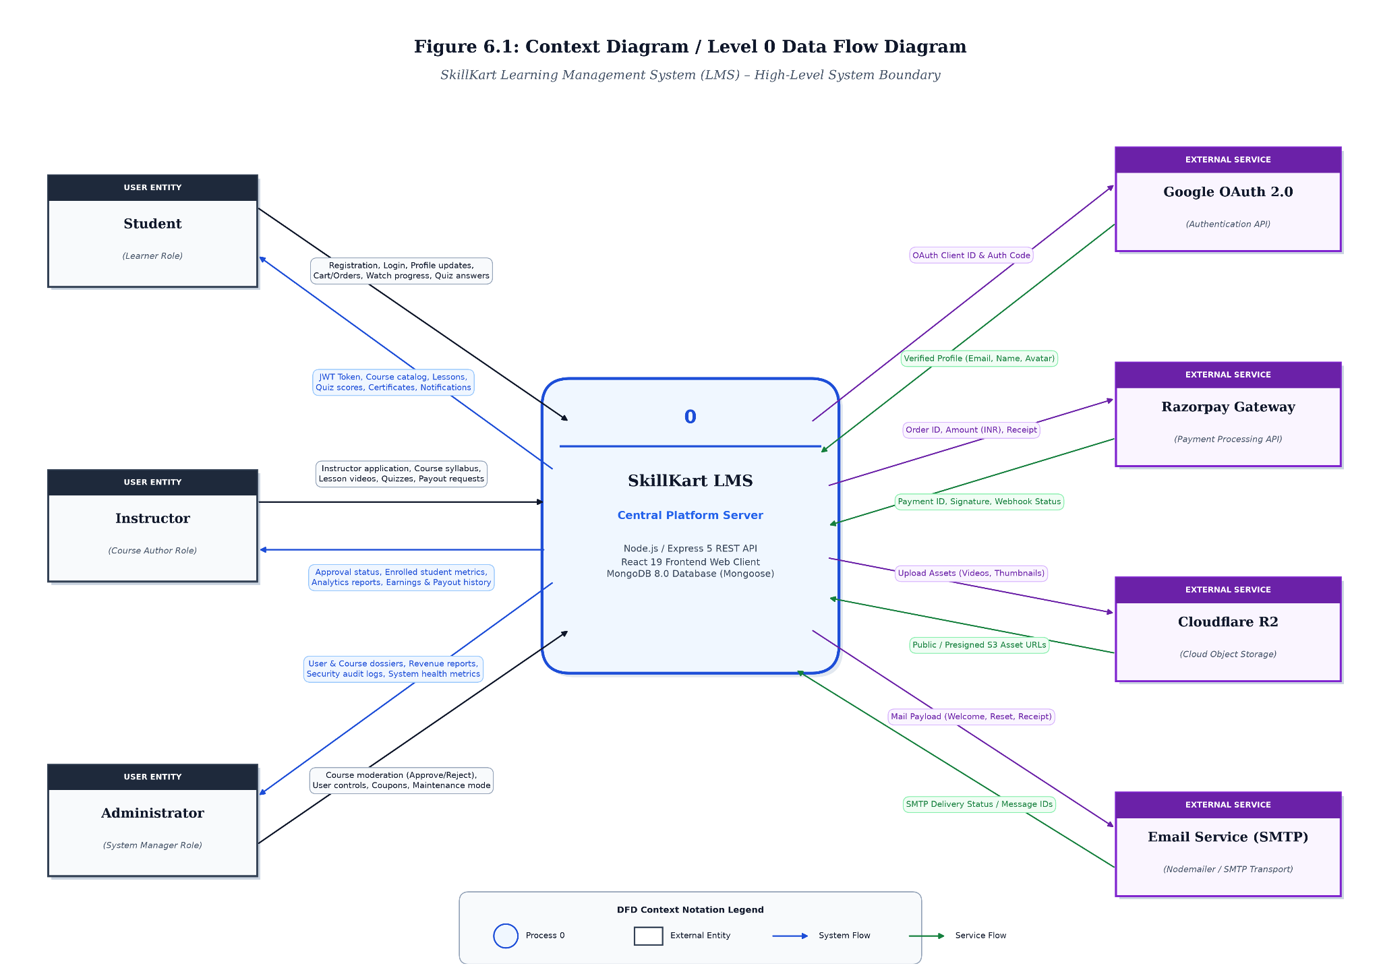
Figure 6.1: Context Diagram / Level 0 Data Flow Diagram

6.3 Level 1 Data Flow Diagram
The Level 1 DFD decomposes the main SkillKart system into its major functional processes.
The primary processes are:
- User and Authentication Management
- Course Management
- Course Discovery
- Enrollment and Commerce
- Learning and Progress Management
- Assessment Management
- Certification and Learner Engagement
- Instructor Management
- Administration

6.3.1 User and Authentication Management
This process handles registration, login, Google authentication, onboarding, profile management, authentication tokens, and role-based access.

6.3.2 Course Management
This process handles course creation, editing, curriculum management, sections, lessons, lesson items, categories, and course moderation.

6.3.3 Course Discovery
This process handles course browsing, searching, filtering, recommendations, and viewing course details.

6.3.4 Enrollment and Commerce
This process handles cart operations, checkout, coupons, orders, payment processing, payment verification, and enrollment.

6.3.5 Learning and Progress Management
This process handles access to course content, lesson progress, completion conditions, and learner progress information.

6.3.6 Assessment Management
This process handles quizzes, quiz attempts, assignments, and assignment submissions.

6.3.7 Certification and Learner Engagement
This process handles certificates, certificate verification, reviews, comments, discussions, notes, bookmarks, wishlist, streaks, and notifications.

6.3.8 Instructor Management
This process handles instructor applications, instructor approval, instructor course management, analytics, earnings, payouts, announcements, and FAQs.

6.3.9 Administration
This process handles platform-level user management, course moderation, categories, coupons, payouts, audit logs, system settings, maintenance, and financial reporting.
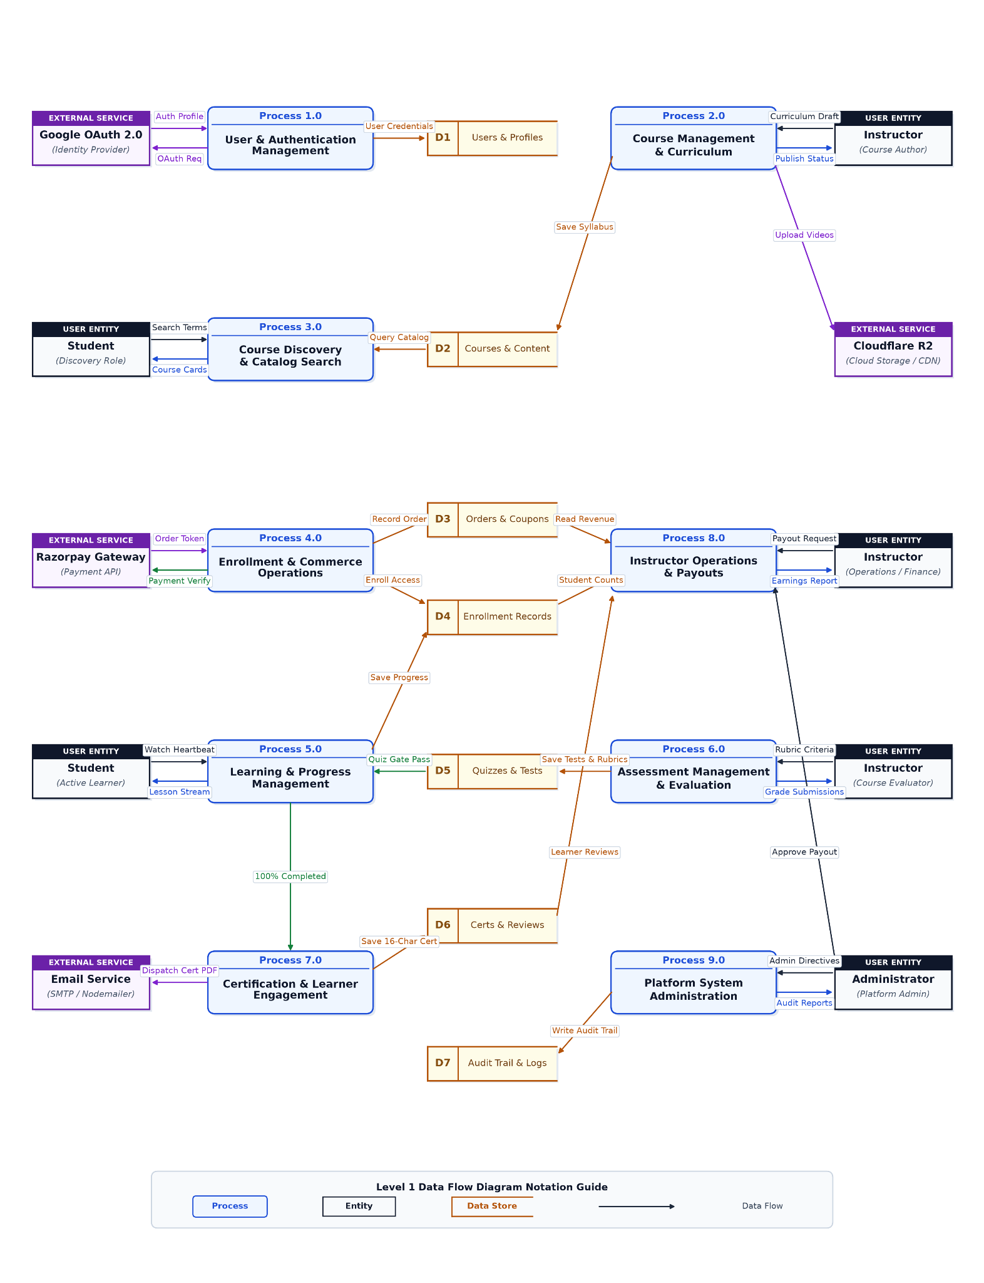
Figure 6.2: Level 1 Data Flow Diagram

6.4 Level 2 Data Flow Diagram
The Level 2 DFD provides a more detailed representation of selected learning and progress-related processes.
The learning workflow can be divided into the following processes:
- Course Access Verification
- Lesson Access
- Learning Activity Tracking
- Completion Validation
- Assessment Validation
- Progress Update
- Course Completion
- Certificate Generation

6.4.1 Course Access Verification
When a student attempts to access learning content, the system verifies whether the student has the required course access or enrollment.

6.4.2 Lesson Access
After access is verified, the student can access the applicable lesson and lesson items.

6.4.3 Learning Activity Tracking
The system records relevant learning activity and progress information.

6.4.4 Completion Validation
Before a learning activity is marked as completed, the system checks the applicable completion conditions.
For example, video-based learning can require a minimum watch percentage and a cooldown between completion requests.

6.4.5 Assessment Validation
Where a course contains assessment-based completion requirements, the system checks the relevant quiz or assessment result before allowing the applicable completion state.

6.4.6 Progress Update
After a valid completion event, the corresponding progress information is updated.

6.4.7 Course Completion
When the required learning activities are completed, the system determines whether the student has satisfied the course completion requirements.
6.4.8 Certificate Generation
When the required conditions are satisfied, the system can generate the corresponding certificate.

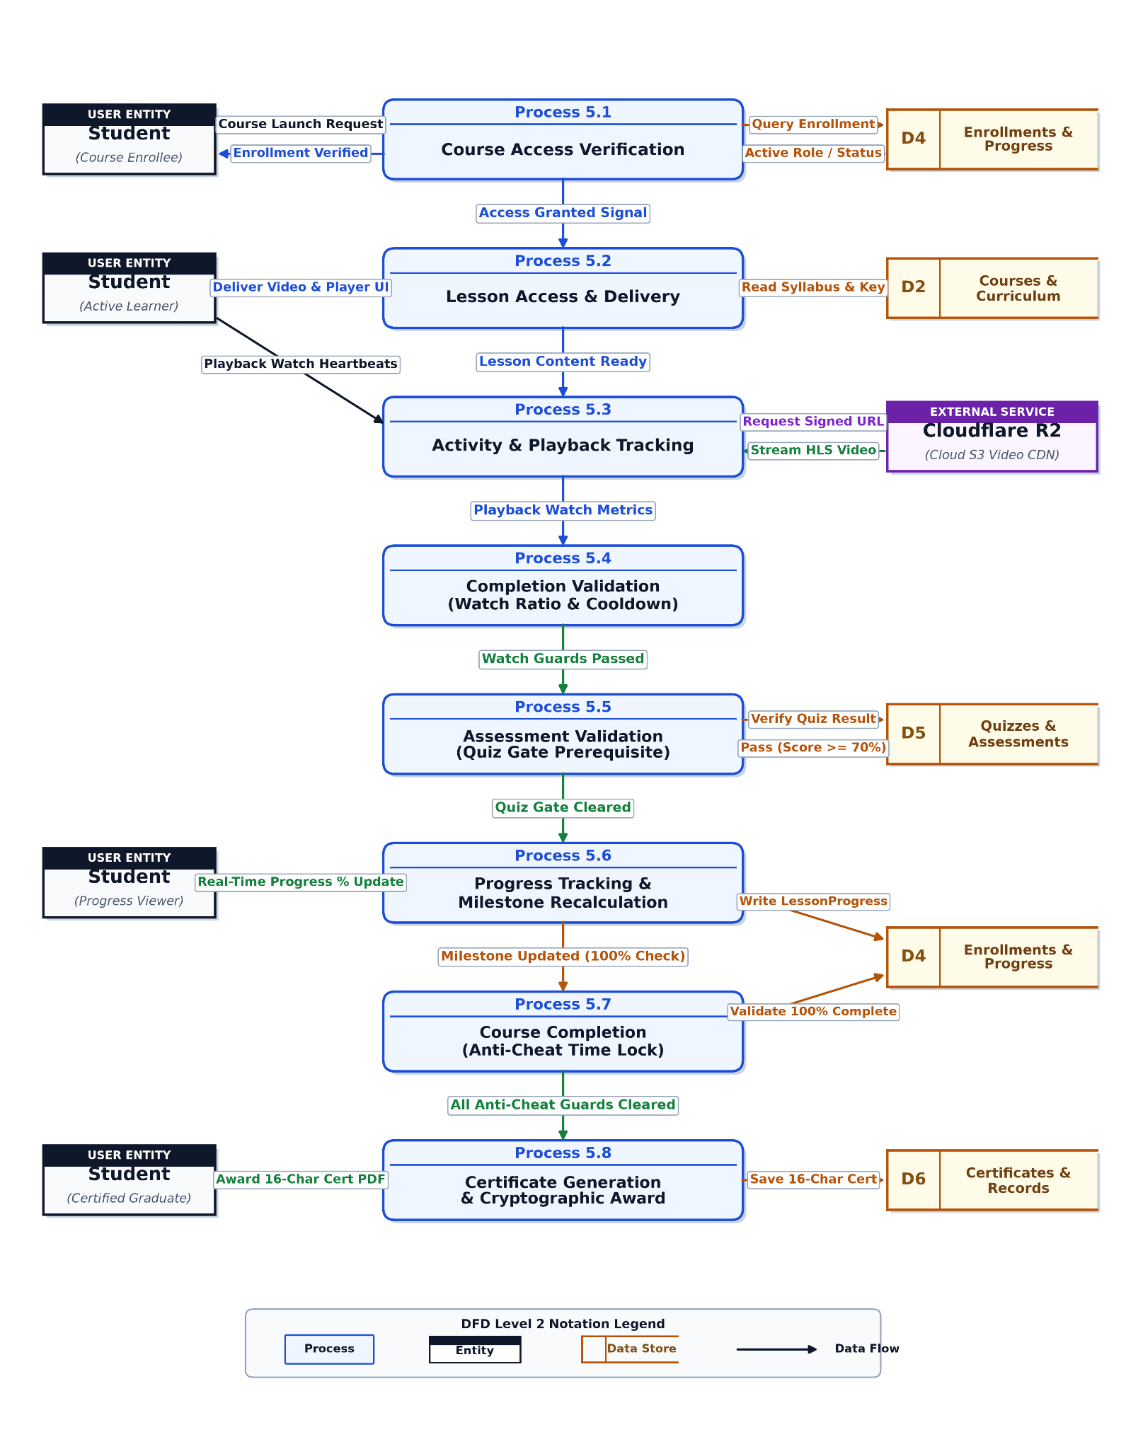
Figure 6.3: Level 2 Data Flow Diagram for Learning and Progress

6.5 Data Dictionary
The data dictionary describes the major data entities used by SkillKart. The current implementation contains entities covering users, learning content, enrollment, assessments, commerce, learner engagement, certification, instructor operations, and administration.
Table 6.1: SkillKart System Data Dictionary
Entity | Description
User | Stores user account, authentication, profile, and role information.
Course | Stores course information and course-level configuration.
Category | Stores categories used to organise courses.
Section | Represents a section within a course.
Lesson | Represents a lesson within a course section.
LessonItem | Represents individual learning content items associated with lessons.
LessonProgress | Stores learner progress for applicable learning content.
Enrollment | Represents a student's enrollment or access to a course.
Quiz | Stores quiz configuration and questions associated with a lesson.
QuizAttempt | Stores a student's quiz attempt and result information.
Assignment | Stores assignment information associated with a course, including the grading rubric, maximum score, and due date.
AssignmentSubmission | Stores student assignment submissions.
Certificate | Stores certificate information generated after course completion.
Review | Stores student reviews and ratings for courses.
Comment | Stores comments and discussion-related information.
Note | Stores student learning notes.
Bookmark | Stores bookmarked learning content.
Wishlist | Stores courses saved by students for later consideration.
Cart | Stores courses currently selected for purchase.
Order | Stores purchase and order information.
Coupon | Stores discount and coupon configuration.
Payout | Stores instructor payout-related information.
Notification | Stores in-application notification information.
Announcement | Stores announcements published by instructors for a course.
CourseFAQ | Stores frequently asked questions associated with courses.
AuditLog | Stores records of relevant administrative or system activities.
SystemSettings | Stores configurable system-level settings.
NewsletterSubscriber | Stores information required for newsletter subscription functionality.
The detailed fields, data types, validation rules, and relationships of these entities are discussed in Chapter 7.

6.6 Entity Relationship Diagram
The Entity Relationship Diagram represents the relationships between the major entities in SkillKart.
The central entities include User, Course, Section, Lesson, Enrollment, LessonProgress, Quiz, Assignment, Order, Review, Certificate, and other supporting entities.
Important relationships include:
- A user can have an associated role and can participate in different system activities.
- An instructor can manage multiple courses.
- A course can optionally belong to a category.
- A course can contain multiple sections.
- A section can contain multiple lessons.
- A lesson can contain multiple lesson items.
- A student can have multiple enrollments.
- An enrollment connects a student with a course.
- A student has a lesson progress record for each lesson they interacted with.
- A lesson can have one quiz, and a course can have multiple assignments.
- A student can create quiz attempts and assignment submissions.
- A course can receive reviews and comments.
- A completed course can produce a certificate for an eligible student.
- A user can have cart and wishlist information.
- Orders contain purchase-related course information.
- Coupons can be associated with applicable order workflows.
- Instructors can have earnings and payout records.
- Users can receive notifications.
- Courses can have announcements and FAQs.
- Administrative activities can generate audit log records.
Entity relationships are represented through Mongoose ObjectId references, managed at the application level rather than through relational foreign key constraints.
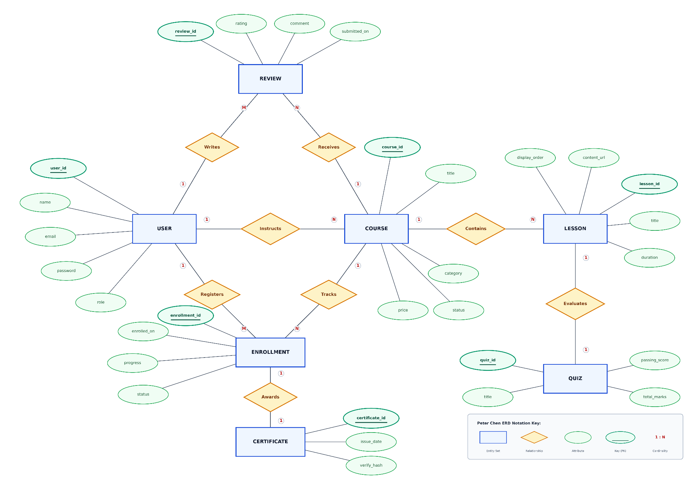
Figure 6.4: Entity Relationship Diagram

6.7 Use Case Diagram
The Use Case Diagram represents the major interactions between the three primary user roles and SkillKart.

6.7.1 Student Use Cases
The student can:
- Register and log in.
- Complete onboarding.
- Manage profile.
- Browse courses.
- Search and filter courses.
- View course details.
- Add courses to wishlist.
- Add courses to cart.
- Apply coupons.
- Complete checkout and payment.
- Enroll in courses.
- Access lessons.
- Track progress.
- Attempt quizzes.
- Submit assignments.
- Add notes.
- Add bookmarks.
- Participate in discussions.
- Submit reviews and ratings.
- View notifications.
- Maintain learning streaks.
- View certificates.
- Verify certificates.

6.7.2 Instructor Use Cases
The instructor can:
- Apply for instructor access.
- Manage instructor profile.
- Create courses.
- Edit courses.
- Manage sections and lessons.
- Manage lesson content.
- View enrolled learners.
- View analytics.
- View earnings.
- Manage payout-related information.
- Publish announcements.
- Manage course FAQs.

6.7.3 Administrator Use Cases
The administrator can:
- Manage users.
- Review instructor applications.
- Manage instructors.
- Manage courses.
- Moderate courses.
- Manage categories.
- Manage coupons.
- Manage payouts.
- View audit logs.
- View financial reports.
- Manage system settings.
- Control maintenance mode.
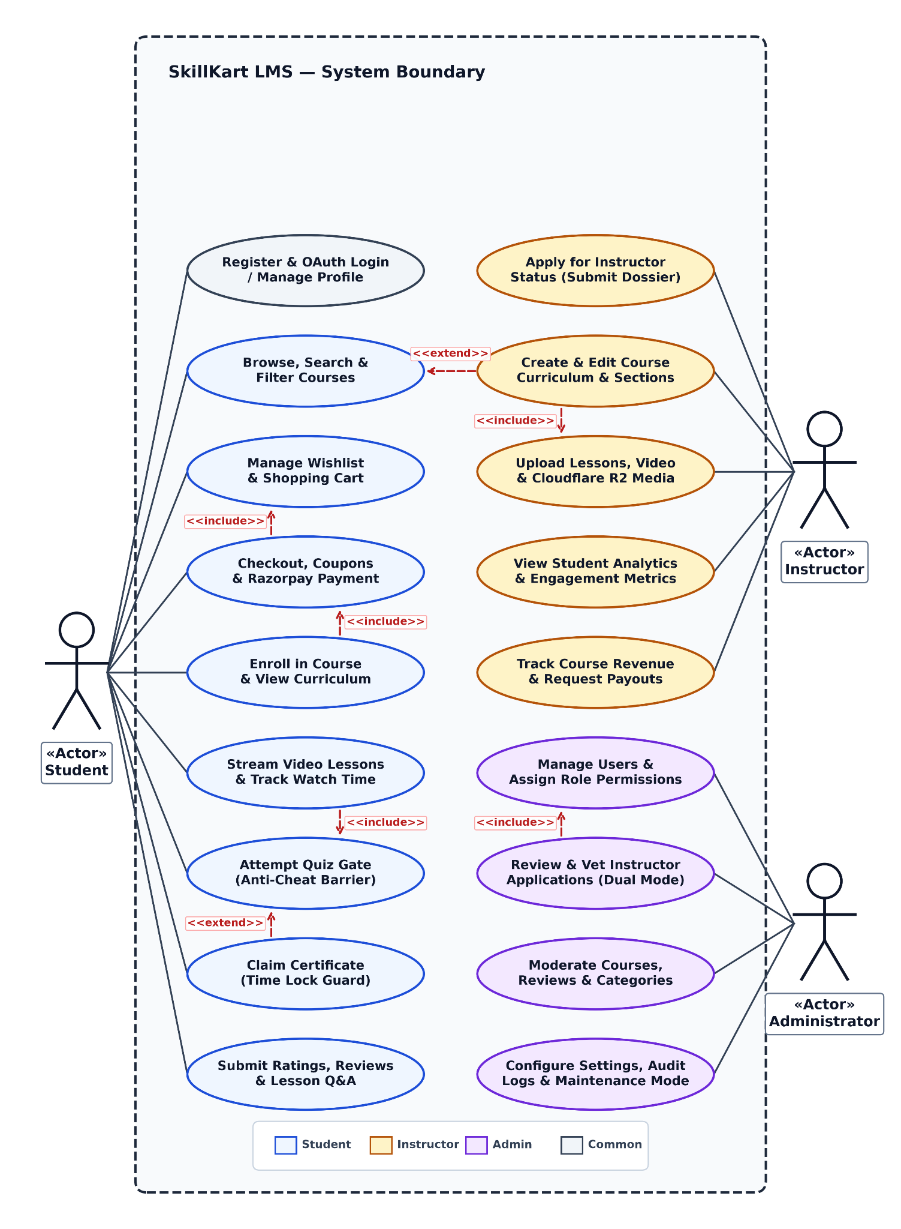
Figure 6.5: Use Case Diagram

6.8 Class Diagram
The Class Diagram represents the major structural entities of the application and their relationships.
The primary classes correspond to the main Mongoose models used by the application.
Important classes include:
- User
- Course
- Category
- Section
- Lesson
- LessonItem
- LessonProgress
- Enrollment
- Quiz
- QuizAttempt
- Assignment
- AssignmentSubmission
- Certificate
- Review
- Comment
- Note
- Bookmark
- Wishlist
- Cart
- Order
- Coupon
- Payout
- Notification
- Announcement
- CourseFAQ
- AuditLog
- SystemSettings
- NewsletterSubscriber
The User class is associated with many user-specific activities and can participate in different roles. Course is related to the curriculum hierarchy and several learning, commerce, and engagement entities.
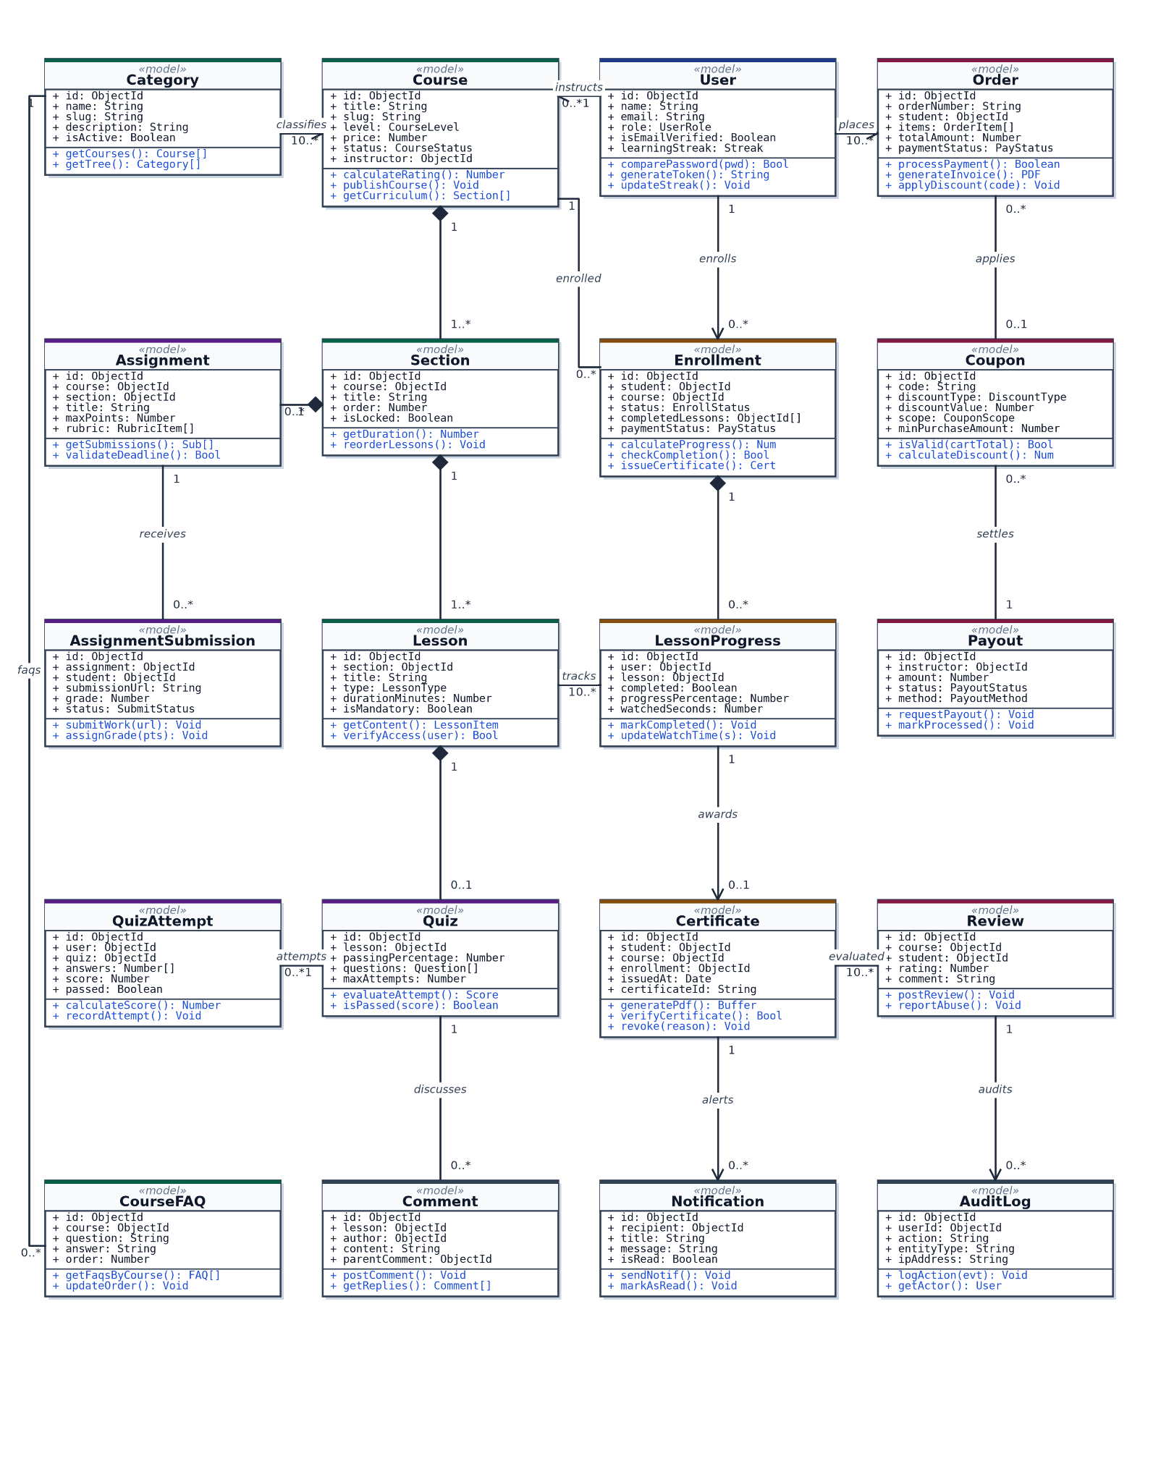
Figure 6.6: Class Diagram

6.9 Activity Diagram
Activity diagrams describe the sequence of actions involved in important system workflows.

6.9.1 Course Enrollment Activity
The course enrollment process can be represented as:
Start → Browse Course → View Course Details → Check Enrollment → Add to Cart / Enroll → Checkout if Required → Apply Coupon if Applicable → Payment → Payment Verification → Create Enrollment → Course Access → End
For free or otherwise directly accessible courses, the payment steps may not be required.
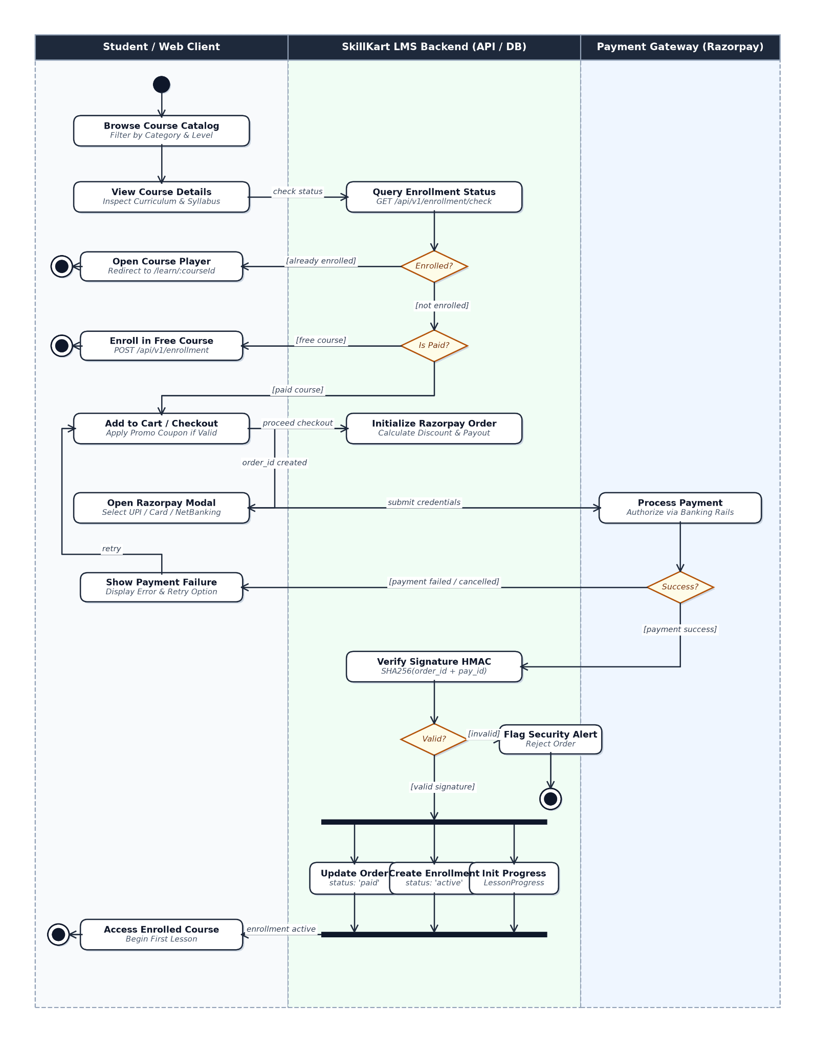
Figure 6.7: Course Enrollment Activity Diagram

6.9.2 Learning and Progress Activity
The learning workflow can be represented as:
Start → Open Enrolled Course → Select Lesson → Access Learning Content → Perform Learning Activity → Check Completion Conditions → Update Progress → Check Course Completion → Continue Learning / Complete Course → Generate Certificate if Eligible → End
The completion validation step ensures that applicable learning conditions are satisfied before progress is recorded as completed.
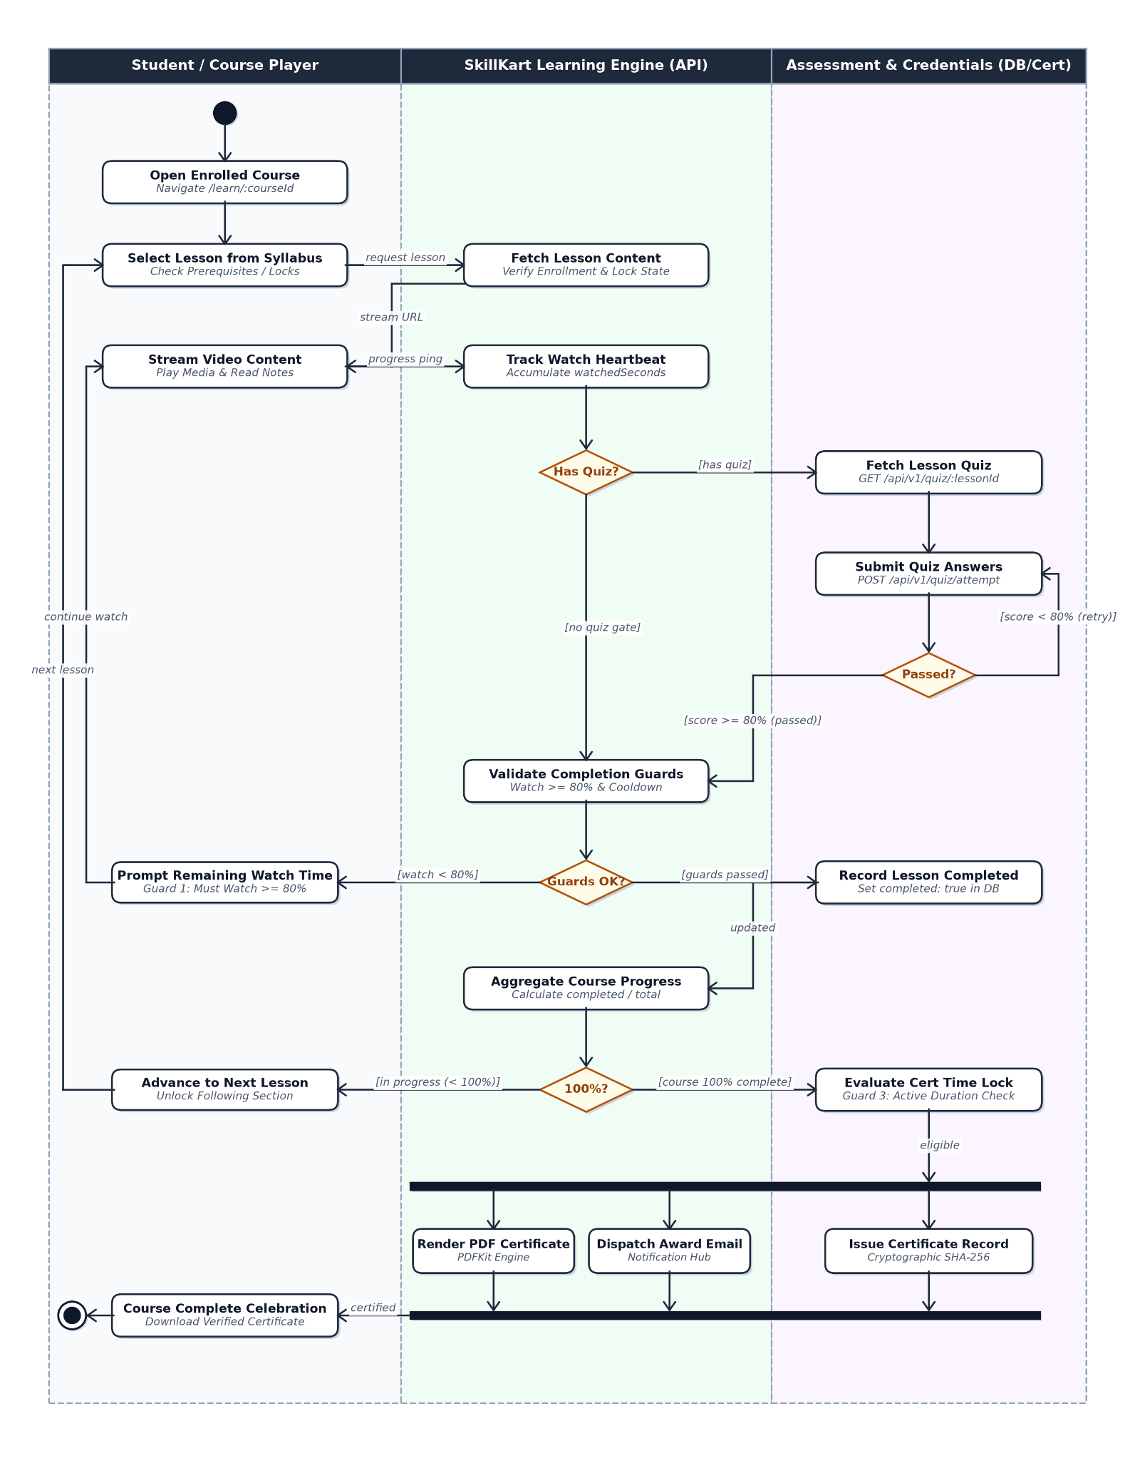
Figure 6.8: Learning and Progress Activity Diagram

6.10 Sequence Diagram
Sequence diagrams describe communication between system components over time.

6.10.1 Authentication Sequence
The authentication process can be represented as:
User → React Frontend → Authentication API → Authentication Logic → User Database → Authentication Response → React Frontend
For normal authentication, the backend verifies the submitted credentials and generates the required authentication information.
For Google authentication, the system additionally communicates with the Google OAuth service.
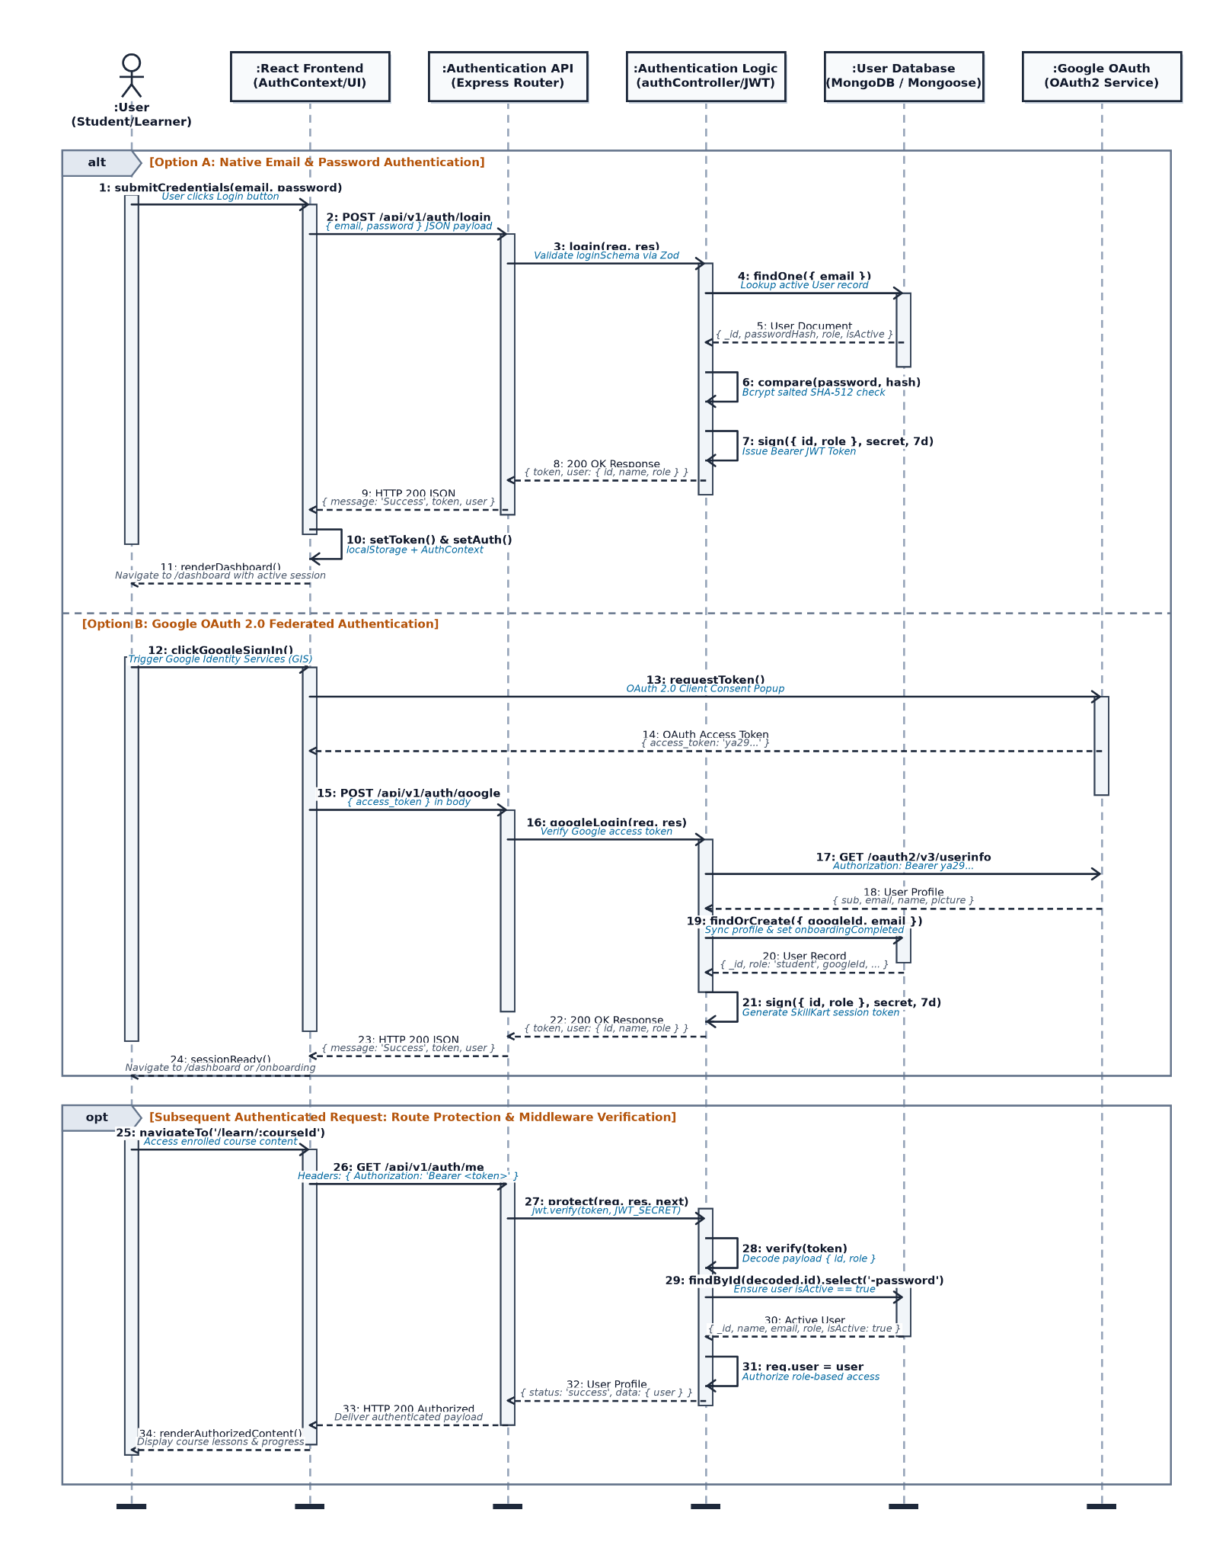
Figure 6.9: Authentication Sequence Diagram

6.10.2 Payment Sequence
The payment workflow can be represented as:
Razorpay payment execution, payment verification, enrollment record creation, and dashboard access granting.
The backend is responsible for processing the payment result and updating the corresponding order and enrollment information according to the implemented payment workflow.
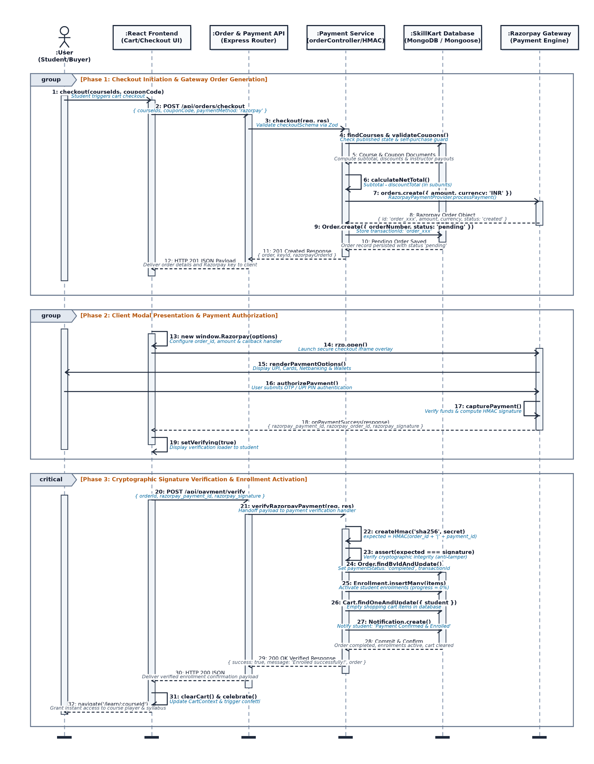
Figure 6.10: Payment Sequence Diagram

6.11 State Diagram
State diagrams represent the different states through which an entity can move during its lifecycle.

6.11.1 Course Lifecycle
A simplified course lifecycle can be represented as:
A course has three status values in the application: Draft, Published, and Archived. A new course starts as Draft. When the instructor publishes it, its status becomes Published. If course approval is required in the system settings, the course remains pending administrative approval and is not visible to learners until an administrator approves it; an administrator can also reject a course and record the reason. A published course can be unpublished or archived, and an archived course can be restored.
Draft → Published (approval pending → approved or rejected) → Archived → Restored
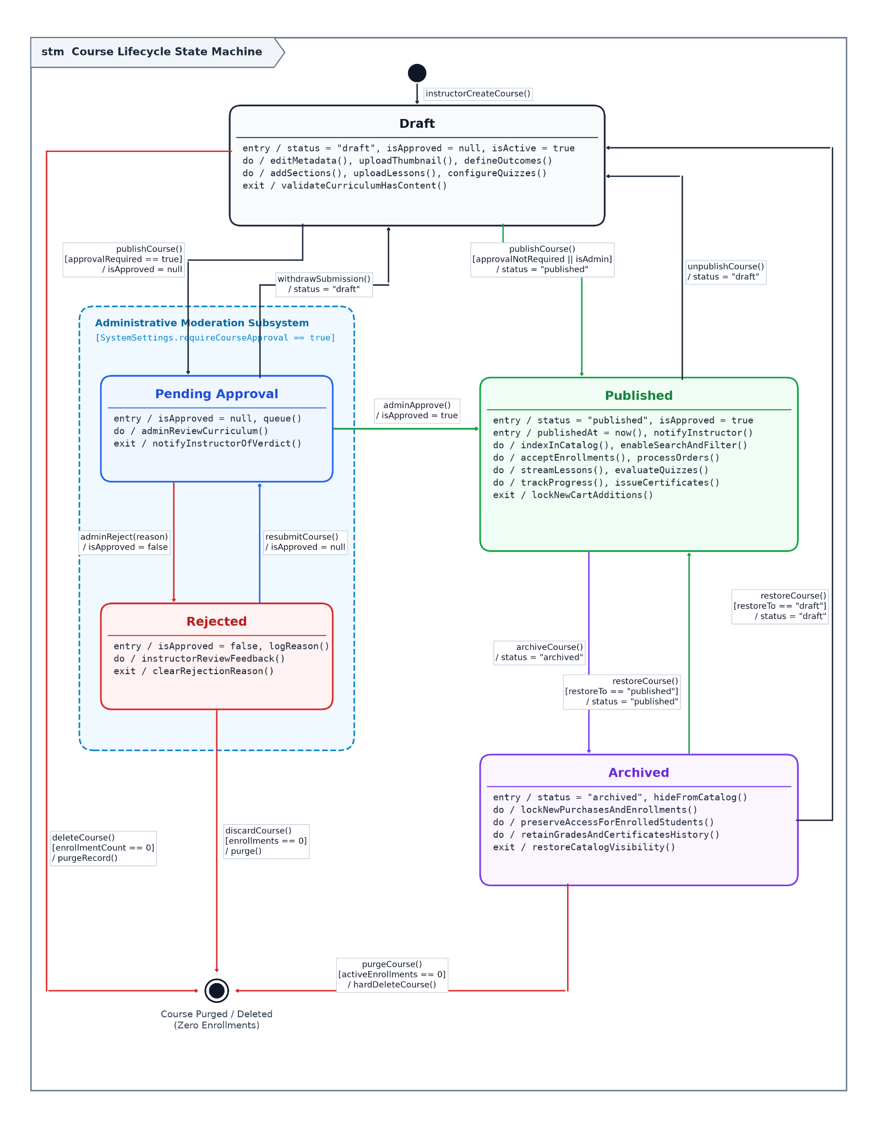
Figure 6.11: Course Lifecycle State Diagram

6.11.2 Learning Progress State
The learning progress of a student can be represented conceptually as:
Not Started → In Progress → Completed
A student enters the In Progress state after beginning the applicable learning activity. The activity moves to Completed only when the configured completion conditions are satisfied.
For a course, the overall learning state can similarly progress from incomplete learning to completed learning when the required content and assessment conditions are fulfilled.
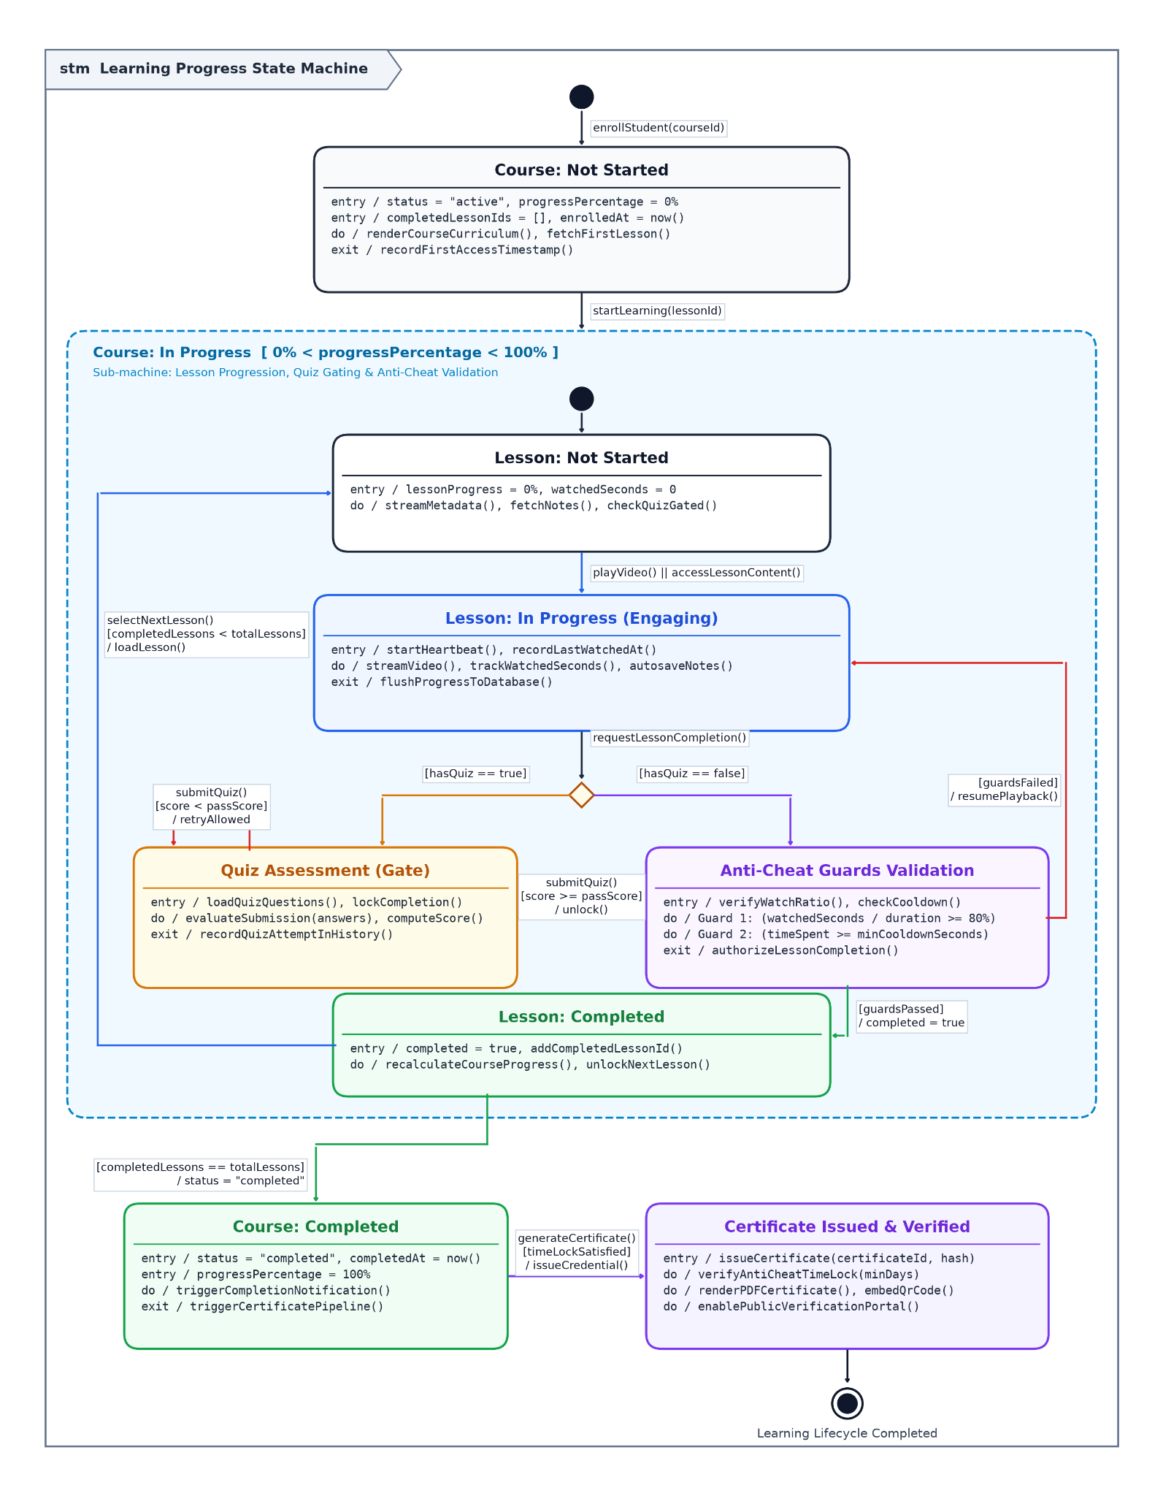
Figure 6.12: Learning Progress State Diagram

6.12 Chapter Summary
This chapter presented the major system models used to describe SkillKart. The Level 0, Level 1, and Level 2 Data Flow Diagrams describe the movement of information through the system. The data dictionary identifies the major entities used by the application, while the ER diagram represents their relationships.
The Use Case Diagram describes interactions between students, instructors, administrators, and the system. The Class Diagram represents the major application entities, while the Activity, Sequence, and State Diagrams describe important workflows and state transitions.
Together, these models provide a visual representation of the structure and behaviour of SkillKart and support the detailed database and implementation discussions presented in the following chapters.

CHAPTER 7: DATABASE DESIGN

7.1 Introduction
The SkillKart Learning Management System uses MongoDB as its primary database and Mongoose as the Object Data Modeling (ODM) library for interaction between the application and the database. MongoDB is a document-oriented NoSQL database that stores data in collections using BSON documents.
The database is designed to support the different activities performed by students, instructors, and administrators. These activities include user management, course creation, enrollment, learning progress, assessments, payments, certificates, communication, instructor management, and administrative operations.
The database design follows a modular approach in which each major functional area of the system is represented by one or more Mongoose models. Relationships between related documents are represented using MongoDB ObjectId references. Mongoose schemas are also used to define field structures, validation rules, default values, and indexes.
The current implementation contains 28 Mongoose models covering the major functional areas of the SkillKart platform.

7.2 Database Technology
SkillKart uses the following database technologies:
Table 7.1: SkillKart Database Technologies
Technology | Purpose
MongoDB | Primary database for storing application data
Mongoose | ODM used to define schemas and interact with MongoDB
MongoDB Atlas | Cloud-hosted MongoDB service that can be used through the configured connection string
ObjectId | Identifier and reference mechanism between related documents
MongoDB was selected because the LMS contains different types of data with varying structures. Course content, lessons, quizzes, assignments, user activities, orders, and other records can be represented naturally as documents.
Mongoose provides a structured layer over MongoDB by defining schemas and applying validation and data access rules at the application level.

7.3 Database Design Approach
The database design was developed around the functional modules of the LMS. Instead of storing all information in a small number of large documents, separate collections are used for major entities and activities.
The main design principles are:
- Separate collections are used for major functional entities.
- MongoDB ObjectId references are used to connect related documents.
- Mongoose schemas define the expected structure of documents.
- Validation is applied to important input fields.
- Indexes are used for frequently queried fields and unique constraints where required.
- Selected values are stored redundantly by design (for example lesson counts and purchase snapshots), while other values are calculated when required.
- User, course, learning, commerce, and administration data are separated logically.
- Database access is performed through Mongoose models from the backend application.
The design also distinguishes between values that are stored, values that are calculated when needed, and values that are deliberately duplicated. For example, the percentage of a course completed is not stored; it is calculated from the number of completed lessons and the total lesson count, both of which are kept on the Enrollment document. The completed-lesson list and total lesson count are stored on the Enrollment so that course progress can be read without scanning every LessonProgress record, and the total is updated whenever lessons are added to or removed from the course. Similarly, each Order stores a snapshot of the course title, price, and payout split at the time of purchase, so that historical orders remain accurate even if the course is later changed.

7.4 Database Collections and Models
The current SkillKart implementation contains 28 Mongoose models.
Table 7.2: SkillKart Database Collections and Mongoose Models
No. | Model | Main Purpose
1 | User | Stores user accounts and profile information
2 | Course | Stores course information
3 | Category | Stores course categories
4 | Section | Stores course sections
5 | Lesson | Stores individual lessons
6 | LessonItem | Stores lesson content items
7 | LessonProgress | Stores learner lesson progress
8 | Enrollment | Stores course enrollment information
9 | Quiz | Stores quiz definitions
10 | QuizAttempt | Stores learner quiz attempts
11 | Assignment | Stores course assignments
12 | AssignmentSubmission | Stores learner assignment submissions
13 | Certificate | Stores issued certificates
14 | Review | Stores course reviews and ratings
15 | Comment | Stores discussion and comment information
16 | Note | Stores learner notes
17 | Bookmark | Stores bookmarked learning content
18 | Wishlist | Stores courses added to a learner's wishlist
19 | Cart | Stores items added to the shopping cart
20 | Order | Stores purchase and order information
21 | Coupon | Stores discount coupon information
22 | Payout | Stores instructor payout information
23 | Notification | Stores in-app notifications
24 | Announcement | Stores announcements
25 | CourseFAQ | Stores frequently asked questions for courses
26 | AuditLog | Stores administrative activity records
27 | SystemSettings | Stores system-level configuration
28 | NewsletterSubscriber | Stores newsletter subscription information
These models collectively support the student, instructor, and administrator workflows implemented in the system.

7.5 User Collection
The User model stores information related to registered users of the platform.
Users may have different roles such as student, instructor, or administrator. The model also supports information required for authentication, onboarding, profile management, and instructor-related functionality.
Typical information represented by the User model includes:
- User identity and profile information
- Email and authentication information
- User role
- Profile details
- Onboarding-related information
- Account status
- Information required for instructor functionality
The User collection acts as one of the central entities of the system because several other models reference users through ObjectIds.

7.6 Course Collection
The Course model stores the primary information about courses available on the platform.
A course can contain information such as:
- Course title
- Description
- Category reference
- Instructor reference
- Course status
- Course pricing information
- Course metadata
- Curriculum-related information
- Course visibility and publishing information
A course is associated with sections and lessons, while other models such as Enrollment, Review, Wishlist, Cart, Order, and Certificate can also reference the relevant course.
Course management is performed through the instructor and administrative functionality of the application.

7.7 Category Collection
The Category model stores categories used to organize courses.
Categories allow courses to be grouped and filtered during course discovery. A course can reference a category using a MongoDB ObjectId.
The Category collection also allows administrators to manage the classification structure used by the course catalog.

7.8 Section Collection
The Section model represents a logical section within a course.
A course may contain multiple sections, and each section can contain multiple lessons. The section structure helps organize course content into meaningful units.
The relationship can be represented as:
Course → Section → Lesson
The Section model therefore provides an intermediate level between a course and its individual lessons.

7.9 Lesson Collection
The Lesson model represents individual learning units within a course section.
Lessons may contain information required to identify and organize the learning material. A lesson belongs to a section and is associated with its parent course structure.
Lessons are also related to LessonProgress records, which are used to track learner activity and completion.
The lesson structure supports the learning workflow implemented by the lesson viewer.

7.10 LessonItem Collection
The LessonItem model represents individual content items associated with lessons.
This provides flexibility for lessons to contain different forms of learning content instead of depending on a single fixed content structure.
Lesson items are associated with lessons and are used as part of the learner's course consumption workflow.
The separation between Lesson and LessonItem allows the system to organize lesson-level information independently from individual content elements.

7.11 Enrollment Collection
The Enrollment model records a learner's enrollment in a course.
An enrollment connects a user with a course and provides the basis for controlling access to learning content.
Enrollment information is used for:
- Determining whether a student has access to a course
- Managing learner-course relationships
- Tracking course participation
- Supporting progress calculations
- Supporting certificate eligibility
The Enrollment document stores the identifiers of the completed lessons, the total lesson count of the course, and the most recently accessed lesson (used to resume learning). The course progress percentage is calculated from the completed and total lesson counts. Detailed per-lesson activity such as watch time is recorded separately in the LessonProgress collection.
The implementation does not treat MongoDB ObjectId references as relational foreign keys. They are document references managed by the application and Mongoose.

7.12 LessonProgress Collection
The LessonProgress model stores learner progress at the lesson level.
It is used to record information related to a student's interaction with course lessons and completion status.
The collection supports the learning progress workflow and helps determine whether the learner has completed the required lessons.
The system uses completion-related controls when updating lesson progress. For example, video lessons can require a minimum watch percentage, and other learning conditions can be checked before completion is accepted.
Each LessonProgress record stores the completion flag, progress percentage, number of seconds watched, and completion time for one learner and one lesson. The watched-seconds value is updated so that it can only increase, which prevents a learner from reducing the recorded watch time. Course-level completion is calculated from the Enrollment document, as described in Section 7.11.

7.13 Quiz and QuizAttempt Collections

7.13.1 Quiz
The Quiz model stores the multiple-choice quiz attached to a lesson. Each lesson can have at most one quiz.
It contains information required to define questions, options, correct answers, and assessment-related configuration.
Quizzes are used to evaluate learner understanding and can also form part of the conditions required for completing particular learning activities.

7.13.2 QuizAttempt
The QuizAttempt model stores individual attempts made by learners.
A quiz attempt can be associated with:
- The learner
- The relevant lesson
- Submitted answers
- Result information
- Attempt-related data
Quiz attempts allow the system to maintain a history of learner assessment activity rather than storing only the latest result.
Quiz completion can also be used as a learning gate where required by the course content.

7.14 Assignment and AssignmentSubmission Collections

7.14.1 Assignment
The Assignment model stores assignments created as part of course content.
Assignments allow instructors to provide tasks that require learner submissions rather than simple objective-based quiz responses.

7.14.2 AssignmentSubmission
The AssignmentSubmission model stores submissions made by learners for assignments.
It connects the learner's submission with the corresponding assignment and provides a separate record for submission-related information.
Together, these models support the assignment-based assessment workflow of the LMS.

7.15 Review, Comment, Note, Bookmark and Wishlist Collections

7.15.1 Review
The Review model stores learner reviews and ratings associated with courses.
Reviews allow learners to provide feedback after interacting with a course and contribute to course evaluation and discovery.

7.15.2 Comment
The Comment model stores discussion and comment information.
Comments support interaction around course-related content and allow learners to participate in discussions.

7.15.3 Note
The Note model stores notes created by learners while studying.
This allows learners to maintain personal learning information associated with their course content.

7.15.4 Bookmark
The Bookmark model stores content bookmarked by learners.
Bookmarks allow learners to save relevant learning material for easier access later.

7.15.5 Wishlist
The Wishlist model stores courses that learners have added to their wishlist.
Wishlist information is separate from enrollment because adding a course to a wishlist does not provide course access.
These models provide additional learner engagement features beyond basic course consumption.

7.16 Cart, Order, Coupon and Payout Collections

7.16.1 Cart
The Cart model stores courses that a learner has selected for purchase.
The cart provides the intermediate stage between course discovery and checkout.

7.16.2 Order
The Order model stores purchase-related information.
Orders provide a record of the transaction associated with course purchases and connect the commerce workflow with enrollment.
The payment workflow supports the Razorpay payment provider as part of the implemented payment service architecture.

7.16.3 Coupon
The Coupon model stores discount information that can be applied during the purchase process.
Coupon records allow the system to validate and apply discounts according to the configured coupon rules.

7.16.4 Payout
The Payout model stores payout-related information for instructors.
The model supports the instructor earnings and payout workflow and allows payout records to be maintained separately from learner purchase records.
The overall commerce relationship can be represented as:
Student → Cart → Order → Payment → Enrollment
and on the instructor side:
Course Purchase → Instructor Earnings → Payout

7.17 Certificate, Notification, Announcement and CourseFAQ Collections

7.17.1 Certificate
The Certificate model stores certificates issued to learners after satisfying the required course completion conditions.
Certificates are associated with the relevant learner and course and support certificate verification functionality.
The system also supports certificate status management, including verification and revocation-related functionality.

7.17.2 Notification
The Notification model stores in-app notifications generated for users.
Notifications can be associated with different activities occurring within the platform.
The current implementation uses application-level notification retrieval rather than a WebSocket or server-sent event based real-time notification system.

7.17.3 Announcement
The Announcement model stores announcements published through the platform.
Announcements are published by instructors for a specific course and are shown to the students enrolled in that course.

7.17.4 CourseFAQ
The CourseFAQ model stores frequently asked questions associated with courses.
It provides a structured way of presenting common questions and answers related to a course.

7.18 AuditLog, SystemSettings and NewsletterSubscriber Collections

7.18.1 AuditLog
The AuditLog model stores records of important administrative actions.
Audit logs provide traceability for relevant administrative operations and support accountability within the administration module.

7.18.2 SystemSettings
The SystemSettings model stores configurable system-level settings.
It supports administrative configuration without requiring every configuration value to be hard-coded into the application.
System settings also support functionality such as system configuration and maintenance-related controls.

7.18.3 NewsletterSubscriber
The NewsletterSubscriber model stores information about users or visitors who subscribe to newsletter communication.
This collection is separate from the main User collection because newsletter subscription does not necessarily require the subscriber to have a complete platform account.

7.19 Relationships and References
MongoDB does not enforce relationships in the same way as a traditional relational database. SkillKart uses MongoDB ObjectId references to associate related documents.
The major relationships can be summarized as follows:
- A User can create or participate in multiple courses.
- An Instructor can manage multiple Courses.
- A Course can optionally belong to a Category.
- A Course contains multiple Sections.
- A Section contains multiple Lessons.
- A Lesson can contain multiple LessonItems.
- A User can have multiple Enrollments.
- A Course can have multiple Enrollments.
- A User has one LessonProgress record for each Lesson the User has interacted with, and an Enrollment stores the list of completed lesson identifiers.
- A Lesson can have one Quiz, and a Course can have multiple Assignments.
- A User can make multiple QuizAttempts for a Lesson.
- An Assignment can have multiple AssignmentSubmissions.
- A Course can have multiple Reviews and Comments.
- A User can create Notes and Bookmarks for learning content.
- A User can maintain Wishlist and Cart records.
- Orders connect users with purchased courses and payment information.
- Payouts are associated with instructors, and instructor earnings are calculated from the item-level payout amounts stored in Orders.
- Certificates connect learners with completed courses.
- Users can receive Notifications and system communication.
- Courses can contain Announcements and FAQs.
- Administrative actions can be recorded through AuditLogs.
A simplified logical relationship is:
User → Enrollment → Course → Section → Lesson → LessonItem
with supporting relationships for:
Lesson → Quiz
User/Lesson → QuizAttempt
Assignment → AssignmentSubmission
Course → Review
User → Cart → Order
Instructor → Payout
User/Course → Certificate
These relationships are implemented using document references rather than relational foreign-key constraints.

7.20 Indexing
Indexes are used to improve query performance for frequently accessed data and to enforce uniqueness where required.
Indexing is particularly relevant for areas such as:
- User authentication and account lookup
- Course discovery and filtering
- Course and category relationships
- Enrollment lookup
- Lesson progress lookup
- Quiz attempts
- Orders and payment-related records
- Coupon lookup
- User-specific wishlist and cart operations
- Certificate verification
- Notification retrieval
Unique constraints are also applied where the application requires a combination of fields to represent a unique record.
For example, enrollment data can use a user-course uniqueness rule so that the same learner is not unintentionally enrolled in the same course multiple times.
Table 7.3 lists the main indexes and unique constraints defined in the Mongoose schemas. Unique compound indexes are also used to prevent duplicate ordering, for example one lesson per order position within a section. The courses collection defines a MongoDB text index on title, description, and tags; however, the current course search uses case-insensitive regular-expression matching so that instructor names can also be searched.
Table 7.3: Key Indexes and Unique Constraints
Collection | Indexes and constraints
users | email (unique); resetPasswordToken
courses | category; tags; instructor; {instructor, status}; text index on title, description, tags
categories | slug (unique); {order, isActive}
sections | {course, order} (unique)
lessons | {section, order} (unique)
lessonitems | {lesson, order} (unique)
enrollments | {student, course} (unique)
lessonprogresses | {user, lesson} (unique)
quizzes | lesson (unique)
assignmentsubmissions | {assignment, student} (unique)
certificates | certificateId (unique); {student, course} (unique)
reviews | {course, student} (unique); {course, createdAt descending}
comments | {lesson, createdAt}; {lesson, parentComment}
notes | {user, lesson, createdAt descending}; {user, course, createdAt descending}
bookmarks | {user, lesson} (unique); {user, course, createdAt descending}
wishlists | {student, course} (unique)
carts | student (unique)
orders | orderNumber (unique); student; paymentStatus; transactionId
coupons | code (unique); creatorRole; scope; isPublic; instructor; isActive
payouts | referenceNumber (unique); instructor; status
announcements | {course, createdAt descending}
coursefaqs | {course, order}
auditlogs | admin; action; targetType; targetId; {createdAt descending}
systemsettings | isSingleton (unique)
newslettersubscribers | email (unique)

7.21 Validation and Data Integrity
Data integrity is maintained through several layers of the application.

7.21.1 Mongoose Schema Validation
Mongoose schemas define the expected structure and validation rules for database documents. This provides a database access layer that helps prevent incorrectly structured data from being stored.

7.21.2 Request Validation
The backend also uses Zod validators to validate incoming request data before it reaches the relevant business logic.
This provides an additional validation layer for API requests.

7.21.3 Authentication and Authorization
Access to protected data is controlled using authentication and authorization middleware. User roles and resource ownership are checked before performing sensitive operations.

7.21.4 Business Rules
Application-level business rules protect important workflows.
Examples include:
- Only authorized users can perform protected operations.
- Course access is checked through enrollment.
- Learning completion conditions are validated before accepting completion.
- Video completion requires the configured watch threshold.
- A cooldown is applied to prevent immediate repeated completion requests.
- Required quizzes can act as completion gates.
- Certificate issuance depends on the required completion conditions.
- A certificate issued after unusually fast completion is held from public verification until the hold period has elapsed.
- Duplicate enrollments, reviews, and certificates for the same learner and course are prevented by unique compound indexes.
These mechanisms help maintain consistency between user actions and the stored database state.

7.22 Sample Documents
The following examples represent simplified versions of documents used by the system.

7.22.1 Sample User Document
{
"_id": "ObjectId",
"name": "Example User",
"email": "user@example.com",
"role": "student",
"onboardingCompleted": true,
"isActive": true,
"instructorStatus": "none",
"currentStreak": 0
}

7.22.2 Sample Course Document
{
"_id": "ObjectId",
"title": "Web Development",
"description": "Course description",
"category": "ObjectId",
"instructor": "ObjectId",
"level": "beginner",
"isPaid": true,
"price": 499,
"status": "published",
"isApproved": true
}

7.22.3 Sample Enrollment Document
{
"_id": "ObjectId",
"student": "ObjectId",
"course": "ObjectId",
"status": "active",
"paymentStatus": "paid",
"completedLessonIds": [],
"totalLessonsCount": 12
}

7.22.4 Sample Order Document
{
"_id": "ObjectId",
"orderNumber": "SK-20260919-0001",
"student": "ObjectId",
"items": [
{
"course": "ObjectId",
"title": "Web Development",
"originalPrice": 499,
"finalPrice": 499,
"instructorPayout": 399.2,
"platformFee": 99.8
}
],
"totalAmount": 499,
"paymentMethod": "razorpay",
"paymentStatus": "completed",
"transactionId": "razorpay-order-id"
}
The examples are simplified to demonstrate the document structure. The actual Mongoose schemas contain additional fields required by the corresponding application modules.

7.23 Summary
The SkillKart database is designed using MongoDB and Mongoose to support the complete functionality of the LMS. The current implementation contains 28 Mongoose models covering user management, courses, curriculum, enrollment, learning progress, assessments, learner engagement, commerce, certificates, notifications, instructor operations, and administration.
The use of separate models provides a clear organization of application data, while ObjectId references connect related documents. Mongoose schemas and Zod request validation provide structural and input validation, while application-level authorization and business rules protect sensitive operations.
The database design also distinguishes between stored, calculated, and deliberately duplicated values. The course completion percentage is calculated, while the completed-lesson list, total lesson count, and order item snapshots are stored to support efficient reads and accurate historical records.

CHAPTER 8: IMPLEMENTATION

8.1 Introduction
The SkillKart Learning Management System was implemented as a full-stack web application using a modern JavaScript and TypeScript-based technology stack. The system provides separate functionality for students, instructors, and administrators.
The frontend was developed using React 19 with TypeScript and Vite. Tailwind CSS is used for styling and responsive interface development. The backend was developed using Node.js, Express 5, and TypeScript. MongoDB is used as the primary database and Mongoose is used for database operations and schema management.
The implementation also integrates external services for authentication, payments, file storage, and email communication. Google OAuth is used for social authentication, Razorpay is integrated into the payment workflow, Cloudflare R2 is used for production file storage, and SMTP-based email services are used for email communication.
The application follows a client-server architecture in which the React frontend communicates with the Express backend through HTTP APIs.

8.2 Technology Stack
The major technologies and libraries used during implementation are shown below.
Table 8.1: Implementation Technology Stack and Libraries
Technology | Version | Purpose
React | ^19.2.0 | Frontend application development
TypeScript | ^5.9.3 | Static typing for frontend and backend code
Vite | ^7.2.4 | Frontend development and build tool
Tailwind CSS | ^4.1.18 | User interface styling
React Router DOM | ^7.13.0 | Client-side routing
Axios | ^1.13.5 | HTTP communication between frontend and backend
@react-oauth/google | ^0.13.4 | Google sign-in button on the frontend
Sonner | ^2.0.8 | Toast notifications
Node.js | runtime | Backend runtime
Express | ^5.2.1 | REST API and server-side application framework
MongoDB | database | Primary database
Mongoose | ^9.1.5 | MongoDB ODM
Zod | ^4.3.6 | Request and input validation
jsonwebtoken | ^9.0.3 | JWT creation and verification
bcryptjs | ^3.0.3 | Password hashing
Multer | ^2.2.0 | Handling multipart file uploads
@aws-sdk/client-s3 | ^3.1131.0 | Upload to Cloudflare R2 (S3-compatible)
Razorpay | ^2.9.8 | Payment processing
Nodemailer | ^9.0.6 | Email communication over SMTP
uuid | ^14.0.1 | Unique identifiers for files, orders, and certificates
tsx | ^4.21.0 | Running TypeScript directly on the backend
The implementation also uses supporting libraries for routing, application configuration, authentication, data processing, and other application requirements.

8.3 Frontend Implementation
The frontend of SkillKart is implemented as a React single-page application.
React components are used to divide the interface into reusable functional units. TypeScript is used throughout the frontend to improve type safety and maintainability.
Vite provides the development server and production build process. Tailwind CSS is used to implement the visual design and responsive layouts.
The frontend communicates with the backend through Axios-based HTTP requests. Authentication information is included when accessing protected resources.
The frontend contains interfaces for the following major areas:
- Authentication
- Student onboarding
- Course discovery
- Course details
- Cart and checkout
- Learning
- Assessments
- Student dashboard
- Certificates
- Instructor management
- Instructor analytics
- Instructor earnings and payouts
- Administrative management
- Notifications
- Profile management
Protected frontend routes are used to restrict access to authenticated and role-specific pages.

8.4 Backend Implementation
The backend is implemented using Node.js, Express 5, and TypeScript.
Express routes receive HTTP requests from the frontend and pass them through the required middleware before executing the relevant application logic.
The backend is organized around several major components:
- Route definitions
- Middleware
- Request validation
- Controllers and business logic
- Services
- Mongoose models
- Database connection
- External service integrations
- Error handling
The general request flow is:
Client → Express Route → Middleware → Controller (Zod Validation → Business Logic) → Service → Mongoose → MongoDB → Response
Depending on the operation, external services such as Razorpay, Google OAuth, Cloudflare R2, or SMTP may also be involved.
The backend currently contains multiple route modules covering authentication, users, courses, learning, assessments, commerce, instructor operations, and administration.

8.5 Authentication Implementation
Authentication is implemented using JSON Web Tokens (JWT).
During normal account authentication, the user's credentials are validated by the backend. Passwords are not stored in plain text. Password hashing is handled using bcryptjs.
After successful authentication, the backend issues the required authentication information, which is used by the frontend when accessing protected API endpoints.
The system also supports Google OAuth for users who prefer to authenticate using their Google account.
The authentication process can be summarized as:
User → Login → Credential Validation → JWT Authentication → Protected API Access
Protected backend routes use authentication middleware to verify the user's identity before allowing access.

8.6 User Onboarding and Profile Implementation
After registration or authentication, the system supports an onboarding process for collecting the information required to configure the user's account.
The onboarding workflow is handled by the frontend and backend through API requests.
User profile functionality allows authenticated users to view and update their profile information.
The backend uses authentication and authorization checks to ensure that users can access and modify only the information permitted for their account.
Instructor-specific information and application status are also handled through the user and instructor workflows.

8.7 Role-Based Access Control
SkillKart implements three primary roles:
- Student
- Instructor
- Administrator
Role-based authorization is implemented through backend middleware.
After authentication, the user's role is checked before access is granted to role-specific operations.
For example:
- Students can enroll in courses and access their learning content.
- Instructors can create and manage courses after obtaining the required instructor access.
- Administrators can manage users, courses, categories, coupons, payouts, settings, and other administrative functions.
The frontend also uses protected routes to provide an appropriate interface based on the authenticated user's role.
Backend authorization remains the main security mechanism because frontend restrictions alone cannot protect an API.

8.8 Instructor Application and Course Management
The system provides an instructor application workflow through which users can apply for instructor access.
Administrative functionality is used to review instructor-related requests and manage instructor access.
Once authorized, instructors can create and manage courses.
Course management includes:
- Course information
- Course description
- Category
- Pricing
- Course structure
- Sections
- Lessons
- Lesson items
- Quizzes
- Assignments
- Course FAQs
- Course announcements
The course management workflow also supports course status and moderation operations.
This allows the administrator to control the availability of courses on the platform.

8.9 Course Discovery and Search
The course discovery functionality allows students to browse available courses.
The implementation provides course listing, search, filtering, course details, and recommendation-related functionality.
Course information retrieved from the backend is displayed through React components.
The discovery workflow allows users to move from browsing to the course details page, where information such as course content, instructor information, pricing, reviews, and other course details can be viewed.
Students can also add courses to their wishlist before deciding to purchase or enroll.

8.10 Cart, Checkout and Payment Implementation
The current implementation includes a complete commerce workflow for course purchasing.
Students can add courses to a cart and proceed to checkout.
The major workflow is:
Course Details → Cart → Checkout → Coupon Validation → Payment → Order Processing → Enrollment
The Cart model stores selected courses, while the Order model maintains purchase information.
Coupons can be applied during checkout when the relevant conditions are satisfied.
The payment implementation uses a provider-based service design. Razorpay is implemented as a payment provider, while a simulated provider is also available for development and testing purposes.
The payment service separates payment-related logic from the rest of the application, making the payment component easier to maintain and extend.
Checkout for Razorpay payments takes place in two steps. In the first step, the backend validates the selected courses (they must be accessible, not owned by the buyer, and not already purchased), applies any valid coupon, calculates the order amount, and asks Razorpay to create a payment order. The order is saved with a pending payment status, and the Razorpay order identifier is returned to the frontend, which opens the Razorpay payment window.
In the second step, after the learner completes the payment, the frontend sends the order identifier, payment identifier, and payment signature to the backend. The backend verifies the signature using HMAC-SHA256 with the Razorpay secret key. Only when the signature is valid is the order marked as completed, the learner enrolled in each purchased course, the coupon redemption count increased, the cart and the matching wishlist entries cleared, and a notification created. A webhook endpoint provides a fallback confirmation that uses the same activation logic. An order whose total is zero, for example after a full-discount coupon, is completed immediately without opening the payment window.
Each order item records the instructor payout and the platform fee. By default the platform commission is 20 percent and the instructor share is 80 percent; both values, and the minimum payout amount (default 50), can be changed by the administrator in the system settings. Coupons have a scope (a single course, all courses of one instructor, or platform-wide), a type (percentage or fixed amount), and a funding source (platform or instructor). The funding source is recorded against each discounted item so that instructor payouts and platform fees are calculated correctly.
Although the data model defines further payment method values such as Stripe, PayPal, card, and UPI, only the simulated, free, and Razorpay methods have provider implementations in the current system.

8.11 Course Learning and Lesson Implementation
The lesson viewer provides students with access to enrolled course content.
Courses are organized into sections, lessons, and lesson items.
The learning workflow checks whether the user has the necessary access before allowing protected course content to be viewed.
The lesson implementation supports different content requirements through the Lesson and LessonItem models.
The learner can move through the course curriculum while the system records relevant progress information.

8.12 Learning Progress Implementation
Learning progress is recorded at two levels. The LessonProgress model stores fine-grained activity for each learner and lesson: the completion flag, progress percentage, number of seconds watched, and completion time. The Enrollment document stores the list of completed lessons and the total lesson count of the course, from which the overall course progress percentage is calculated.
The backend applies four controls to reduce invalid completion requests:
1. Video watch threshold: for video lessons with a declared duration, the learner must have watched at least 80% of the duration. The watched time is stored using an update that can only increase the value, so a later request cannot reduce it.
2. Completion cooldown: a 30-second gap is required between marking successive lessons as complete, so lessons cannot be completed in rapid batches.
3. Quiz gate: if a lesson has a quiz, the learner must have passed the quiz before the lesson can be marked complete.
4. Certificate time lock: when all lessons are complete, the enrollment is marked completed and a certificate is issued. If the time between enrollment and completion is less than 30% of the total course duration, the certificate is held and cannot be publicly verified until that minimum period has elapsed (see Section 8.16).
These controls help ensure that recorded progress reflects actual interaction with the learning content.

8.13 Quiz and Assessment Implementation
SkillKart provides quiz-based assessment functionality.
Instructors can create quizzes containing questions and answer options. Students can attempt available quizzes through the learning interface.
The system records quiz attempts using the QuizAttempt model.
The quiz implementation supports:
- Quiz creation
- Question management
- Answer submission
- Result calculation
- Attempt recording
- Passing conditions
- Quiz-based learning restrictions
Quiz results can also be used as part of the course completion workflow.

8.14 Assignment Implementation
In addition to quizzes, the current system supports assignment-based assessment.
Instructors can create assignments associated with course content.
Students can submit their work through the assignment submission workflow.
The Assignment model stores assignment information, while AssignmentSubmission stores the corresponding learner submissions.
This provides support for assessments that require learner responses beyond objective-based quiz questions.

8.15 Review, Discussion and Learner Engagement
Several features were implemented to improve learner interaction with course content.

Reviews
Students can submit reviews and ratings for courses. Review records are stored separately and associated with the relevant user and course.

Discussions and Comments
The Comment model supports discussions and comments related to course content.

Notes
Students can create personal notes while learning.

Bookmarks
Learning content can be bookmarked for later access.

Wishlist
Students can add courses to a wishlist without enrolling in them.

Learning Streaks
The system also maintains learning streak functionality to encourage continued learning activity.
These features extend the LMS beyond basic course consumption and provide additional tools for learner engagement.

8.16 Certificate Implementation
Certificates are generated for learners who satisfy the required course completion conditions.
Certificate information is stored using the Certificate model.
The certificate workflow is connected to the learner's course completion state and therefore depends on the required learning conditions being satisfied.
The system also provides certificate verification functionality so that a certificate can be checked independently.
Certificate status management also supports revocation-related operations when required by the system.
Each certificate has a unique 16-character identifier that is used for public verification. To discourage completing a course only to obtain a certificate, a certificate can carry a hold date: if a learner completes the course in less than 30% of its total duration, the certificate is issued but cannot be publicly verified until the hold date, and verification attempts during the hold receive a "verification hold active" response. Administrators can revoke a certificate with a recorded reason and reinstate it later. A revocation marked as disciplinary prevents the certificate from being reissued automatically when the course is completed again. Revoked certificates remain in the database and are reported as revoked during verification. A learner who has completed a course can also claim the certificate through a dedicated claim endpoint.

8.17 Notification and Announcement Implementation
The platform provides an in-app notification system.
Notification records are stored using the Notification model and can be retrieved by authenticated users.
The current implementation uses HTTP-based retrieval and does not depend on WebSockets, Socket.IO, or server-sent events.
Announcements provide another communication mechanism for publishing information to learners.
Announcements are created by instructors for a specific course and are displayed to the students enrolled in that course.

8.18 Instructor Dashboard and Analytics
The instructor dashboard provides instructors with information related to their courses and learners.
The implementation includes functionality for:
- Course management
- Learner information
- Course analytics
- Earnings
- Payout information
- Announcements
- Course FAQs
- Instructor profile management
Analytics are generated from the application data stored in MongoDB.
The instructor earnings and payout functionality provides a separate workflow for managing financial information associated with instructor activity.

8.19 Administrative Implementation
The administrator section provides management functionality across the platform.
Administrative operations include:
- User management
- Instructor management
- Course management
- Course moderation
- Category management
- Enrollment overview
- Coupon management
- Payout management
- Certificate revocation and reinstatement
- Financial reporting
- Audit logs
- System settings
- Maintenance mode
Administrative routes are protected by authentication and role-based authorization middleware.
Audit logging provides a record of relevant administrative actions, while system settings provide configurable application-level controls.

8.20 API Communication
Communication between the frontend and backend is implemented through REST-style HTTP APIs.
Axios is used by the React frontend to send requests to the Express backend.
A typical API request follows this sequence:
- The user performs an action in the React interface.
- The frontend creates an HTTP request.
- Axios sends the request to the appropriate backend endpoint.
- Authentication and authorization middleware process the request.
- Request validation is performed where required.
- The backend executes the relevant business logic.
- Mongoose communicates with MongoDB when database access is required.
- The backend returns the result.
- The frontend updates the user interface.
This separation allows the frontend and backend to evolve independently while communicating through defined API endpoints.

8.21 Data Validation
Validation is implemented at multiple levels.

8.21.1 Zod Validation
Zod is used to validate incoming API request data.
This helps ensure that values received from the client have the expected structure and data types before being processed.

8.21.2 Mongoose Validation
Mongoose schemas provide another layer of validation before data is persisted to MongoDB.
Together, request validation and schema validation reduce the possibility of malformed data entering the database.

8.21.3 Business Validation
The application also performs business-level validation for operations such as:
- Course enrollment
- Course access
- Coupon application
- Payment processing
- Learning completion
- Quiz requirements
- Certificate eligibility
- Role-specific operations

8.22 File Upload and Storage Implementation
File uploads are handled using Multer.
Uploaded files are first processed by the backend and can then be stored using the configured storage mechanism.
The system supports:
- Local file storage during development
- Cloudflare R2 for production-oriented object storage
Cloudflare R2 provides external object storage for uploaded application files, while the application database stores the information required to reference the uploaded resources.
This separation prevents large files from unnecessarily increasing the size of MongoDB documents.

8.23 Database Implementation
MongoDB is used as the primary persistence layer.
The backend connects to MongoDB through Mongoose models. Each major application domain is represented by its corresponding Mongoose model.
The current implementation contains 28 models covering:
- Users
- Courses
- Categories
- Curriculum
- Learning progress
- Enrollment
- Assessments
- Reviews and discussions
- Learner tools
- Shopping and orders
- Coupons
- Payouts
- Certificates
- Notifications
- Announcements
- FAQs
- Audit logs
- System settings
- Newsletter subscriptions
ObjectId references are used to associate related documents.
The database implementation is described in greater detail in Chapter 7.

8.24 Error Handling
The backend includes error-handling mechanisms to prevent application errors from being exposed directly to users.
Errors can occur during:
- Authentication
- Request validation
- Database operations
- File uploads
- Payment processing
- External service communication
- Authorization
- Business rule validation
The backend processes these errors and returns appropriate HTTP responses to the frontend.
The frontend can then display suitable messages to the user rather than exposing internal implementation details.
Error handling is particularly important for payment and external-service operations because these operations involve systems outside the application's direct control.

8.25 Security Implementation
Security is implemented across multiple layers of the application.
The major security mechanisms include:
- JWT-based authentication
- Password hashing using bcryptjs
- Role-based authorization
- Protected backend routes
- Protected frontend routes
- Request validation using Zod
- Mongoose schema validation
- Enrollment-based course access
- Ownership and permission checks
- Secure handling of uploaded files
- Controlled payment processing
- Business-rule validation for learning completion
Sensitive operations are not protected only at the frontend level. Backend middleware and business logic perform the necessary authorization checks before processing protected requests.
Learning integrity controls also provide additional protection against invalid completion requests.

8.26 Project Structure
The project is separated into frontend and backend applications.
The frontend contains the React application, reusable components, pages, routing, API communication, and user interface logic.
The backend contains the Express application, route modules, controllers, middleware, validation logic, services, database models, and supporting utilities.
A simplified representation of the project structure is:
skillkart/
├── backend/
│ └── src/
│ ├── server.ts (entry point)
│ ├── config/ (database connection)
│ ├── models/ (28 Mongoose models)
│ ├── controllers/ (request handling and business logic)
│ ├── routes/ (21 Express router files)
│ ├── middleware/ (authentication, roles, maintenance, onboarding, upload, enrollment)
│ ├── services/ (email, storage, payment, audit, streak, course generator)
│ ├── validators/ (Zod schemas)
│ ├── types/
│ └── scripts/ (seed scripts)
├── frontend/
│ └── src/
│ ├── App.tsx, main.tsx
│ ├── pages/
│ ├── features/ (auth, admin, instructor, student, enrollment, wishlist)
│ ├── components/ (common, course, layout)
│ ├── context/ (cart, currency, maintenance, theme)
│ ├── providers/
│ ├── lib/ (Axios instance)
│ ├── utils/
│ └── styles/
├── doc/ and docs/
├── netlify.toml
└── README.md
The exact project structure may change during development, but the separation between frontend and backend responsibilities remains consistent.

8.27 Additional Implemented Features
The following features are implemented in addition to the main modules described above.

8.27.1 Password Recovery and Change
Users who forget their password can request a reset link by email. The link carries a time-limited token stored on the user record, and the password is updated when the token is validated. Logged-in users can change their password from the profile page. Accounts created through Google sign-in do not have a local password.

8.27.2 Account Status Control
Administrators can deactivate a user account. A deactivated account cannot log in, but its records are retained (a soft ban).

8.27.3 Maintenance Mode
When maintenance mode is enabled in the system settings, requests that change data from non-administrator users are rejected with an HTTP 503 response that shows a configurable message and estimated end time. Administrators are exempt from the restriction.

8.27.4 Bulk Lesson Upload
Instructors can create several lessons in a section at once by uploading a CSV file.

8.27.5 Demonstration Course Generator
Administrators can generate fully populated demonstration courses (sections, lessons, quizzes, FAQs, announcements, and assignments) from predefined course presets. The generator uses predefined content and does not use artificial intelligence.

8.27.6 Recently Viewed Courses and Recommendations
The most recently viewed courses of each user are stored on the user record and shown back to the user as a "recently viewed" list. Course recommendations match the user's interests against course tags and fall back to the most popular courses by enrollment count when no match is found.

8.27.7 Theme and Currency Display
Users can switch between light, dark, and system themes; the choice is saved in the browser.

8.27.8 Newsletter Subscription
Visitors can subscribe to a newsletter from the home page footer. Subscriber email addresses are stored in a separate collection, independent of user accounts.

8.28 Implementation Summary
The SkillKart LMS was implemented as a full-stack TypeScript application using React, Node.js, Express, MongoDB, and Mongoose.
The implementation covers the complete workflow from authentication and course discovery to enrollment, payment, learning, assessment, certification, and administrative management.
The system also includes supporting functionality such as reviews, discussions, notes, bookmarks, wishlists, learning streaks, notifications, instructor analytics, earnings, payouts, course moderation, audit logs, and system settings.
External integrations including Google OAuth, Razorpay, Cloudflare R2, and email services extend the capabilities of the core application.
The implementation uses validation, authentication, authorization, business rules, and database-level schema controls to maintain the reliability and security of the application. The resulting system provides a structured platform for students, instructors, and administrators to perform their respective LMS activities.

CHAPTER 9: USER INTERFACE DESIGN

9.1 Introduction
The user interface of SkillKart is designed to provide a simple and consistent way for students, instructors, and administrators to interact with the Learning Management System.
The interface is implemented using React 19, TypeScript, and Tailwind CSS. Different interfaces are provided according to the user's role and the operations available to that role.
The student interface focuses on course discovery and learning, while the instructor interface focuses on course creation and management. The administrator interface provides system-wide management and monitoring functionality.
The interface also supports responsive layouts so that the main application functions can be accessed across different screen sizes.

9.2 User Interface Design Principles
The following principles were considered during the development of the SkillKart interface:

9.2.1 Simplicity
The interface is designed to keep commonly used actions easy to locate and understand.

9.2.2 Consistency
Common interface elements such as navigation, buttons, forms, cards, dialogs, and status indicators follow a consistent design approach.

9.2.3 Role-Based Navigation
Users are presented with functionality relevant to their role. Students, instructors, and administrators have different dashboards and management options.

9.2.4 Responsive Design
The interface uses responsive layouts so that pages can adapt to different screen sizes.

9.2.5 Feedback
The interface provides appropriate feedback for operations such as authentication, course enrollment, payment, form submission, and other user actions.

9.2.6 Accessibility and Readability
Clear labels, structured layouts, readable content, and recognizable controls are used throughout the application.

9.3 Login and Registration Interface
The login and registration screens provide the initial access point to SkillKart.
The registration interface allows a new user to create an account, while the login interface allows existing users to authenticate.
The authentication interface also supports Google-based authentication through Google OAuth.
The main functions include:
- User registration
- User login
- Google authentication
- Authentication error handling
- Navigation to the appropriate application area after authentication
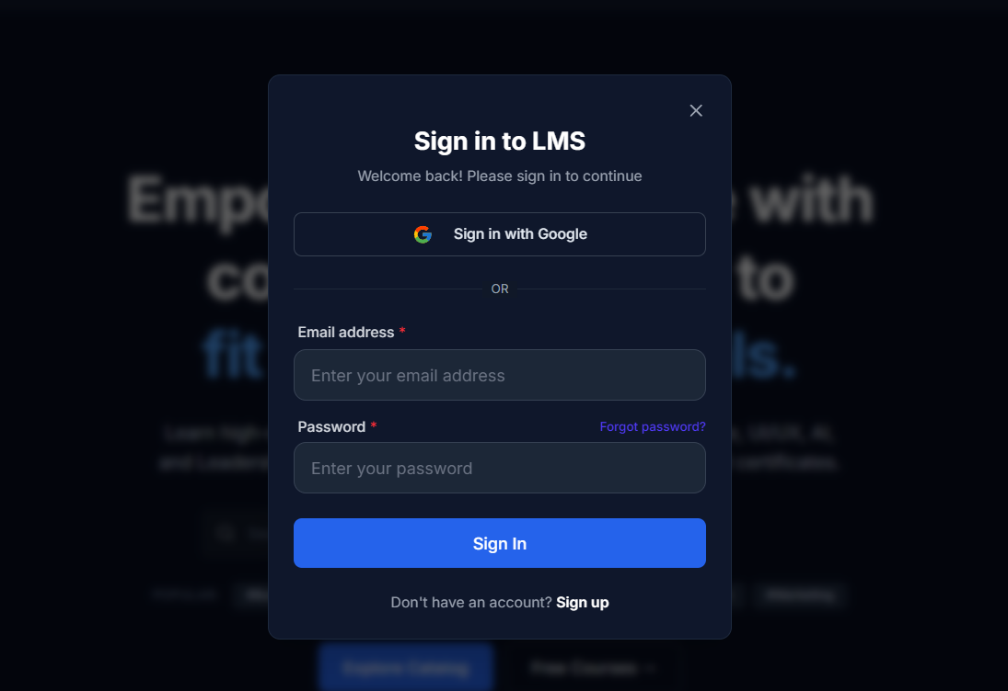
Figure 9.1: Login and Registration Interface

9.4 User Onboarding Interface
After authentication, users can complete the onboarding process required by the application.
The onboarding interface collects the information required to configure the user's account and provides an initial setup flow.
The interface is designed as a guided process rather than requiring the user to configure every profile setting manually at once.
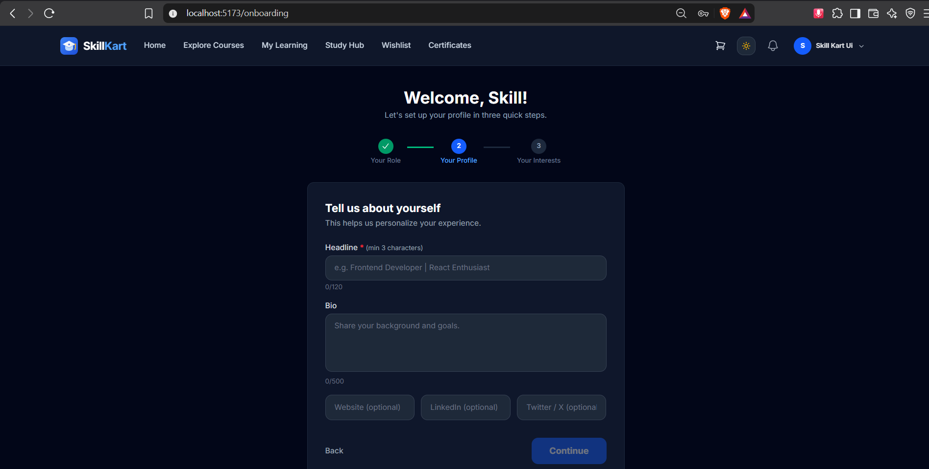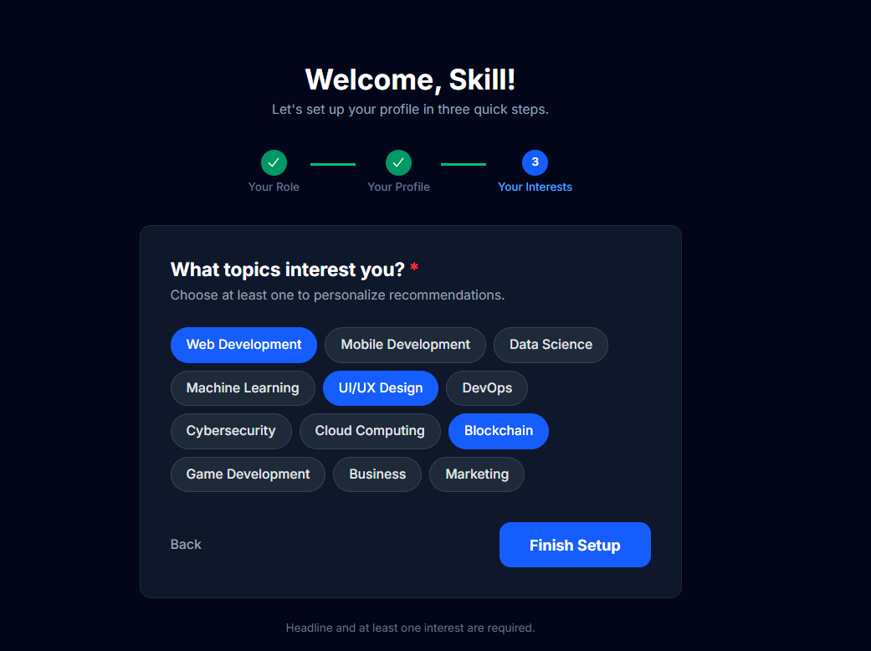
Figure 9.2: User Onboarding Interface

9.5 Home Page
The SkillKart home page acts as the main entry point for discovering the platform.
It provides access to course discovery and other major sections of the application.
The page can contain course-related information, navigation elements, recommendations, and links to relevant sections of the LMS.
The navigation presented to an authenticated user can vary according to the user's role.
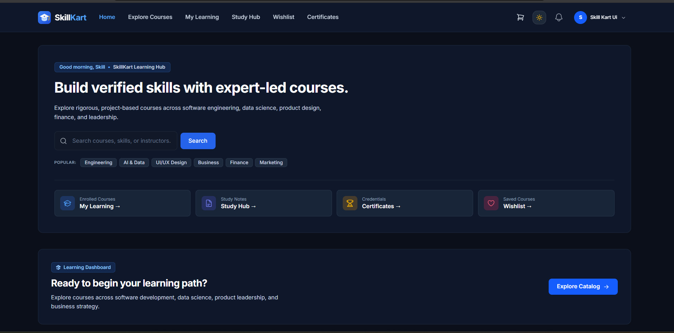
Figure 9.3: SkillKart Home Page

9.6 Course Catalog and Search Interface
The course catalog provides students with an organized view of available courses.
The interface supports course discovery through:
- Course listing
- Search
- Category-based filtering
- Course recommendations
- Course selection
Course cards provide important information that helps learners decide which course to inspect.
Selecting a course takes the user to the course details interface.
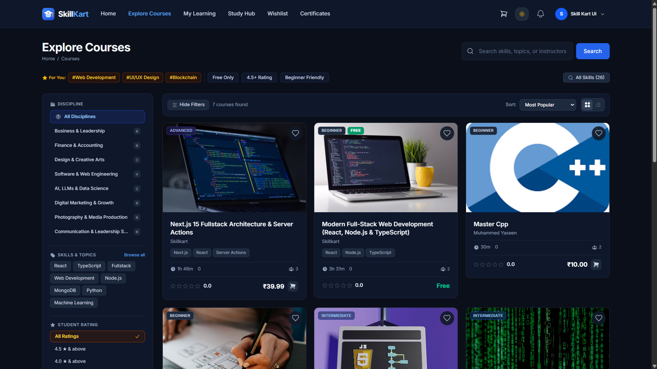
Figure 9.4: Course Catalog and Search Interface

9.7 Course Details Interface
The course details page presents detailed information about a selected course.
The interface can provide:
- Course title
- Course description
- Instructor information
- Course category
- Pricing
- Course structure
- Reviews and ratings
- Course FAQs
- Enrollment or purchase options
Students can also add a course to their wishlist or proceed toward purchasing the course.
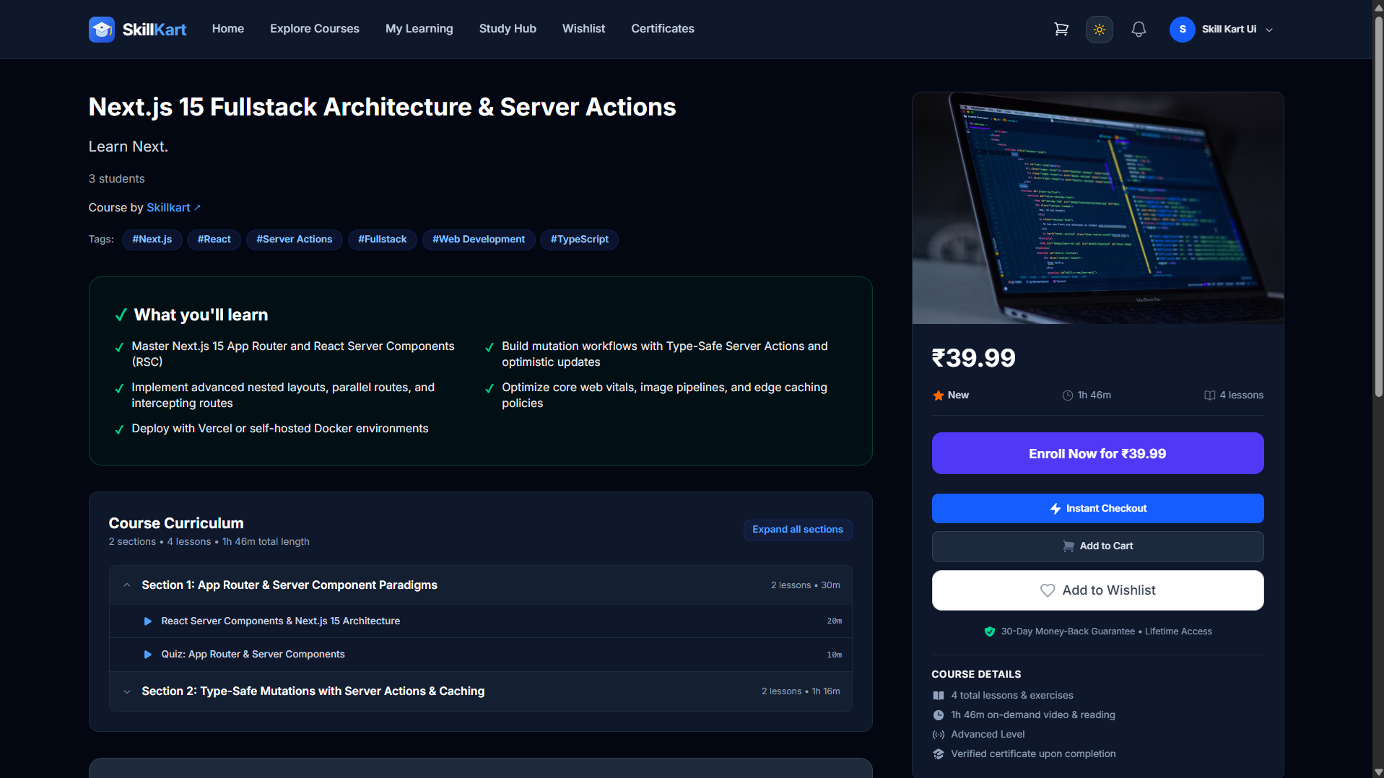
Figure 9.5: Course Details Interface

9.8 Cart and Checkout Interface
The shopping cart provides students with an intermediate step before purchasing courses.
Courses selected by the learner are displayed in the cart along with relevant purchase information.
The checkout interface provides the next stage of the purchasing process.
The workflow can be represented as:
Course Details → Cart → Checkout → Coupon → Payment → Order → Enrollment
The checkout interface allows users to review their selected courses and apply available coupons before continuing to payment.
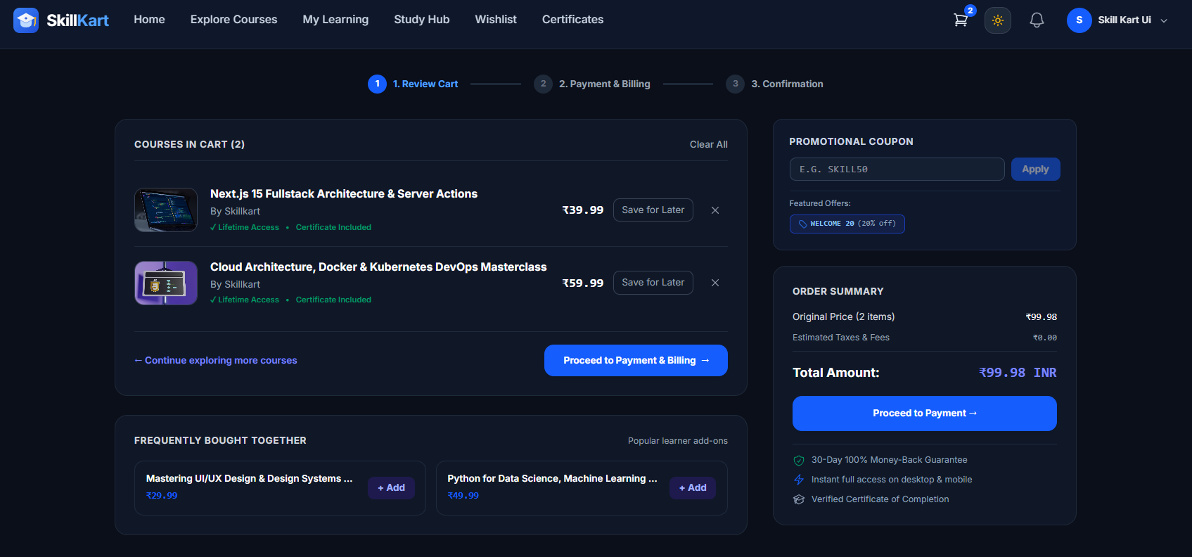
Figure 9.6: Cart and Checkout Interface

9.9 Payment Interface
The payment interface is part of the course purchasing workflow.
SkillKart integrates Razorpay for payment processing. The user is taken through the configured payment process after confirming the order.
The interface provides appropriate feedback for payment completion or failure.
After successful payment processing, the corresponding order is recorded and the learner can receive access to the purchased course according to the enrollment workflow.
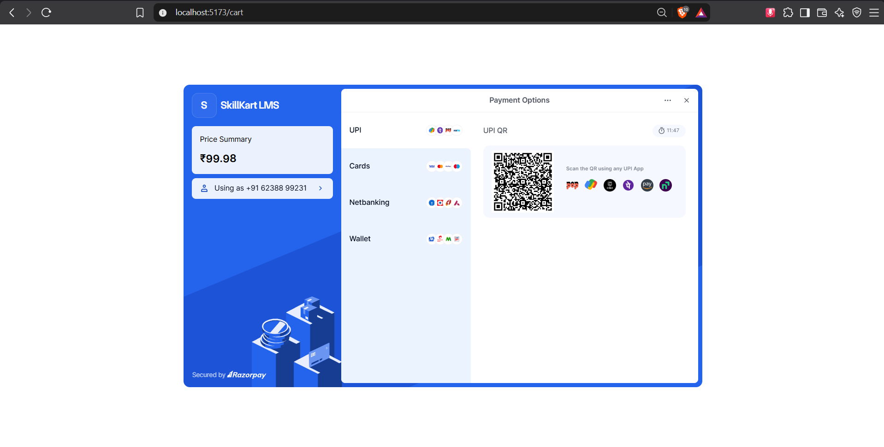
Figure 9.7: Payment Interface

9.11 My Courses Interface
The My Courses section displays courses in which the student is enrolled.
The interface allows learners to select a course and continue learning.
Course progress information can be displayed to help the learner understand their current position within the course.
The section separates purchased or enrolled learning content from courses that the learner has not yet acquired.
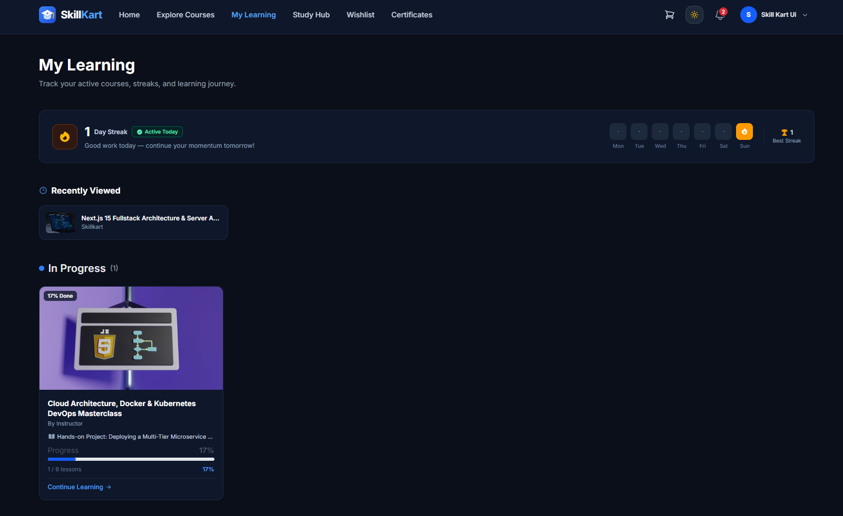
Figure 9.9: My Courses Interface

9.12 Lesson Viewer Interface
The lesson viewer is one of the main learning interfaces of SkillKart.
It provides access to the course curriculum and lesson content.
The interface can include:
- Course sections
- Lessons
- Lesson items
- Learning content
- Progress information
- Navigation between lessons
- Completion controls
The system checks the learner's access before providing protected course content.
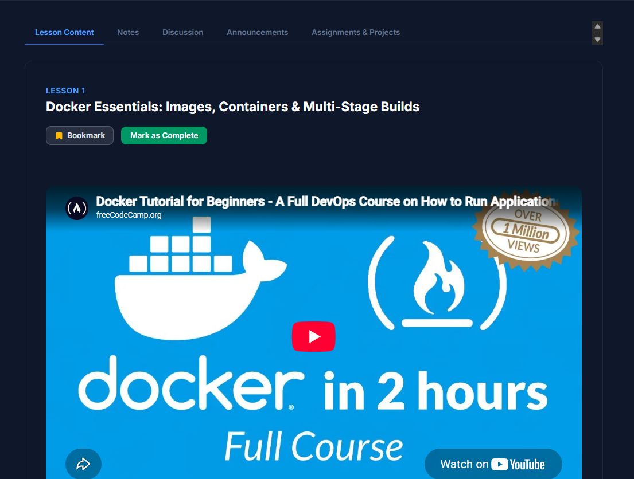
Figure 9.10: Lesson Viewer Interface

9.13 Learning Progress Interface
Learning progress is displayed as part of the learner's course experience.
The interface provides information about completed and incomplete learning activities.
Progress is calculated from the completed lessons recorded for the enrollment and the total number of lessons in the course.
For applicable video content, the system requires the configured minimum watch percentage before allowing completion. The current implementation uses an 80% watch threshold.
A completion cooldown and other learning conditions are also applied by the backend.
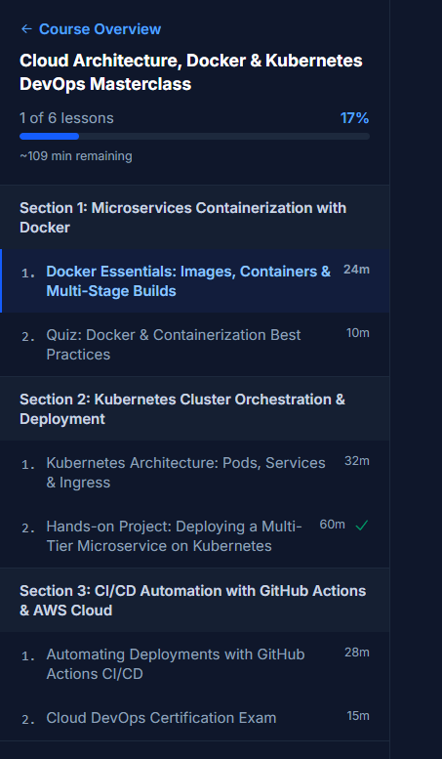
Figure 9.11: Learning Progress Interface

9.14 Quiz and Assessment Interface
The quiz interface allows students to attempt assessments associated with their courses.
The interface provides:
- Quiz questions
- Answer options
- Submission controls
- Result information
- Attempt-related feedback
Quiz attempts are recorded by the backend.
Where required, successful quiz completion can also be used as a condition for progressing through the learning content.
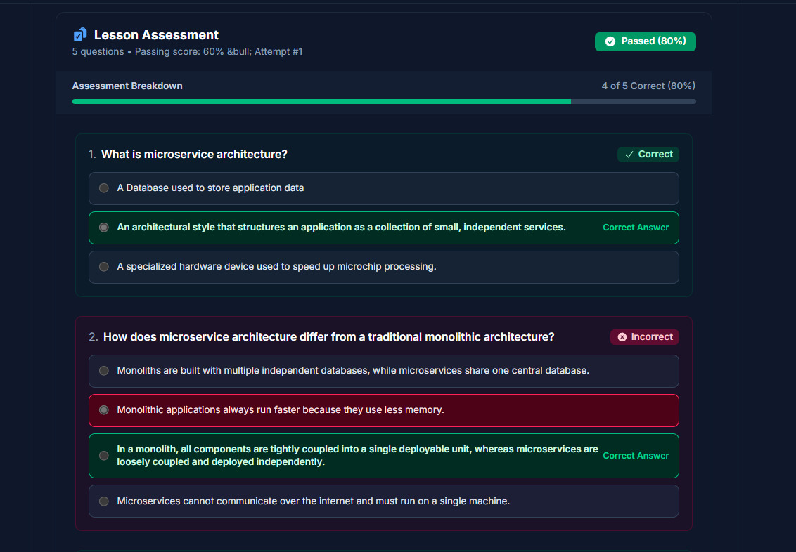
Figure 9.12: Quiz and Assessment Interface

9.15 Assignment Interface
Assignments provide another form of assessment within SkillKart.
The assignment interface allows learners to view assignment requirements and submit their work.
The submission is sent to the backend and recorded as an AssignmentSubmission.
The interface is designed to keep assignment information and submission actions together so that learners can easily understand the task and complete the required action.
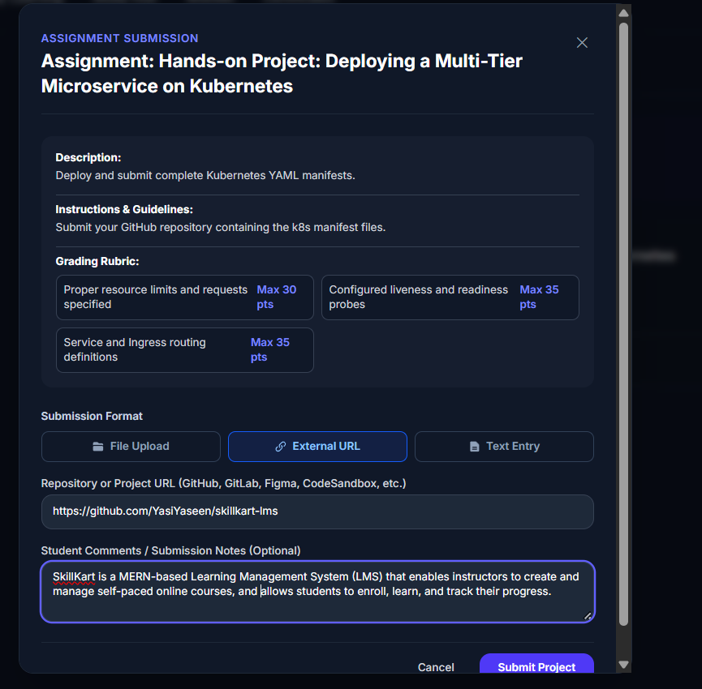
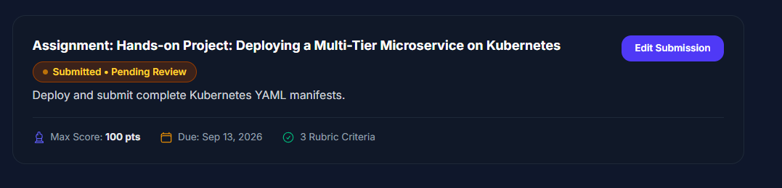
Figure 9.13: Assignment Interface

9.16 Reviews, Discussions and Learner Tools
SkillKart provides several interfaces that support learner engagement.

Reviews
Students can submit ratings and reviews for courses.

Discussions
Comments provide a mechanism for discussion around course-related content.

Notes
Students can create personal notes while learning.

Bookmarks
Important learning content can be bookmarked for later access.

Wishlist
Courses can be added to a personal wishlist for future consideration.

Learning Streak
The application also provides learning streak functionality to represent continued learning activity.
These features are integrated into the learner's overall course experience.
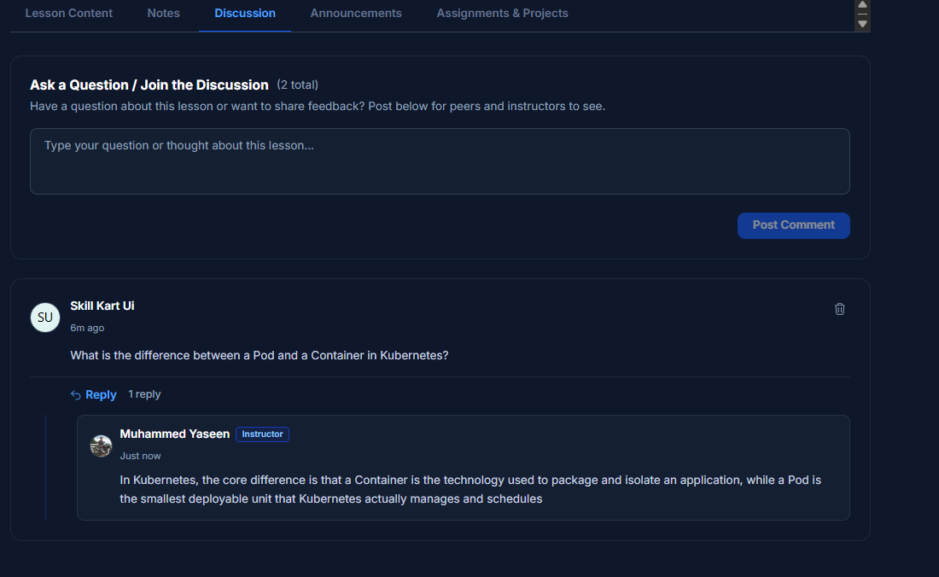
Figure 9.14: Learner Engagement Features

9.17 Certificate Interface
The certificate interface allows learners to view certificates issued after satisfying the required course completion conditions.
Certificate information is associated with the relevant course and learner.
The interface provides access to certificate-related information and supports the certificate verification workflow.
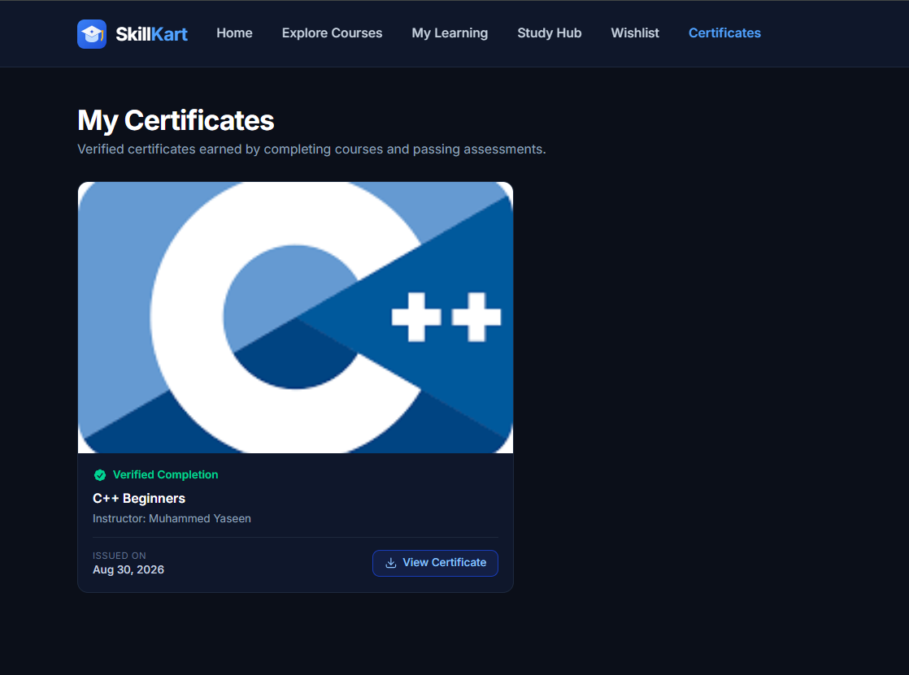
Figure 9.15: Certificate Interface

9.18 Certificate Verification Interface
SkillKart provides a separate certificate verification interface.
This allows certificate information to be checked without requiring the verifier to access the learner's complete account.
The verification interface can display the relevant certificate information and its current status.
Certificate status management also supports revocation-related functionality.
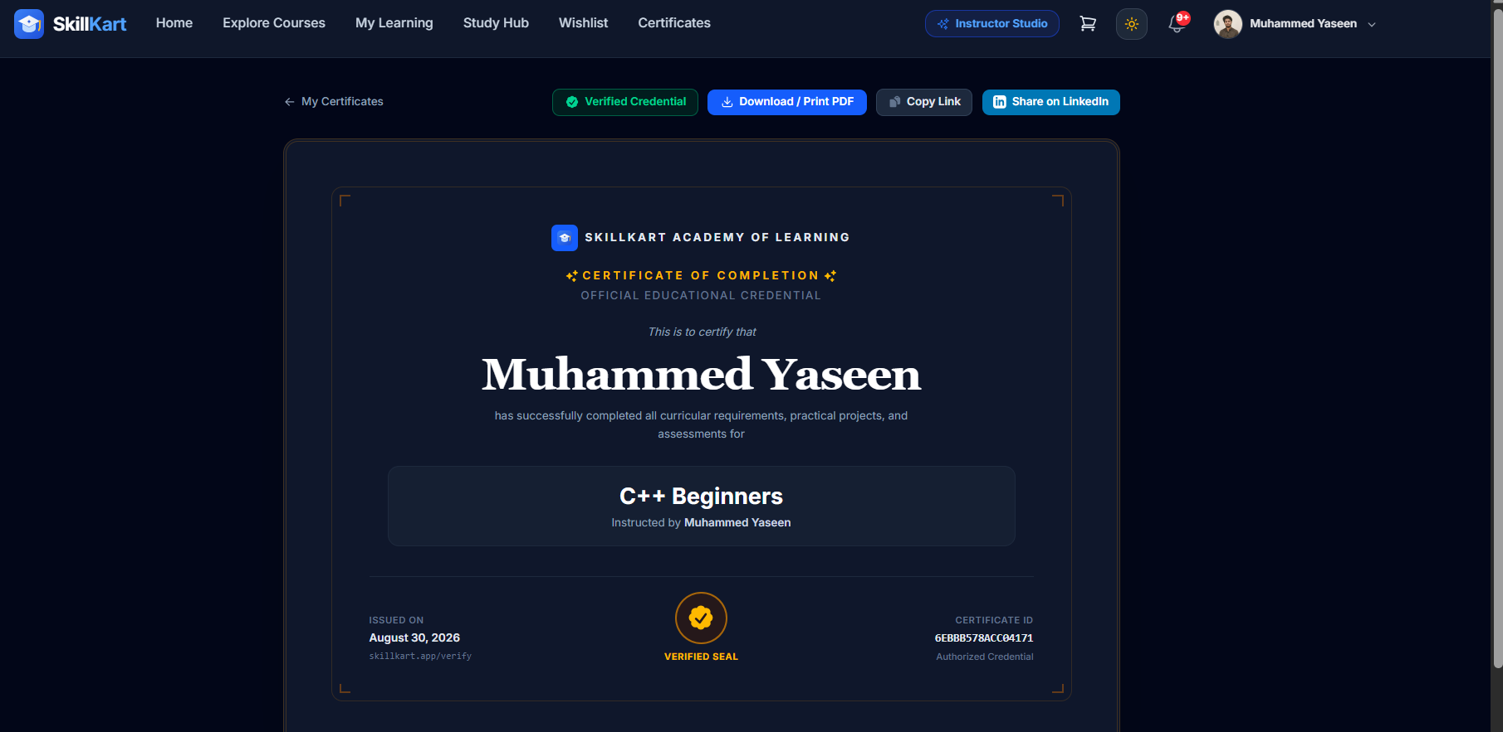
Figure 9.16: Certificate Verification Interface

9.19 Instructor Application and Profile Interface
Users who want to become instructors can access the instructor application workflow.
The application allows the user to provide the required information and submit the request.
Administrative functionality is used to review instructor applications.
Instructor profile functionality provides information about instructors and their associated courses.
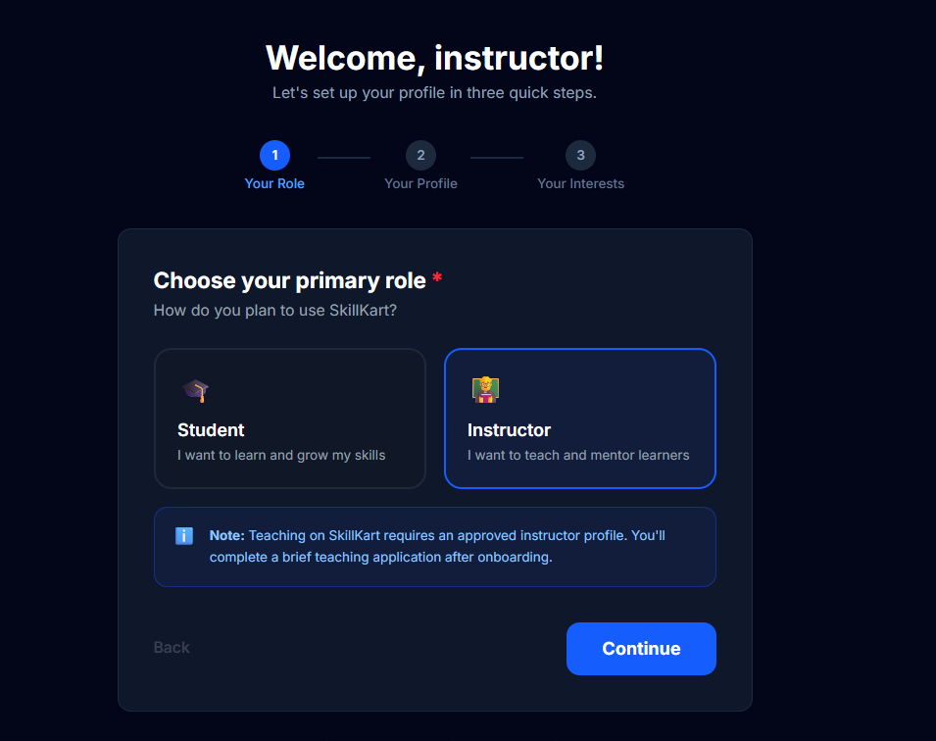
Figure 9.17: Instructor Application and Profile Interface

9.20 Instructor Dashboard
The instructor dashboard provides instructors with tools for managing their teaching activities.
The dashboard provides access to areas such as:
- Courses
- Learners
- Course analytics
- Earnings
- Payouts
- Announcements
- FAQs
- Instructor profile
The dashboard provides a centralized interface for managing the instructor's activities on the platform.
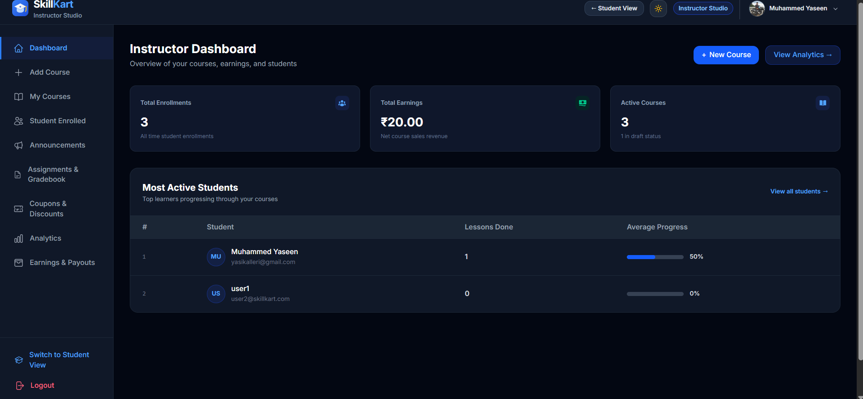
Figure 9.18: Instructor Dashboard

9.21 Course Creation and Editing Interface
Instructors can create and modify courses through the course management interface.
The interface allows instructors to enter course information and configure relevant properties.
Course creation includes information such as:
- Course title
- Description
- Category
- Pricing
- Course content
- Course structure
- The interface also supports editing existing course information.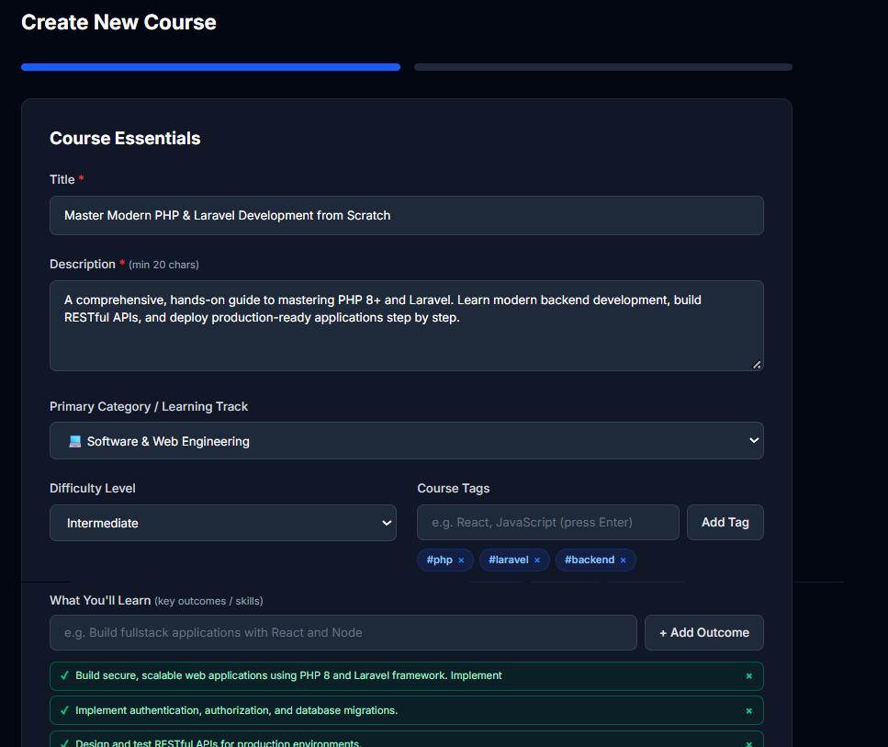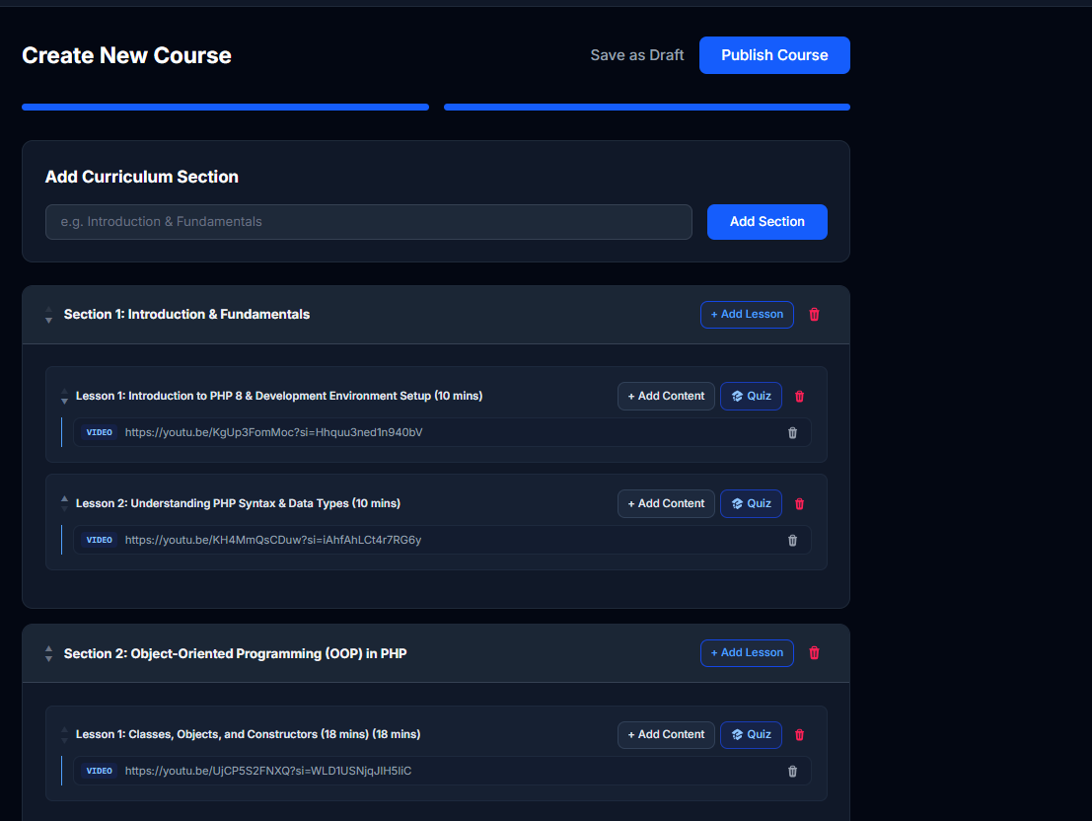
Figure 9.19: Course Creation and Editing Interface

9.22 Curriculum Management Interface
The curriculum management interface allows instructors to organize course content.
The course structure is divided into sections and lessons. Lesson items can be added as part of the learning content.
The interface also provides access to assessment-related content such as quizzes and assignments.
This provides instructors with a structured method of creating the learning sequence followed by students.
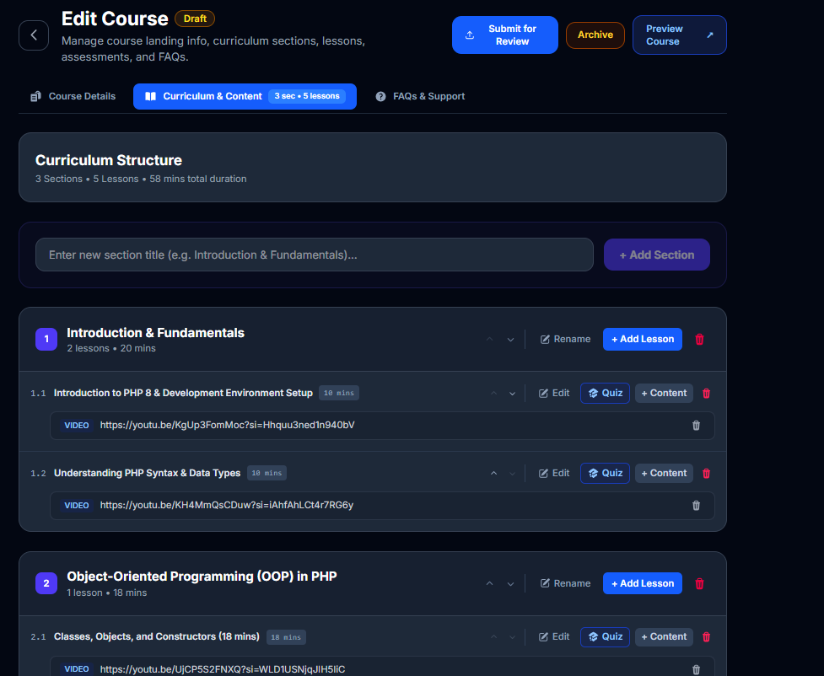
Figure 9.20: Curriculum Management Interface

9.23 Instructor Analytics and Earnings Interface
The instructor analytics interface provides information about course performance and learner activity.
The earnings section provides financial information associated with the instructor's courses.
Payout-related information is also presented through the instructor interface.
These features allow instructors to monitor both learning-related and financial aspects of their courses.
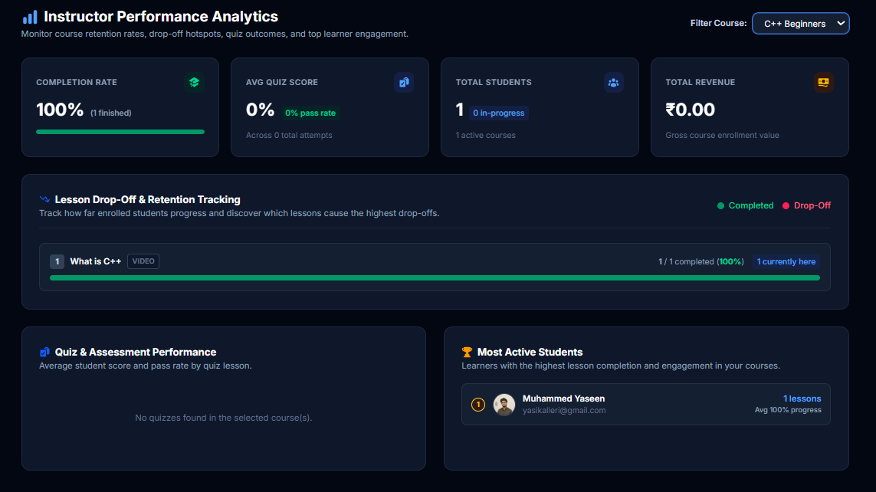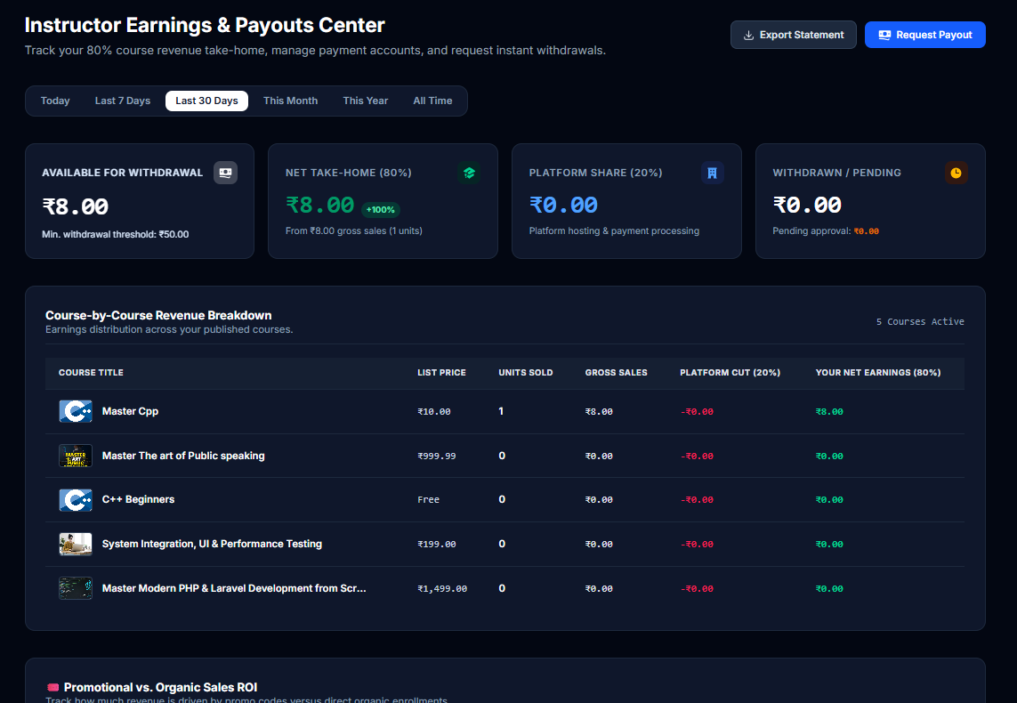
Figure 9.21: Instructor Analytics and Earnings Interface

9.24 Instructor Announcements and FAQ Interface
Instructors can manage course-related announcements and frequently asked questions.
Announcements provide a method for communicating relevant information to learners.
The FAQ interface allows instructors to provide answers to commonly asked questions about a course.
Both features reduce the need to repeat common information individually to learners.
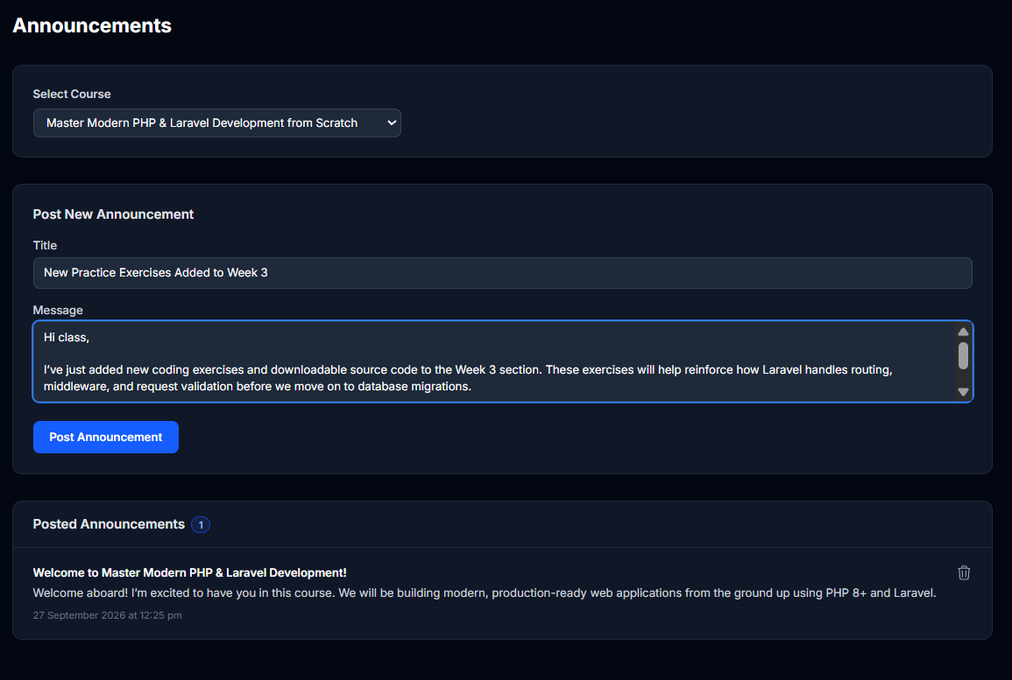
Figure 9.22: Instructor Announcements and FAQ Interface

9.25 Administrator Dashboard
The administrator dashboard provides an overview of the platform's administrative functionality.
Administrators can access management areas covering users, courses, commerce, instructors, payouts, reports, and system configuration.
The dashboard acts as the central entry point for administrative operations.
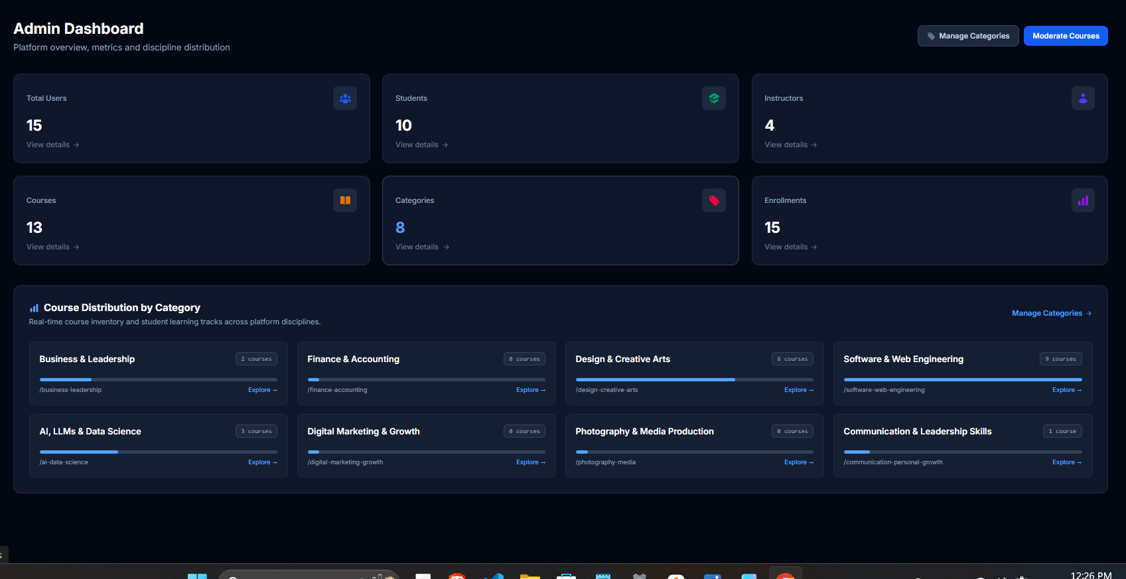
Figure 9.23: Administrator Dashboard

9.26 User and Course Management Interface
Administrators can manage users and courses through dedicated management interfaces.
User management includes operations related to platform accounts and roles.
Course management provides administrative control over courses and supports course moderation.
Administrators can review and manage course-related information before courses are made available to learners.
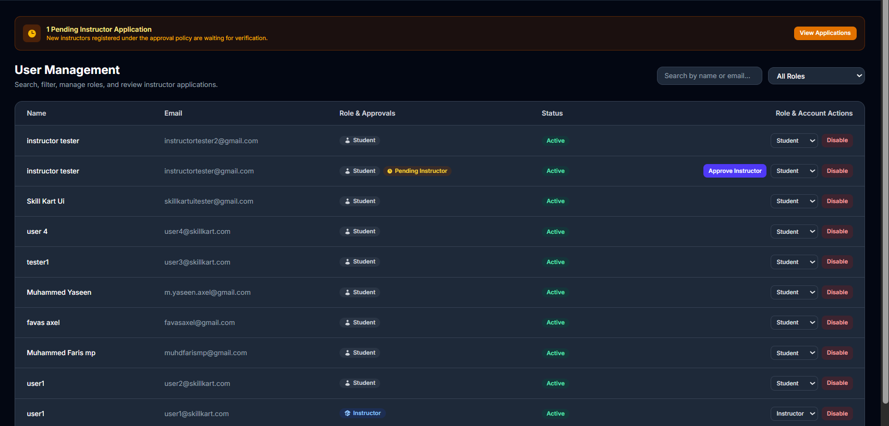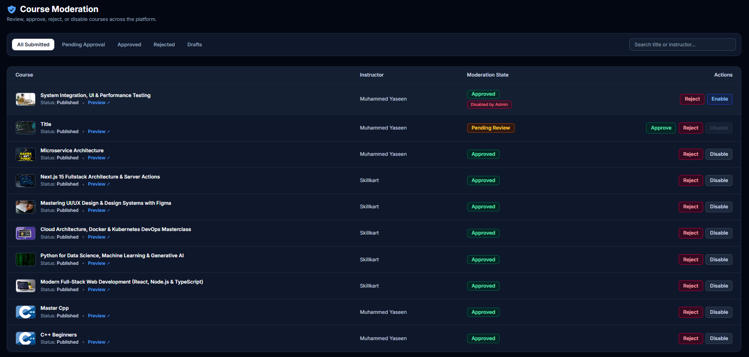
Figure 9.24: Administrator User and Course Management

9.27 Commerce and Financial Management Interface
The administrative interface provides management functionality for the platform's commerce operations.
The relevant areas include:
- Coupons
- Instructor payouts
- Financial reports (revenue, order details, and CSV export)
This provides administrators with a centralized view of the platform's commercial activities.
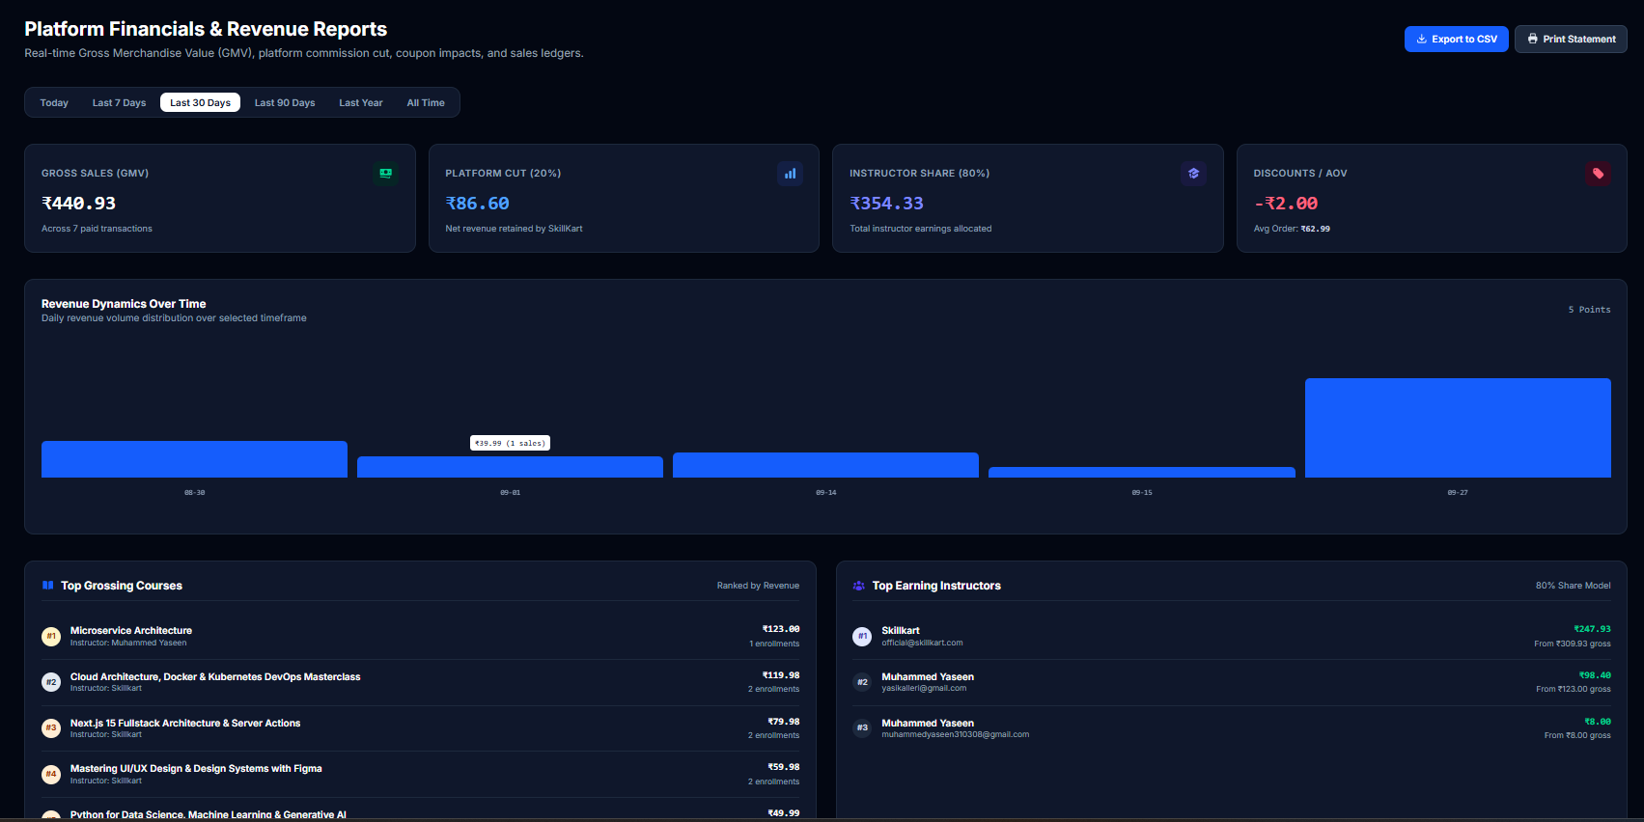
Figure 9.25: Commerce and Financial Management Interface

9.28 Audit Logs and System Settings Interface
Administrative operations that require traceability can be recorded through the audit logging functionality.
The system settings interface allows administrators to manage configurable system-level settings.
The administration section also supports maintenance-related controls.
These features provide administrators with greater control over the operation of the LMS.
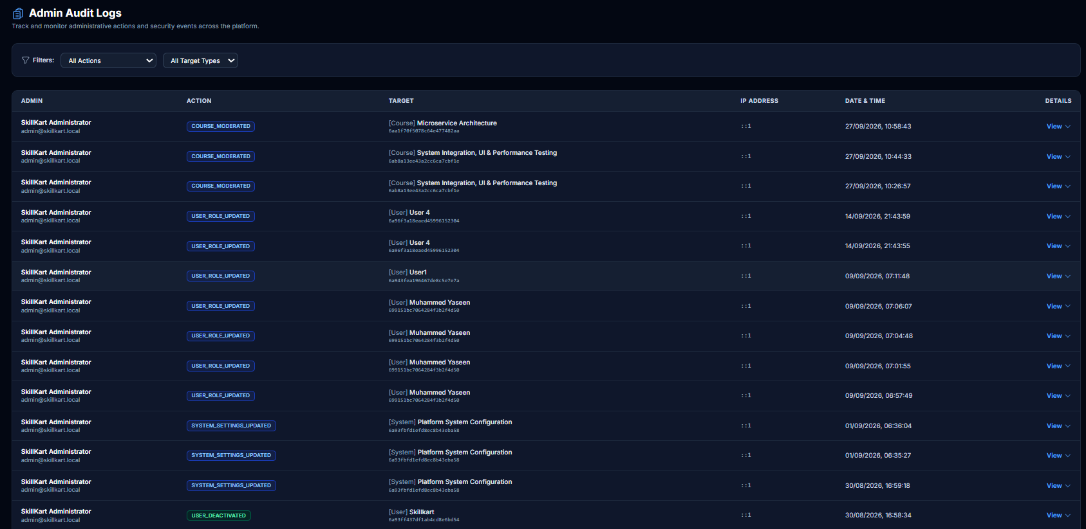
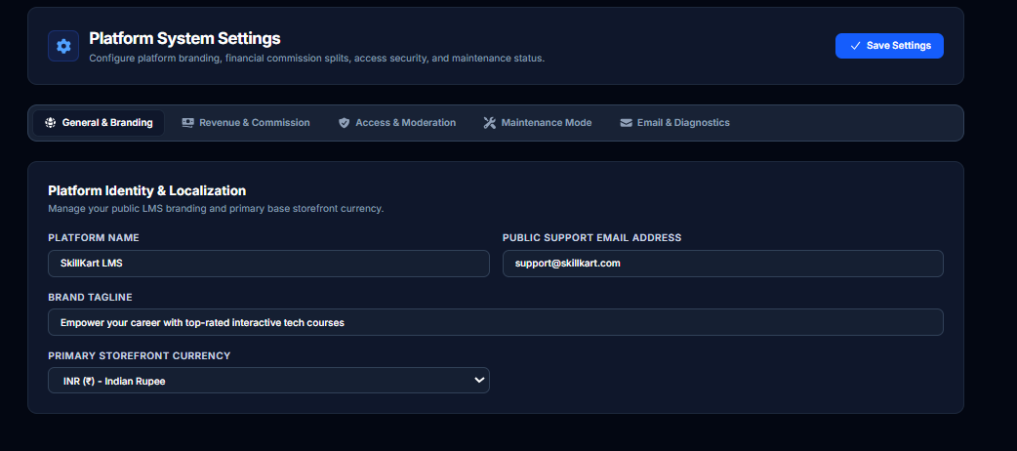
Figure 9.26: Audit Logs and System Settings Interface

9.29 Notification Interface
The notification interface displays notifications generated for the user.
Notifications can be related to different activities within the application.
The current implementation retrieves notifications through the application's HTTP API rather than using a WebSocket-based real-time communication system.
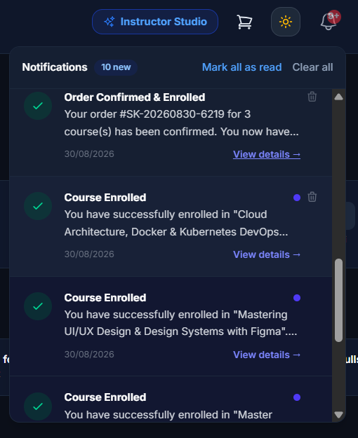
Figure 9.27: Notification Interface

9.30 Responsive Interface
The application uses responsive layouts so that the interface can adapt to different screen sizes.
Responsive behavior is particularly important for:
- Course browsing
- Student learning
- Dashboards
- Forms
- Course management
- Administrative interfaces
Tailwind CSS utility classes are used to implement responsive layouts throughout the React application.
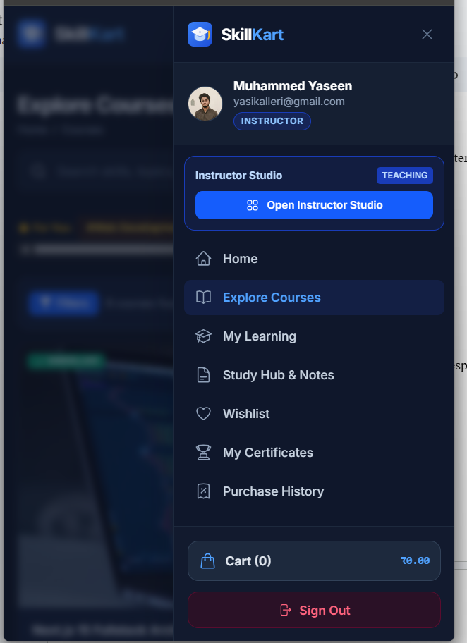
Figure 9.28: Responsive User Interface

9.31 UI Navigation Flow
The major student workflow can be summarized as:
Login/Registration → Onboarding → Home → Course Catalog → Course Details → Cart/Checkout → Payment → Enrollment → My Courses → Lesson Viewer → Assessment → Progress → Certificate
The instructor workflow can be summarized as:
Login → Instructor Application → Approval → Instructor Dashboard → Course Creation → Curriculum Management → Course Moderation → Learner Management → Analytics → Earnings/Payouts
The administrator workflow can be summarized as:
Login → Administrator Dashboard → User Management → Course Management → Commerce Management → Payouts → Reports → Audit Logs → System Settings
These workflows provide separate interfaces according to the responsibilities of each user role.

9.32 Chapter Summary
The SkillKart user interface provides role-specific functionality for students, instructors, and administrators.
Students can discover and purchase courses, access learning content, complete assessments, track progress, obtain certificates, and use additional learning tools. Instructors can create and manage courses, monitor learners, manage assessments, review analytics, and manage earnings and payouts. Administrators can manage users, courses, commerce operations, payouts, audit logs, and system settings.
The React, TypeScript, and Tailwind CSS implementation provides a consistent and responsive interface across these modules. The interface is connected to the backend through HTTP APIs, allowing user actions to be processed and persisted in the SkillKart database.

CHAPTER 10: TESTING

10.1 Introduction
Testing is an important stage in the development of the SkillKart Learning Management System. The purpose of testing is to verify that the implemented features operate according to the specified requirements and that different modules work correctly when used together.
Testing was performed across the major functional areas of the application, including authentication, user management, course management, enrollment, payments, learning, assessments, certificates, instructor functionality, and administration.
The testing process focused mainly on functional testing, integration testing, workflow testing, negative testing, and system-level validation. Since the current project does not contain a dedicated automated test suite, the results described in this chapter are based on manual execution and verification of application workflows.

10.2 Testing Objectives
The main objectives of testing were:
- To verify that the implemented functions work according to their requirements.
- To verify authentication and authorization.
- To verify role-based access control.
- To verify course creation and management.
- To verify course discovery and enrollment.
- To verify cart, checkout, coupon, and payment workflows.
- To verify learning and progress tracking.
- To verify quiz and assignment functionality.
- To verify certificate generation and verification.
- To verify instructor and administrative functionality.
- To verify file upload and storage functionality.
- To verify validation and error handling.
- To identify incorrect or unexpected application behavior.
- To ensure that different modules work together correctly.

10.3 Testing Strategy
The testing strategy was based on different levels of functional and workflow verification.

10.3.1 Functional Testing
Functional testing was used to verify individual application features.
Examples include:
- User registration
- User login
- Course creation
- Course search
- Course enrollment
- Coupon application
- Quiz submission
- Assignment submission
- Certificate verification

10.3.2 Integration Testing
Integration testing was used to verify communication between different application components.
Examples include:
- React frontend and Express backend communication
- Express backend and MongoDB
- Google OAuth authentication
- Razorpay payment integration
- Cloudflare R2 file storage
- Email service integration

10.3.3 Workflow Testing
Complete user workflows were tested from beginning to end.
For example, the course purchase workflow was tested as:
Course Discovery → Course Details → Cart → Checkout → Payment → Order → Enrollment → Course Access
The learning workflow was tested as:
Enrollment → Lesson Access → Progress → Assessment → Completion → Certificate

10.3.4 Negative Testing
Negative testing was performed by providing invalid or incomplete input and attempting operations without the required permissions.
Examples include:
- Invalid login credentials
- Missing required fields
- Invalid course information
- Unauthorized API requests
- Accessing another user's protected resources
- Invalid coupon information
- Attempting restricted course access
- Invalid assessment submissions

10.3.5 System Testing
System-level testing was used to verify the application as a complete LMS rather than testing individual functions in isolation.
This included testing the interaction between authentication, learning, commerce, assessment, certificate, instructor, and administration modules.

10.4 Testing Environment
Testing was performed using the development version of the SkillKart application.
The main environment consisted of:
Table 10.1: Testing Environment Configuration
Component | Technology
Frontend | React 19, TypeScript, Vite
Backend | Node.js, Express 5, TypeScript
Database | MongoDB
ODM | Mongoose
Browser | Modern web browser
Authentication | JWT and Google OAuth
Payment | Razorpay and simulated payment provider
File Storage | Local storage / Cloudflare R2
Email | SMTP-based email service
The application was tested using representative student, instructor, and administrator accounts.

10.5 Authentication Testing
Authentication was tested to verify that users can securely access the application.
Table 10.2: Authentication Test Cases and Results
Test ID | Test Case | Expected Result | Actual Result | Status
AUTH-01 | Register with valid information | Account is created successfully | [Enter value] | [Enter value]
AUTH-02 | Register with invalid or incomplete information | Validation error is displayed | [Enter value] | [Enter value]
AUTH-03 | Login with valid credentials | User is authenticated | [Enter value] | [Enter value]
AUTH-04 | Login with invalid credentials | Authentication fails with an appropriate error | [Enter value] | [Enter value]
AUTH-05 | Access protected resource without authentication | Access is denied | [Enter value] | [Enter value]
AUTH-06 | Login using Google OAuth | User is authenticated through Google | [Enter value] | [Enter value]
AUTH-07 | Access role-specific functionality using an unauthorized role | Access is denied | [Enter value] | [Enter value]
Authentication testing confirmed that protected resources require valid authentication and that role-specific operations are controlled by the backend.

10.6 User and Onboarding Testing
The onboarding and profile functionality was tested for different user scenarios.
The following operations were verified:
- New user onboarding
- Profile information submission
- Profile updates
- Authenticated profile access
- Role-specific profile behavior
- Instructor application submission
- Instructor application management
Invalid and incomplete information was also tested to verify that the application performs appropriate validation.

10.7 Role-Based Authorization Testing
Role-based access control was tested using student, instructor, and administrator accounts.
The purpose was to ensure that users could access only the operations permitted for their roles.
For example:
Table 10.3: Role-Based Access Control Test Cases and Results
Test ID | User Role | Example Operation | Expected Access | Actual Result | Status
RBAC-01 | Student | Browse courses | Allowed | [Enter value] | [Enter value]
RBAC-02 | Student | Access enrolled course | Allowed | [Enter value] | [Enter value]
RBAC-03 | Student | Manage another user's course | Denied | [Enter value] | [Enter value]
RBAC-04 | Instructor | Create course | Allowed after authorization | [Enter value] | [Enter value]
RBAC-05 | Instructor | Manage own course | Allowed | [Enter value] | [Enter value]
RBAC-06 | Instructor | Perform administrator operation | Denied | [Enter value] | [Enter value]
RBAC-07 | Administrator | Manage users | Allowed | [Enter value] | [Enter value]
RBAC-08 | Administrator | Manage courses | Allowed | [Enter value] | [Enter value]
RBAC-09 | Administrator | Manage system settings | Allowed | [Enter value] | [Enter value]
Backend authorization was specifically considered because frontend restrictions alone are not sufficient for protecting application resources.

10.8 Course Management Testing
Course management was tested using instructor and administrator accounts.
The following functions were verified:
- Course creation
- Course editing
- Category selection
- Course pricing
- Section creation
- Lesson creation
- Lesson item management
- Quiz creation
- Assignment creation
- FAQ management
- Announcement management
- Course moderation
The course management workflow was also checked to ensure that unauthorized users cannot modify protected course information.

10.9 Course Discovery and Enrollment Testing
Course discovery was tested from the student interface.
The following operations were verified:
- Course listing
- Course search
- Category filtering
- Course details
- Course recommendations
- Wishlist functionality
- Course access after enrollment
Enrollment was also checked against the user's purchase and access status.
The expected workflow was:
Browse Course → View Details → Purchase/Enroll → Enrollment Created → Course Available

10.10 Cart, Coupon and Payment Testing
The commerce workflow was tested as an integrated process.
The following operations were verified:
- Adding courses to the cart
- Removing courses from the cart
- Viewing cart contents
- Proceeding to checkout
- Applying valid coupons
- Rejecting invalid coupon conditions
- Creating an order
- Processing payment
- Handling payment success
- Handling payment failure
- Establishing enrollment after successful purchase
Both the implemented Razorpay payment workflow and the simulated payment provider were considered during development and testing.
The main workflow tested was:
Cart → Checkout → Coupon → Payment → Order → Enrollment

10.11 Learning and Progress Testing
The learning module was tested using enrolled student accounts.
The following functions were verified:
- Accessing enrolled courses
- Opening course sections
- Opening lessons
- Accessing lesson items
- Recording lesson progress
- Completing learning activities
- Viewing progress
- Moving between learning activities
Learning completion restrictions were also tested.
The implementation includes an 80% minimum video watch requirement for applicable video content. A 30-second cooldown is also applied to completion requests.
Where a quiz is required as a learning condition, the quiz pass requirement was also verified.
These tests were intended to ensure that progress records are not created simply by sending an unrestricted completion request.

10.12 Quiz Testing
Quiz functionality was tested through the learner interface.
The following cases were considered:
Table 10.4: Quiz Test Cases and Results
Test ID | Test Case | Expected Result | Actual Result | Status
QUIZ-01 | Open available quiz | Quiz is displayed | [Enter value] | [Enter value]
QUIZ-02 | Submit valid answers | Answers are processed | [Enter value] | [Enter value]
QUIZ-03 | Submit quiz | Result is calculated | [Enter value] | [Enter value]
QUIZ-04 | Pass quiz | Passing status is recorded | [Enter value] | [Enter value]
QUIZ-05 | Fail quiz | Failing result is recorded | [Enter value] | [Enter value]
QUIZ-06 | Attempt restricted quiz | Access follows configured course conditions | [Enter value] | [Enter value]
QUIZ-07 | Submit invalid request | Request is rejected | [Enter value] | [Enter value]
Quiz attempts were also checked to ensure that assessment activity is recorded correctly.

10.13 Assignment Testing
Assignment functionality was tested separately from quizzes.
The following operations were verified:
- Viewing an assignment
- Reading assignment requirements
- Submitting an assignment
- Recording a submission
- Handling invalid submission requests
- Restricting unauthorized access
The Assignment and AssignmentSubmission models were checked to ensure that assignment information and learner submissions are stored separately.

10.14 Certificate Testing
Certificate functionality was tested after completing the required learning conditions.
The following operations were verified:
- Meeting course completion requirements
- Certificate creation
- Certificate display
- Certificate verification
- Certificate status handling
- Certificate revocation-related functionality
The testing confirmed that certificate functionality is connected to the course completion workflow rather than being available without satisfying the required conditions.

10.15 Learner Engagement Testing
The additional learner features were tested as part of the student workflow.
The following features were verified:
- Reviews
- Ratings
- Comments
- Notes
- Bookmarks
- Wishlist
- Learning streaks
- Notifications
Each feature was checked for correct creation, retrieval, and access according to the user's permissions.
User-specific information was also checked to ensure that one learner cannot unintentionally access another learner's private records.

10.16 Instructor Functionality Testing
The instructor workflow was tested using an authorized instructor account.
The following functions were verified:
- Instructor dashboard
- Course creation
- Course editing
- Curriculum management
- Learner information
- Course analytics
- Earnings
- Payout information
- Announcements
- Course FAQs
- Instructor profile
Instructor-specific operations were also checked against authorization rules to ensure that instructors cannot perform administrative operations reserved for administrators.

10.17 Administrative Functionality Testing
Administrative functionality was tested using an administrator account.
The following areas were verified:
- User management
- Instructor management
- Course management
- Course moderation
- Category management
- Coupon management
- Payout management
- Financial reporting
- Audit logs
- System settings
- Maintenance controls
Unauthorized access to administrative routes was also tested using non-administrator accounts.

10.18 File Upload and Storage Testing
File upload functionality was tested using the application's upload workflow.
The testing covered:
- Uploading supported files
- Handling multipart requests
- Processing uploaded files
- Local storage during development
- Cloud storage integration
- Retrieving uploaded resources
- Handling invalid upload requests
Multer was verified as the upload processing layer, while Cloudflare R2 was considered for production-oriented object storage.

10.19 Notification and Email Testing
Notification and email functionality was tested separately.

In-App Notifications
Notification creation and retrieval were tested through the application's HTTP API.
The current system does not depend on WebSockets or Socket.IO for notification delivery. Notifications are retrieved through normal API requests.

Email
Email-related workflows were tested using the configured SMTP/email service.
The testing focused on:
- Email generation
- Recipient handling
- Successful sending
- Handling email service failures
Development email behavior was also supported through the configured development email environment.

10.20 Validation Testing
Validation was tested at both the API and database layers.
Zod validation was used to verify incoming request data before business logic execution.
Mongoose schema validation was used to verify data before persistence.
The following cases were tested:
- Required fields missing
- Invalid data types
- Invalid field values
- Incorrect identifiers
- Invalid request structures
- Duplicate records where uniqueness is required
Validation testing helped reduce the possibility of malformed data entering the application.

10.21 Error Handling Testing
Error handling was tested by deliberately creating invalid application conditions.
Examples include:
- Invalid authentication
- Unauthorized access
- Invalid request data
- Missing database records
- Invalid ObjectIds
- Payment failure
- External service failure
- Invalid file upload
- Invalid course access
- Invalid assessment requests
The expected behavior was that the backend should return an appropriate error response and that the frontend should present a suitable message to the user.
Internal implementation details should not be unnecessarily exposed through user-facing error messages.

10.22 Integration Testing
Integration testing was performed for the major external and internal integrations.
Table 10.5: External Service Integration Testing Summary
Integration | Testing Area
React ↔ Express | API communication
Express ↔ MongoDB | Data persistence and retrieval
Google OAuth ↔ Authentication | Social login
Razorpay ↔ Payment Service | Payment processing
Application ↔ Cloudflare R2 | File storage
Application ↔ SMTP | Email communication
The purpose was to verify that each external dependency works correctly with the relevant SkillKart module.

10.23 Regression Testing
Regression testing was performed after changes to major modules to verify that existing functionality continued to work.
Particular attention was given to features that are connected to multiple modules.
For example, changes to course or enrollment functionality can affect:
- Course access
- Learning progress
- Certificates
- Reviews
- Orders
- Instructor analytics
- Payout calculations
Similarly, changes to authentication and authorization can affect nearly every protected module.
Therefore, previously working workflows were rechecked after significant implementation changes.

10.24 Defect Identification and Correction
During development and testing, issues were identified through functional execution and workflow verification.
The general defect correction process was:
Identify Issue → Reproduce Issue → Determine Cause → Modify Implementation → Re-test → Verify Related Functionality
Defects were not considered resolved immediately after changing the source code. The affected workflow was tested again to ensure that the modification corrected the original problem without introducing an obvious regression.

10.25 Test Result Recording
Table 10.6 summarises the number of test cases executed in each area, together with the number that passed and failed.
Table 10.6: Overall Test Execution and Validation Summary
Testing Area | Test Cases | Passed | Failed | Remarks
Authentication | [Enter value] | [Enter value] | [Enter value] | [Remarks]
User Management | [Enter value] | [Enter value] | [Enter value] | [Remarks]
Course Management | [Enter value] | [Enter value] | [Enter value] | [Remarks]
Enrollment | [Enter value] | [Enter value] | [Enter value] | [Remarks]
Commerce and Payment | [Enter value] | [Enter value] | [Enter value] | [Remarks]
Learning and Progress | [Enter value] | [Enter value] | [Enter value] | [Remarks]
Assessments | [Enter value] | [Enter value] | [Enter value] | [Remarks]
Certificates | [Enter value] | [Enter value] | [Enter value] | [Remarks]
Instructor Module | [Enter value] | [Enter value] | [Enter value] | [Remarks]
Administration | [Enter value] | [Enter value] | [Enter value] | [Remarks]
Integrations | [Enter value] | [Enter value] | [Enter value] | [Remarks]

10.26 Testing Limitations
The testing process has some limitations.
First, the current implementation does not contain a dedicated automated unit or integration test suite. Therefore, the testing described in this chapter is primarily based on manual functional and workflow verification.
Second, large-scale load and stress testing was not performed as part of the project. Therefore, the results should not be interpreted as proof of performance under very high concurrent traffic.
Third, a professional penetration test or formal security audit was not performed.
Fourth, testing of external services such as payment gateways, email services, OAuth, and cloud storage depends partly on the availability and behavior of those external systems.
These limitations are considered when interpreting the testing results.

10.27 Testing Summary
Testing was performed across the major functional areas of the SkillKart Learning Management System.
Authentication, authorization, course management, discovery, enrollment, commerce, learning, assessments, certificates, learner engagement, instructor operations, administration, file storage, notifications, email, and external integrations were considered.
Functional, integration, workflow, negative, validation, regression, and system-level testing were used to identify incorrect behavior and verify the implemented workflows.
The testing process helped validate the interaction between the React frontend, Express backend, MongoDB database, and external services. Although the project does not currently include a dedicated automated test suite or large-scale load testing, manual verification of the major application workflows provided a basis for validating the implemented system.

CHAPTER 11: RESULTS AND DISCUSSION

11.1 Introduction
This chapter presents the results obtained from the development and testing of the SkillKart Learning Management System. The discussion focuses on the functionality implemented in the final system, the achievement of the project objectives, the observed behavior during testing, and the limitations identified during development.
The final implementation provides a complete learning platform covering student, instructor, and administrator workflows. In addition to the core learning features, the system includes course purchasing, assessments, certificates, learner engagement tools, instructor management, administrative controls, and integration with external services.
The results discussed in this chapter are based on the implemented application and the functional and workflow testing described in Chapter 10.

11.2 Implementation Outcome
The project resulted in the development of a full-stack web-based Learning Management System using React, TypeScript, Node.js, Express, and MongoDB.
The completed system provides separate functionality for three main user roles:
- Student
- Instructor
- Administrator
The implementation covers the complete learning lifecycle from account creation and course discovery to enrollment, learning, assessment, completion, and certification.
The system also includes supporting modules for commerce, communication, learner engagement, instructor management, and administration.
The final implementation therefore extends considerably beyond the basic LMS functionality described in the initial version of the project.

11.3 Functional Results
The major functional areas implemented in SkillKart are summarized below.
Table 11.1: Functional Implementation Results Summary
Functional Area | Result
User Registration and Authentication | Implemented
Google OAuth | Implemented
User Onboarding and Profiles | Implemented
Role-Based Access Control | Implemented
Instructor Application | Implemented
Course Creation and Management | Implemented
Course Moderation | Implemented
Course Search and Filtering | Implemented
Course Recommendations | Implemented
Enrollment | Implemented
Wishlist | Implemented
Cart | Implemented
Checkout | Implemented
Coupons | Implemented
Razorpay Payment | Implemented
Lesson Learning | Implemented
Progress Tracking | Implemented
Quiz Assessment | Implemented
Assignment Assessment | Implemented
Reviews and Ratings | Implemented
Discussions and Comments | Implemented
Notes and Bookmarks | Implemented
Learning Streaks | Implemented
Notifications | Implemented
Certificates | Implemented
Certificate Verification | Implemented
Instructor Analytics | Implemented
Instructor Earnings | Implemented
Instructor Payouts | Implemented
Announcements and FAQs | Implemented
Administrator Management | Implemented
Audit Logs | Implemented
System Settings | Implemented
Maintenance Controls | Implemented
File Upload and Storage | Implemented
Email Communication | Implemented
The table demonstrates that the final application contains functionality across the major areas identified during requirements analysis.

11.4 Achievement of Project Objectives
The project objectives defined during the initial stages of development were evaluated against the final implementation.

11.4.1 Course Discovery
The system allows students to browse, search, filter, and view courses.
Result: Achieved.

11.4.2 Secure Authentication
The application provides account registration, login, JWT-based authentication, and Google OAuth.
Result: Achieved.

11.4.3 Role-Based Access
The system provides separate capabilities for students, instructors, and administrators.
Result: Achieved.

11.4.4 Course Management
Authorized instructors can create and manage courses, curriculum, assessments, FAQs, and announcements.
Result: Achieved.

11.4.5 Course Purchasing and Enrollment
Students can add courses to a cart, proceed through checkout, apply coupons, make payments, and obtain course access.
Result: Achieved.

11.4.6 Learning and Progress Tracking
Students can access course lessons and track their learning progress.
Result: Achieved.

11.4.7 Assessment
The platform supports quizzes and assignments as part of the learning process.
Result: Achieved.

11.4.8 Certification
The system supports certificate generation, verification, and certificate status management.
Result: Achieved.

11.4.9 Learner Engagement
Reviews, comments, notes, bookmarks, wishlists, notifications, and learning streaks provide additional learner functionality.
Result: Achieved.

11.4.10 Instructor Management
The system provides instructor dashboards, analytics, earnings, and payout-related functionality.
Result: Achieved.

11.4.11 Administrative Management
Administrators can manage users, courses, categories, coupons, payouts, financial reports, audit logs, and system settings.
Result: Achieved.

11.5 Usability Observations
The implemented interface provides separate workflows based on the user's role.
For students, the main workflow moves from course discovery to course details, purchasing or enrollment, learning, assessment, and certification.
For instructors, the interface focuses on course creation, curriculum management, learner management, analytics, and earnings.
For administrators, the interface provides system-wide management functionality.
The use of React components and Tailwind CSS provides a consistent approach to the presentation of these different modules.
The responsive interface also allows the application to adapt to different screen sizes.
No formal usability survey was conducted as part of the project. Therefore, numerical usability or satisfaction scores are not presented.

11.6 Testing Results
The application was tested using functional, integration, workflow, negative, validation, regression, and system-level testing.
The testing covered:
- Authentication
- Authorization
- User onboarding
- Course management
- Course discovery
- Enrollment
- Cart and checkout
- Coupons
- Payment
- Learning
- Progress tracking
- Quizzes
- Assignments
- Certificates
- Learner engagement
- Instructor operations
- Administration
- File uploads
- Notifications
- Email
- External integrations
The testing process identified issues during development, which were corrected and subsequently re-tested.
The quantitative test summary is presented in Table 10.6.

11.7 Performance Observations
The application was observed during normal functional use to verify that the main workflows respond correctly.
The system separates frontend presentation from backend processing and database access. This structure allows individual parts of the application to be maintained and optimized independently.
MongoDB indexes are used for relevant lookup operations, while Mongoose provides structured access to database documents.
The application also separates external service functionality such as payment processing and file storage from the core application logic.
No formal large-scale performance benchmark or load test was conducted as part of the project. Therefore, specific response-time or concurrent-user claims are not made.

11.8 User Feedback
The system was developed and evaluated primarily through functional testing and iterative verification during implementation.
The interface and workflows were adjusted based on observations made during development and testing.
However, a formal user survey with a defined sample size and measurable satisfaction scale was not conducted as part of the project.
Therefore, the report does not present numerical user satisfaction results or claim statistical user acceptance.

11.9 Comparison with the Initial System Scope
The initial project scope focused primarily on the core LMS workflow involving users, courses, enrollment, learning content, quizzes, progress, reviews, certificates, and instructor management.
During implementation, the system was extended with additional functionality.
The final system includes:
- Course purchasing
- Razorpay payment processing
- Shopping cart
- Coupons
- Wishlist
- Assignments
- Discussions
- Notes
- Bookmarks
- Learning streaks
- Instructor applications
- Course moderation
- Instructor analytics
- Instructor earnings
- Instructor payouts
- Announcements
- FAQs
- Certificate verification
- Certificate revocation-related functionality
- Administrative management
- Audit logs
- System settings
- Maintenance controls
- Cloud file storage
These additions expanded the project from a basic learning management application into a more complete platform covering learning, commerce, administration, and instructor operations.

11.10 Major Achievements
The major achievements of the project include the following.

11.10.1 Full-Stack Implementation
A complete frontend and backend application was developed using React, TypeScript, Node.js, Express, and MongoDB.

11.10.2 Multi-Role Platform
The system supports separate workflows for students, instructors, and administrators.

11.10.3 Complete Learning Workflow
The application supports course discovery, enrollment, learning, progress tracking, assessments, and certificates.

11.10.4 Integrated Commerce
The application includes cart, checkout, coupons, orders, and Razorpay payment processing.

11.10.5 Expanded Learner Features
Learners have access to reviews, discussions, notes, bookmarks, wishlists, notifications, and learning streaks.

11.10.6 Instructor Management
The system provides course management, analytics, earnings, and payout functionality for instructors.

11.10.7 Administrative Controls
Administrative functionality covers users, courses, commerce, payouts, reporting, audit logs, and system configuration.

11.10.8 External Service Integration
The system integrates Google OAuth, Razorpay, Cloudflare R2, and email services.

11.10.9 Learning Integrity Controls
The application applies completion conditions such as video watch requirements, completion cooldowns, quiz-based learning gates, and a certificate time lock that delays public verification when a course is completed unusually quickly.

11.11 Technical Challenges
Several technical challenges were encountered during implementation.

11.11.1 Managing Multiple User Roles
The system requires different permissions and workflows for students, instructors, and administrators.
This was addressed through authentication middleware, role-based authorization, protected frontend routes, and business-level permission checks.

11.11.2 Managing Course Structure
A course contains multiple sections, lessons, and lesson items, along with assessments and supporting information.
Separating these entities into appropriate Mongoose models helped keep the course structure manageable.

11.11.3 Maintaining Learning Progress
Learning progress must remain consistent with actual learner activity.
Completion conditions, video watch thresholds, cooldowns, and quiz requirements were therefore incorporated into the learning workflow.

11.11.4 Payment Integration
Payment processing introduces additional states and external dependencies.
The payment service was separated from the core business logic and implemented using a provider-based structure.

11.11.5 File Storage
Learning platforms can require storage for uploaded files.
The application uses Multer for upload processing and supports local storage during development and Cloudflare R2 for production-oriented object storage.

11.11.6 Administrative Complexity
As the application expanded, administrative functionality had to cover multiple independent areas such as users, courses, coupons, payouts, reports, audit logs, and system settings.
Separating these functions into dedicated modules helped maintain the overall organization of the system.

11.12 Technical and Practical Implications
The implementation demonstrates how a modern web technology stack can be used to develop an integrated learning platform.
From a technical perspective, the project demonstrates:
- React-based frontend development
- TypeScript-based application development
- REST API communication
- Node.js and Express backend development
- MongoDB document-based data management
- Authentication and authorization
- External API integration
- Payment processing
- Cloud object storage
- Request validation
- Role-based application design
From a practical perspective, the system brings learning, course management, assessment, purchasing, certification, and administration into a single platform.

11.13 Scalability Considerations
The system has been structured so that different application responsibilities are separated between the frontend, backend, database, and external services.
The React frontend communicates with the backend through APIs, while the backend accesses MongoDB through Mongoose.
The use of MongoDB allows the application to work with document-oriented data and provides indexing capabilities for frequently queried information.
External services such as payment processing and object storage are separated from the main application logic.
These design decisions provide a foundation for future scaling. However, large-scale performance and load characteristics were not formally measured as part of this project.

11.14 Security Results
Security was considered across the major application layers.
The implementation includes:
- JWT-based authentication
- Password hashing
- Google OAuth
- Role-based authorization
- Protected API routes
- Protected frontend routes
- Request validation
- Database schema validation
- Enrollment-based access control
- Ownership and permission checks
- Controlled file uploads
- Payment service integration
- Learning completion controls
The combination of these mechanisms provides multiple layers of protection around the application's main workflows.
A professional penetration test or formal security audit was not performed, so the results should not be interpreted as a complete security certification.

11.15 Deviations from the Initial Implementation Plan
The final implementation contains several additions compared with the initial project scope.
The original system was primarily focused on the core LMS functions. During development, additional requirements and useful features were introduced.
The major additions include:
- E-commerce functionality
- Payment integration
- Coupons
- Assignments
- Learner engagement features
- Instructor applications
- Course moderation
- Instructor analytics
- Earnings and payouts
- Administrative management
- Audit logging
- System settings
- Cloud file storage
- Additional communication features
The project also adopted a TypeScript-based implementation across the frontend and backend, providing stronger type checking than a purely JavaScript-based implementation.
These changes increased the scope of the final application but remained consistent with the overall objective of developing a comprehensive LMS.

11.16 Discussion
The final implementation demonstrates that the original LMS requirements can be combined with additional commerce, assessment, instructor, and administrative functionality within a single web application.
The student workflow covers the complete learning journey from discovering a course to completing the course and obtaining a certificate.
The instructor workflow provides tools for creating and managing learning content and monitoring course-related activity.
The administrator workflow provides centralized management of the platform and its supporting operations.
The use of separate modules and services also helps keep the implementation organized as the number of features increases.
At the same time, the project has practical limitations. The current system has not undergone large-scale load testing, formal penetration testing, or extensive real-world user evaluation. These areas would require additional work before making conclusions about production-scale performance or security.

11.17 Limitations
The major limitations identified in the final system are:
1. A dedicated automated unit and integration test suite has not been implemented.
2. Large-scale load and stress testing has not been performed.
3. Formal penetration testing has not been conducted.
4. Production-grade monitoring and disaster recovery mechanisms are outside the scope of the project.
5. The current notification implementation does not provide WebSocket-based real-time communication.
6. A native mobile application has not been developed.
7. Some advanced analytics capabilities can be expanded further.
8. Advanced AI-powered personalization and recommendations can be developed further.
9. The availability and behavior of external services can affect corresponding application features.
10. Multi-step operations such as checkout are performed as sequential database operations without multi-document transactions, so a failure part-way through is not automatically rolled back.
11. There is no application-level caching, and the course listing returns all matching courses in a single response without pagination.
12. Rating and duration filters in course search are applied after the database query, one course at a time, which would not scale to a very large catalogue.
13. Financial reports are aggregated in application memory rather than with database aggregation pipelines.
14. Course search uses regular-expression matching even though a MongoDB text index is defined.
15. The authentication token is stored in the browser's local storage and remains valid for seven days.
16. Some settings, such as email verification, enrollment expiry, and section locking, are stored in the data model but are not enforced by the current application logic.
17. Payment methods other than Razorpay and the simulated provider are defined in the data model but have no provider implementation.
These limitations define areas that can be addressed in future versions.

11.18 Summary
The SkillKart Learning Management System successfully implements the major objectives defined for the project.
The final application provides a multi-role LMS supporting students, instructors, and administrators. It combines course discovery, purchasing, enrollment, learning, assessment, progress tracking, certification, learner engagement, instructor management, and administration within one platform.
Functional and workflow testing was performed across the major modules, while integration testing was used for important internal and external components.
The project also demonstrates the practical application of modern web development technologies including React, TypeScript, Node.js, Express, MongoDB, Mongoose, REST APIs, JWT authentication, OAuth, payment integration, and cloud object storage.
Although further work is required in areas such as automated testing, large-scale performance testing, formal security assessment, real-time communication, and advanced platform capabilities, the completed implementation provides the intended functionality of the SkillKart LMS and establishes a foundation for future development.

CHAPTER 12: CONCLUSION AND FUTURE SCOPE

12.1 Introduction
The SkillKart Learning Management System was developed to provide a centralized platform for online learning, course management, assessment, certification, and related educational activities.
The final system supports three major user roles: students, instructors, and administrators. The application combines learning functionality with course purchasing, learner engagement, instructor management, and administrative operations.
This chapter summarizes the work completed, the contribution of the project, its limitations, and possible areas for future development.

12.2 Conclusion
SkillKart provides an integrated web-based environment for managing the different stages of an online learning process.
Students can register, complete onboarding, discover courses, purchase courses, access learning content, track progress, complete quizzes and assignments, participate in discussions, maintain notes and bookmarks, and receive certificates after satisfying the required completion conditions.
Instructors can apply for instructor access, create and manage courses, organize curriculum, create assessments, communicate with learners, view analytics, manage earnings, and access payout-related information.
Administrators can manage users, instructors, courses, categories, coupons, payouts, audit logs, and system settings, and can view financial reports.
The system was implemented using React, TypeScript, Node.js, Express, MongoDB, and Mongoose. Additional services such as Google OAuth, Razorpay, Cloudflare R2, and email services were integrated to support authentication, payment, file storage, and communication requirements.
The project therefore demonstrates the development of a complete full-stack LMS rather than a collection of isolated learning features.

12.3 Contributions of the Project
The major contributions of the SkillKart project are as follows.

12.3.1 Centralized Learning Platform
The system brings course discovery, learning, assessment, progress tracking, and certification into a single application.

12.3.2 Multi-Role Architecture
Separate workflows were implemented for students, instructors, and administrators.

12.3.3 Integrated Course Commerce
The application supports cart management, checkout, coupons, orders, and Razorpay payment processing.

12.3.4 Structured Learning and Assessment
The system supports courses, sections, lessons, lesson items, quizzes, assignments, and progress tracking.

12.3.5 Learner Engagement
Features such as reviews, comments, notes, bookmarks, wishlists, notifications, and learning streaks provide additional support for learners.

12.3.6 Instructor Management
The system provides instructor applications, course management, analytics, earnings, and payout-related functionality.

12.3.7 Administrative Management
Administrative functionality provides centralized control over users, courses, coupons, payouts, financial reports, audit logs, and system settings.

12.3.8 External Service Integration
The project demonstrates integration with authentication, payment, cloud storage, and email services.

12.4 Limitations
Although the implemented system provides the major functionality required for the project, several limitations remain.

12.4.1 Automated Testing
The current project does not contain a comprehensive automated unit and integration testing suite. Testing was primarily performed through manual functional, integration, workflow, and system-level verification.

12.4.2 Large-Scale Performance Testing
The system has not been subjected to extensive load or stress testing. Therefore, its behavior under very high levels of concurrent traffic has not been formally measured.

12.4.3 Production Monitoring
Advanced production monitoring, centralized observability, automated incident handling, and comprehensive disaster recovery are outside the scope of the current project.

12.4.4 Security Assessment
The application implements several security mechanisms, but a professional penetration test or formal security audit has not been conducted.

12.4.5 Real-Time Communication
The current notification functionality uses HTTP-based communication rather than a real-time WebSocket-based communication system.

12.4.6 Mobile Application
The current project is implemented as a web application. A dedicated native or cross-platform mobile application has not been developed.

12.4.7 Advanced AI Features
The current implementation does not provide a comprehensive AI-based personalization or recommendation system. More advanced AI capabilities could be introduced in future versions.

12.4.8 Implementation Limitations
The current implementation also has the technical limitations listed in Section 11.17, including the absence of database transactions for multi-step operations, the lack of caching and pagination for the course listing, and the storage of the authentication token in browser local storage. These are candidates for the improvements described in Section 12.5.9.

12.5 Future Scope
Several areas can be considered for future development.

12.5.1 Advanced Payment Capabilities
The payment module can be expanded to support additional payment providers, refunds, subscription-based courses, recurring payments, and more detailed transaction management.

12.5.2 Advanced Analytics
The existing analytics functionality can be extended with more detailed learner and instructor analytics.
Possible additions include:
- Learning behavior analysis
- Course completion trends
- Learner retention analysis
- Revenue forecasting
- Course performance comparisons
- Advanced administrative dashboards

12.5.3 Richer Assessment System
The assessment module can be expanded with additional question types and more advanced evaluation mechanisms.
Possible features include:
- Coding assessments
- Practical assignments
- Question banks
- Randomized questions
- Timed examinations
- Detailed assessment analytics
- Automated grading for additional assessment types

12.5.4 Live Classes
Live teaching functionality can be added to support instructor-led learning.
This could include:
- Live video classes
- Screen sharing
- Live chat
- Attendance tracking
- Recorded sessions
- Scheduled classes
This would extend the platform from primarily self-paced learning to a combination of self-paced and instructor-led education.

12.5.5 Real-Time Communication
The current HTTP-based notification mechanism could be extended using WebSocket-based communication.
This could support:
- Real-time notifications
- Instructor-student messaging
- Live discussions
- Real-time announcements
- Online presence indicators

12.5.6 Advanced Recommendation System
The course recommendation functionality can be expanded into a more sophisticated recommendation system.
Future versions could consider:
- Previous learning activity
- Course completion history
- User interests
- Search behavior
- Course ratings
- Similar learner behavior
Machine learning techniques could be used to improve the personalization of course recommendations.

12.5.7 Advanced AI-Assisted Learning
AI capabilities could be introduced to provide additional learning assistance.
Possible applications include:
- AI-based learning assistants
- Personalized study plans
- Automated question generation
- Course content summarization
- Intelligent tutoring
- Learner progress analysis
- Personalized explanations
Such features would require appropriate AI models, data handling, evaluation, and safeguards.

12.5.8 Mobile Application
A dedicated mobile application could be developed using a cross-platform framework such as React Native or Flutter.
The mobile application could provide:
- Course access
- Video learning
- Progress tracking
- Notifications
- Assessments
- Certificates
- Offline learning support

12.5.9 Cloud Scalability
The application can be further adapted for larger-scale deployment.
Possible improvements include:
- Horizontal application scaling
- Load balancing
- Dedicated caching
- Background job processing
- Centralized logging
- Automated deployment
- Enhanced monitoring
- Database performance optimization
These improvements would become more important as the number of users and courses increases.

12.5.10 Advanced Administration and Reporting
The administration module can be extended with more advanced reporting and management capabilities.
Future functionality could include:
- Custom report generation
- Scheduled reports
- More detailed financial analytics
- Automated compliance reports
- Advanced audit analysis
- Configurable dashboards

12.6 Overall Conclusion
The SkillKart project successfully resulted in the development of a full-stack Learning Management System that combines online learning, course management, assessment, certification, commerce, instructor operations, and administration within a single platform.
The project demonstrates the practical application of modern web development technologies including React, TypeScript, Node.js, Express, MongoDB, Mongoose, REST APIs, JWT authentication, OAuth, payment integration, cloud object storage, and email communication.
The final system provides separate workflows for students, instructors, and administrators and implements the major requirements identified during the project.
Although there are opportunities for further development in areas such as automated testing, large-scale deployment, real-time communication, mobile applications, advanced analytics, and AI-assisted learning, the current implementation establishes a functional foundation that can be extended as the requirements of the platform grow.
Overall, the project demonstrates the design and implementation of a complete web-based LMS and provides practical experience in full-stack development, database design, API development, authentication, third-party service integration, testing, and system management.

REFERENCES

Books and Documentation
- MongoDB Inc., MongoDB Documentation.
- Mongoose ODM, Mongoose Documentation.
- OpenJS Foundation, Node.js Documentation.
- OpenJS Foundation, Express.js Documentation.
- React Team, React Documentation.
- Microsoft, TypeScript Documentation.
- Vite Team, Vite Documentation.
- Axios, Axios Documentation.
- Auth0, JSON Web Token Introduction and Documentation.
- Zod, Zod Documentation.

Additional References
- Mozilla Developer Network (MDN), Web Development Documentation and References.
- W3C, HTML and Web Standards Documentation.
W3C, CSS Specifications and Web Standards.

APPENDICES

APPENDIX A: SELECTED API ENDPOINTS
The following table presents representative API endpoints implemented in the SkillKart backend.
Table A.1: Representative API Endpoints by Module
Module | Method | Endpoint | Purpose
Authentication | POST | /api/auth/register | Creates a new user account
Authentication | POST | /api/auth/login | Authenticates a user
Authentication | POST | /api/auth/google | Authenticates through Google
Authentication | POST | /api/auth/forgot-password | Sends a password reset link
Authentication | POST | /api/auth/reset-password | Sets a new password using the reset token
Courses | GET | /api/courses | Retrieves courses with search and filters
Courses | GET | /api/courses/:courseId | Retrieves course details
Courses | POST | /api/courses | Creates a new course
Courses | PATCH | /api/courses/:courseId | Updates course information
Courses | PATCH | /api/courses/:courseId/publish | Publishes a course
Enrollment | POST | /api/enrollments | Enrolls the student in a free course
Learning | GET | /api/courses/:courseId/curriculum | Retrieves sections and lessons
Learning | POST | /api/lessons/:lessonId/progress | Records lesson progress
Assessment | POST | /api/lessons/:lessonId/quiz/submit | Submits quiz answers
Assessment | POST | /api/assignments/:id/submit | Submits an assignment
Commerce | POST | /api/orders/checkout | Creates an order and starts payment
Commerce | POST | /api/orders/razorpay/verify | Verifies a Razorpay payment
Reviews | POST | /api/courses/:courseId/reviews | Adds a course review
Reviews | GET | /api/courses/:courseId/reviews | Retrieves course reviews
Notifications | GET | /api/notifications | Retrieves notifications for the user
Certificates | GET | /api/certificates/mine | Retrieves the user's certificates
Certificates | GET | /api/certificates/verify/:certificateId | Verifies a certificate publicly
Instructor | GET | /api/instructor/analytics | Retrieves instructor analytics
Instructor | GET | /api/instructor/earnings | Retrieves instructor earnings
Administration | PATCH | /api/admin/courses/:courseId/status | Approves or rejects a course
Administration | GET | /api/admin/financial-reports | Retrieves financial reports
Administration | GET | /api/admin/audit-logs | Retrieves audit logs

*Note: The table presents representative API operations rather than the complete API specification.*

APPENDIX B: DATABASE MODELS
SkillKart uses MongoDB with Mongoose for database management. The application contains 28 models representing the major entities of the system, including User, Course, Category, Section, Lesson, LessonItem, Enrollment, LessonProgress, Quiz, QuizAttempt, Assignment, AssignmentSubmission, Certificate, Review, Comment, Note, Bookmark, Wishlist, Cart, Order, Coupon, Payout, Notification, Announcement, CourseFAQ, AuditLog, SystemSettings, and NewsletterSubscriber.

[INSERT DATABASE MODEL / ER DIAGRAM HERE]
Figure B.1: SkillKart Database Entity Relationships

APPENDIX C: USER INTERFACE SCREENSHOTS
This appendix contains selected screenshots of the completed SkillKart application.

C.1 Login Page
[PASTE SCREENSHOT HERE]
Figure C.1: SkillKart Login Page

C.2 Student Dashboard
[PASTE SCREENSHOT HERE]
Figure C.2: Student Dashboard

C.3 Course Discovery
[PASTE SCREENSHOT HERE]
Figure C.3: Course Discovery Page

C.4 Course Details
[PASTE SCREENSHOT HERE]
Figure C.4: Course Details Page

C.5 Learning Interface
[PASTE SCREENSHOT HERE]
Figure C.5: Learning Interface

C.6 Instructor Dashboard
[PASTE SCREENSHOT HERE]
Figure C.6: Instructor Dashboard

C.7 Course Management
[PASTE SCREENSHOT HERE]
Figure C.7: Course Management Interface

C.8 Assessment Interface
[PASTE SCREENSHOT HERE]
Figure C.8: Assessment Interface

C.9 Certificate
[PASTE SCREENSHOT HERE]
Figure C.9: Certificate Interface

C.10 Notifications
[PASTE SCREENSHOT HERE]
Figure C.10: Notification Interface

APPENDIX D: SAMPLE TEST EXECUTION EVIDENCE
This appendix contains screenshots demonstrating selected manually executed functional workflows and test cases, verifying key user interactions such as authentication, course creation, enrollment, assessment submission, and course completion.

D.1 Successful Login
[PASTE SCREENSHOT HERE]
Figure D.1: Successful User Login

D.2 Course Creation
[PASTE SCREENSHOT HERE]
Figure D.2: Successful Course Creation

D.3 Course Enrollment
[PASTE SCREENSHOT HERE]
Figure D.3: Successful Course Enrollment

D.4 Assessment Submission
[PASTE SCREENSHOT HERE]
Figure D.4: Assessment Submission Result

D.5 Course Completion
[PASTE SCREENSHOT HERE]
Figure D.5: Course Completion / Certificate

APPENDIX E: PROJECT SOURCE CODE
The complete source code of SkillKart is maintained separately as part of the project development repository. The source code is organised into frontend and backend components. Selected source-code excerpts may be included in this appendix where necessary to demonstrate important implementation techniques.

[OPTIONAL: INSERT SHORT CODE EXCERPT HERE]

